Title: In vitro Synthesized Functioning Reporter mRNA from Common eGFP Plasmid Allows Evaluation of Kozak Sequence Function Directly in the mRNA Strand
Gustavo Torres de Souza, UFJF/EMBRAPA, Brazil

Abstract

The extensive growth in number and importance of experiments and clinical-aimed techniques based solely or majorly on the activity of RNA strands, e.g. CRSPR/Cas9 and siRNA, has put emphasis on the necessity of standardisation of experiments with RNA and studying the function of signal sequences in the RNA strand. Thus, here, we aimed at the optimisation of an easily performed protocol to produce a suitable eGFP mRNA. We produced, by utilising molecular biology kits customary employed in molecular biology laboratories working with RNA-based techniques and starting from any eGFP coding vector, we produced four mRNA molecules: 1) eGFP mRNA (non-polyadenylated); 2) Kozak-eGFP mRNA (non-polyadenylated, produced from the Kozak-containing amplicon); 3) eGFP-PolyA mRNA (polyadenylated); 4) Kozak-eGFP-PolyA mRNA (containing both signals, Kozak sequence and poly(A) tail). These mRNA molecules were transfected into HEK 293 FT cells, readily transfectable, and into the MDBK bovine lineage, which has been observed as difficult-to-transfect DNA constructs. eGFP expression could be detected both by flow cytometry and by fluorescence microscopy after transfection with the polyadenylated mRNAs. Upon cytometric analysis we noted a marked difference among the mRNA groups (p < 0.01), both in fluorescent population percentage and in florescence intensity. We showed here the necessity of the polyadenylation step in order to achieve cell expression of the eGFP observable under fluorescence microscopy. The presence of the Kozak sequence, as a 5’ element, seems to augment significantly the level of protein produced upon mRNA transfection. We presented here an easy protocol to allow production of functioning mRNAs from any DNA construct. Furthermore, the results showed that presence of the Kozak sequence impacts translation directly regardless of transcription. The augmentation of eGFP production occurred in transfected cells of two mammalian species, thus being putatively conserved. The method may be useful in the study of other RNA signalling sequences.
Image
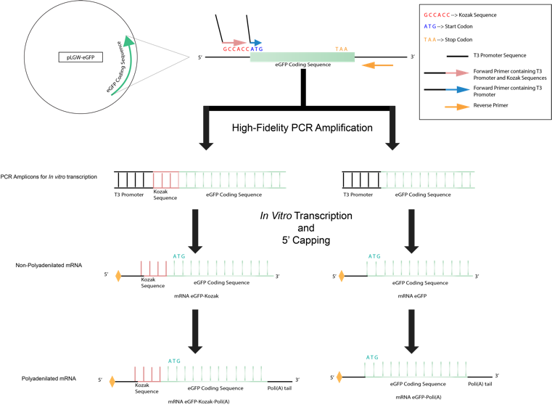
Figure 1: Schematic representation of the protocol for eGFP mRNA production.
Recent Publications
- DE SOUZA, GUSTAVO TORRES; HELL, RAFAELA CHITARRA RODRIGUES ; DA SILVA SOUZA, JÉSSICA FERNANDA ; DE ALMEIDA CAMARGO, LUIZ SÉRGIO . Easy In Vitro Synthesis of Optimised Functioning Reporter mRNA from Common eGFP Plasmid. MOLECULAR BIOTECHNOLOGY, v. 60, p. 762-771, 2018.
- JASMIN, . ; SOUZA, GUSTAVO TORRES ; ANDRADE LOUZADA, RUY ; ROSADO-DE-CASTRO, PAULO HENRIQUE ; MENDEZ-OTERO, ROSALIA ; CARVALHO, ANTONIO CARLOS CAMPOS . Tracking stem cells with superparamagnetic iron oxide nanoparticles: perspectives and considerations. International Journal of Nanomedicine (Online), v. Volume 12, p. 779-793, 2017.
- SOUZA, GUSTAVO TORRES DE; ZANETTE, RAFAELLA DE SOUZA SALOMÃO ; ET AL. Satellite Cells: Regenerative Mechanisms and Applicability in Muscular Dystrophy. Stem Cells International, v. 2015, p. 1-12, 2015.
- MARANDUBA, CARLOS MAGNO DA COSTA ; DE CASTRO, SANDRA BERTELLI RIBEIRO ; SOUZA, GUSTAVO TORRES DE; ET AL. Intestinal Microbiota as Modulators of the Immune System and Neuroimmune System: Impact on the Host Health and Homeostasis. Journal of Immunology Research, v. 2015, p. 1-14, 2015.
- SILVA, FERNANDO DE SÁ ; GUSTAVO TORRES DE ; ZANETTE ; MARANDUBA, CARLOS MAGNO DA COSTA . Toward Personalized Cell Therapies by Using Stem Cells: Seven Relevant Topics for Safety and Success in Stem Cell Therapy. Journal of Biomedicine and Biotechnology (Print), v. 2012, p. 1-12, 2012.

Biography
Gustavo was an undergraduate student at Juiz de Fora Federal University and intern in the human genetics and cell therapy laboratory (GENETEC) where had experience in culture of mesenchymal and cancer cell and molecular biology techniques, aiming the use of mesenchymal stem cells as study models. International student in the year of 2012 at Colorado College where he worked with computational chemistry. He has been developing his graduate research in Genetics And Biotechnology in the Laboratory of Animal Reproduction at EMBRAPA in collaboration with Recombinetics Inc. His aims are the optimization of production of genetically modified animals for various purposes
Email:gustavotsouza@hotmail.com
- Full Name: Gustavo Torres de Souza
- Personal Email: gustavotsouza@hotmail.com
- Mobile Number: +5532988130555
- Linked In: -
- Facebook: https://www.facebook.com/gustavo.torres.1460693
- Session Name/ number: Structural and Molecular Biology
- Category: Oral presentation
- Date of Birth: 28th May, 1992
- Postal Address: Ladeira Alexandre Leonel, 740, Cascatinha, ZIP 36033-240. City: Juiz de Fora. State: Minas Gerais. Brazil

Notes or Comments:

