Stroke Education for APNs: How can they improve the care process
Erica Edfort, DNP, MN, NVRN-BC, FAHA, Chamberlain University, USA
Varsha Singh, DNP, APN, St. Joseph Regional Medical Center, USA

Abstract (300 word limit)
Background: The 1st state-wide study investigating the perceptions of stroke care in New Jersey, identified lack of documentation of stroke pathway/orders as one of the reasons affecting outcomes of care (Edfort, 2010). The issue identified as a reason for the missed measures at some hospitals were related to lack of documentation. Some items that were identified as affecting stroke care compliance were:
- Deep vein Thrombosis treatment by end of day 2- 79%
- Screen for dysphagia before oral intake– 77%
- Stroke prevention education- 72%
Objective: The need for guideline compliance for acute stroke care is an ongoing problem for all healthcare facilities. Edfort (2010) recommended implementing processes to address the deficiencies in stroke guideline compliance.
Method: In 2017, a second state-wide stroke study was conducted in New Jersey implementing Dr. Edfort’s recommendations for improving stroke core measure compliance (Singh, 2017). This study identified the necessity of educating Advanced Practice Nurses (APNs) in stroke core measure management. APNs are front line staff in most acute care hospitals with prescribing capabilities; however, they may not be knowledgeable in the measures needed to manage stroke patients.
Results: Attending a stroke specific education program, attendees reported increasing their knowledge of managing stroke patients as well as increasing their proficiency level in care processes.
Conclusion: Providing an education program focusing on the core measures provides an advantage to our patients as well as keeping the health care facility in compliance with stroke management protocols.

Image
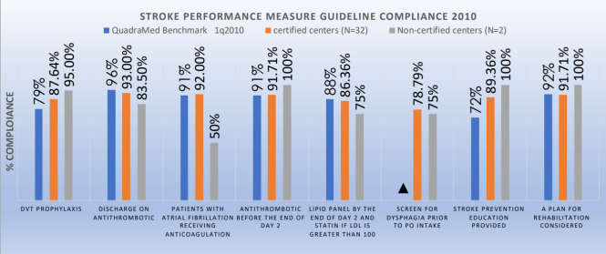

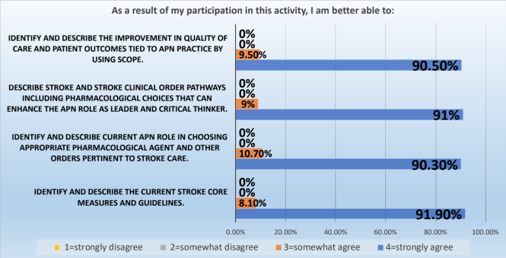

References:

Bowen, P. (2016). Early Identification, Rapid Response, and Effective Treatment of Acute Stroke: Utilizing Teleneurology to Ensure Optimal Clinical Outcomes. MEDSURG Nursing, 25(4), 241-243.
Dippel, D. W., & Simoons, M. L. (2009). Improving adherence to guidelines for acute stroke management. Circulation, 119, 16-18.
Douglas, V.C., Burchett, B.M., Kuchibbhatla, M.N., Cohen, H.J., Blazer, D.G. (2005). Do the Brain Attack Coalition’s criteria for stroke centers improve care for ischemic stroke? Neurology, 64, 422-427.
Elder, K. G., Lemon, S. K., & Costello, T. J. (2015). Increasing compliance with
national quality measures for stroke through use of a standard order set. American Journal of Health-System Pharmacy, 72(S1), S6-S10.
Frangione-Edfort E. (2014) A Guideline for acute stroke: evaluation of New Jersey's practices. Journal of Neuroscience Nurses. 46(6). E25-32.


Biography (150 word limit)
Dr. Edfort is a seasoned health care professional offering 30+ years of progressive leadership experience (management/supervision and program development) along with education (didactic, clinical and virtual). Dr. Edfort is an Assistant Professor at Chamberlain University, USA. Dr. Edfort is a Fellow with the American Stroke Association for her work in the field of stroke. She has worked at several acute care hospitals preparing them for Stoke Center designation and provided education to nursing staff, medical staff, patients, families and community member. Dr. Edfort has presented her stroke research at numerous local, regional, national and international venues.
Email: telenurss@aol.com

Notes/Comments:

Full name: Dr. Erica Edfort, DNP, MSN, NVRN-BC, RN-BVC, FASRN, FAHA
Contact number: 732-715-9020
Twitter account:
Linked In account: https://www.linkedin.com/in/erica-edfort-dnp-nvrn-bc-rn-bc-fasrn-faha-5158b514/
Session name/ number:
Category: (Oral presentation/ Poster presentation): Oral Presentation

