Ashwagandha (Withania somnifera) for sleep quality, psychology and reducing stress
Ven Dr. Sumedh Thero, Dr Jitendra Morya* and Dr H. B. Kataria**
Sumedh Bhoomi Buddha Vihar, Dr Ambedkar Park, Jhansipura, Lalitpur-284403 India

Abstract (300 word limit)

The global prevalence of stress is adversely affects cognitive ability, sleep quality, and overall psychological well-being. Ashwagandha (Withania somnifera (L.) Dunal), an essential medicine in Ayurveda, is reportedly beneficial in reducing stress and improving memory. Withania somnifera (Ashawagandha) is an evergreen shrub that grows in Asia and Africa. It is commonly used for stress. Ashwagandha contains chemicals that might help calm the brain, reduce swelling, lower blood pressure, and alter the immune system. Taking ashwagandha by mouth seems to help reduce stress in some people. It might also help reduce stress-related weight gain.Large doses of ashwagandha might cause stomach upset, diarrhea, and vomiting. Rarely, liver problems might occur. Pregnancy, Breastfeeding, multiple sclerosis, lupus systemic lupus erythematosus, rheumatoid arthritis, or other conditions avoid using or limited use of ashwagandha. Limitations- Ashwagandha might increase thyroid hormone levels and might cause sleepiness and slowed breathing, lower blood sugar levels as well as blood pressure. It is Medhya Rasayanas is best seen in children with memory deficits, or when memory is compromised following head injury, or a prolonged illness and in old age (Singh and Udupa., 1993). Ashwagandha also reduced the succinate dehydrogenase enzyme activity in the mitochondria of granulation tissue (Begum & Sadique, 1987). It is one of the best nervine tonics of Ayurveda, the most ancient system of Medical Sciences. Our clinical experience showed that besides the enumerated neurological conditions, brain strokes causing paralysis and neuronal deficit also improve in the long term treatment with Ashwagandha. Treatment with one Ashwagandha once daily for 90 days improved memory and focus, psychological well-being, and sleep quality, reduced stress levels, and was safe and well-tolerated

Image
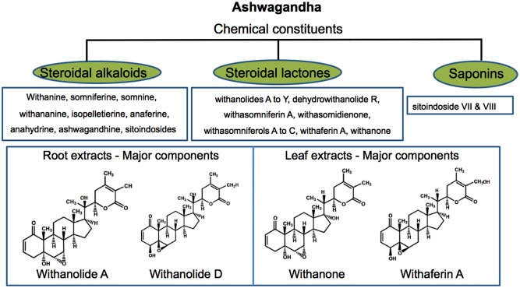
Recent Publications (minimum 5)
- Begum, V.H., Sadique, J. (1987). Effect Of Withania-Somnifera On Glycosaminoglycan Synthesis in CarrageeninInduced Air Pouch Granuloma. Biochemical Medicine and Metabolic Biology, 38(3): 272-277.
- Eun-Hyun L. Review of the psychometric evidence of the perceived stress scale. Asian Nursing Research . 2012;6(4):121–127.
- Kumarpillai et al 2021 Efficacy and Safety of Ashwagandha Root Extract on Cognitive Functions in Healthy, Stressed Adults: A Randomized, Double-Blind, Placebo-Controlled Study. Evidence-Based Complementary and Alternative Medicine Volume 2021, Article ID 8254344, 10 pages https://doi.org/10.1155/2021/8254344
- Patricia B. M., Bloom B., Nahin R. L. Complementary and alternative medicine use among adults and children; United States, 2007. National Health Statistical Report . 2008;12:1–23.
- Singh R.H., Udupa K.N. (1993) Clinical and experimental studies on rasayana drugs and rasayana therapy. Special Research Monograph, Central Council for Research in Ayurveda and Siddha (CCRAS), Ministry of Health and Family Welfare, New Delhi

o here

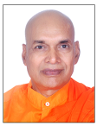Biography (150 word limit)
Ven Dr. Sumedh Thero (Dr Banwari Lal Suman) completed his PhD from Indian Agricultural research Institute, New Delhi, India. He is Ex Principal Scientist Agronomy, Chief Buddhist Monk and Founder of Sumedh Bhoomi Buddha Vihar Dr Ambedkar Park Jhansipura Lalitpur 284403 India. Credited 12 books (8 in Hindi and 4 in English) 300 papers in reputed Journals seminar symposium etc. Publisher and Founder Editor Ancient Buddhism ISSN 2395-471X
Email: vensumedh12@gmail.com

Notes/Comments:

Presenting author details
Full name: Ven Dr. Sumedh Thero
Contact number: +919415945895
Twitter account: https://twitter.com/vensumedh
Linked In account:NA
Session name/ number: 11 Managing Stress
Category: (Oral presentation virtual as suggested and send request by Meghan Heidi on Dec 16, 2021)

