Stem cell therapy in End -stage constrictive Pericarditis
Ramachandran Muthiah
Morning Star hospital, Marthandam, Kanyakumari District, India.
Abstract
The pericardium increases the cardiac efficacy by limiting the distance of cardiac chambers, protects the heart by reducing external friction and provide a barrier to extension of infection and malignancy. In constrictive pericarditis, the thickened, fibrous pericardium that form a non-complaint shell around the heart, inhibits the diastolic filling. “End-stage” constrictive pericarditis has posed a diagnostic dilemma since it presented with features of right-sided heart failure. Etiology remains unknown in majority of case and inflammatory process play a central role in its development. Currently, pericardiectomy is the only accepted curative treatment for improving cardiac hemodynamics in constrictive pericarditis. Pericardium resection (or pericardial stripping) is a surgical procedure where the entire pericardium is pealed away from the heart. In advanced (end-stage) constrictive pericarditis, pericardiectomy may not offer a cure or desired long term results. Amniotic stem cell therapy consisting of either stem cells with extracellular matrix or extracellular matrix alone in the form of human amniotic membrane allograft, an emerging anti-inflammatory and antifibrotic treatment and four human allograft membranes were topically placed over the right atrium, right ventricle and left ventricle prior to closure. Stem cells promote cardiac cell regeneration through direct and paracrine factors, decreases cardiac muscle apoptosis and improves blood supply to ischemic regions of the heart
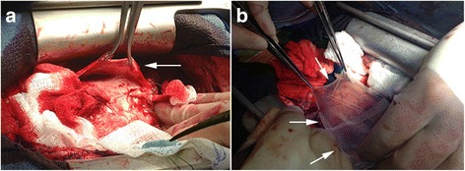
Four human amniotic membrane allografts were topically placed over right atrium, right ventricle and left ventricle

Publications
- Muthiah, R. (2021) Isolated Acute Rheumatic Pancreatitis—A Case Report. Case Reports in Clinical Medicine, 10, 52-77
- Muthiah, R. (2019) Infective Endocarditis in Tetralogy of Fallot Complicating Brain Abscess—A Case Report. Case Reports in Clinical Medicine, 8, 105-126
- Muthiah, R. (2018) Native Aortic Valve Endocarditis—A Case Report. Case Reports in Clinical Medicine, 7, 483-504.
- Muthiah, R. (2018) Tropical Coronary Artery Disease and Arrhythmogenic Potentials—The Changing Pattern towards Endomyocardial Fibrosis—An Analysis. Case Reports in Clinical Medicine, 7, 397-429
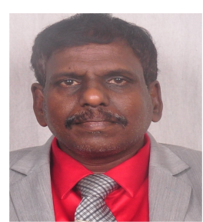
Muthiah, R. (2018) Isolated Patent Ductus Arteriosus in an Elderly Female, Aged 65 Years—A Case Report. Case Reports in Clinical Medicine, 7, 352-379

Biography
Ramachandran Muthiah, Consultant Physician & Cardiologist, Zion hospital, Azhagiamandapam and Morning star hospital, Marthandam, Kanyakumari District, India. Born on 10/5/1966.. Mother Swornam belongs to keezhkulam village and Father Muthiah belongs to Enayam thoppu and both were farmers. Published many papers in Cardiosource, American College of Cardiology Foundation, Case Reports in Clinical Medicine (SCIRP) and Journal of saudi heart assocoation.
Name/Address: Ramachandran Muthiah
Palaninta vilai, keezhkulam-629193, kanyakumari district, Tamil nadu state, India
(landline-+914651 203014,
mobile +91 7598755201)
Category: Oral
Passport No:P8925619

