

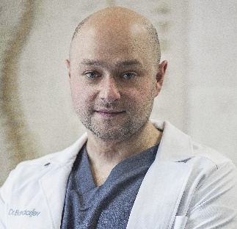

Title: Regenerative medicine in orthopaedics and traumatology.
Name: Gennadii Bondariev

Institute of traumatology and orthopedics NAMS of Ukraine, Sandler clinic, Kyiv, Ukraine.

On the basis of the Scientific and Practical Center for Tissue and Cell Therapy of the Institute of Traumatology and Orthopedics of the National Academy of Medical Sciences of Ukraine and the Sandler clinic, biotechnologies have been used to treat various injuries and pathologies of the musculoskeletal system since 2012. These are autologous concentrates of platelets, blood fibrin, mononuclear fraction of the bone marrow, medicinal signaling cells of the bone marrow and stromal-vascular fraction, as well as allogenic mesenchymal cells of the umbilical cord and placenta. This is mainly a conservative treatment using regenerative injection methods with ultrasound or X-ray navigation by introducing cellular products into joints, bones, intervertebral discs, ligaments, tendons and other structures of the musculoskeletal system. Besides there is also a high-precision intraoperative delivery of cells to hard-to-reach pathological areas, the use of autologous, allogenic and xenografts enriched with medicinal signaling cells for large defects of bone, cartilage or soft tissues. We also offer systemic intravenous administration of autologous and donor MSCs, purchases from different types of tissues for treatment of many orthopedic pathologies, including treatment of systemic diseases such as rheumatoid arthritis.

Biography
Gennadii Bondariev is a doctor orthopedist-traumatologist at the Institute of Traumatology and Orthopedics of the National Academy of Medical Sciences of Ukraine, Scientific and Practical Center for Tissue and Cell Therapy since 2011. Leading orthopedic traumatologist at the Sandler Clinic. Deputy Head of the Association of Interventional Orthopedics and Traumatology of Ukraine. An author and co-author of many scientific works, including the introduction of new methods. He is engaged in conservative and surgical regenerative treatment of injuries and pathologies of the musculoskeletal system using a wide range of biotechnological products.

