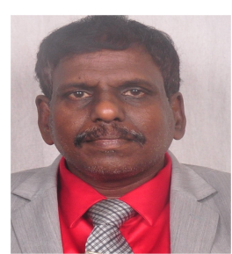
Stem cell therapy in End -stage constrictive Pericarditis
Ramachandran Muthiah
Morning Star hospital, Marthandam, Kanyakumari District, India.
Abstract
The so-called “ inflammatory hypothesis ”is now a targeted, therapeutic area in clinical and experimental cardiology. Antiinflammatory agents have no benefit and associated with side effects.The rationale of stem cell therapy therapy is to improve blood supply to the ischemic areas of heart, decrease cardiac fibrosis and cardiac muscle apoptosis. In constrictive pericarditis, the thickened, fibrous pericardium that form a non-complaint shell around the heart, inhibits the diastolic filling. “End-stage” constrictive pericarditis has posed a diagnostic dilemma since it presented with features of right-sided heart failure. Etiology remains unknown in majority of case and inflammatory process play a central role in its development. Pericardium resection (or pericardial stripping) is a surgical procedure where the entire pericardium is pealed away from the heart. In advanced (end-stage) constrictive pericarditis, pericardiectomy may not offer a cure or desired long term results. Amniotic stem cell therapy consisting of either stem cells with extracellular matrix or extracellular matrix alone in the form of human amniotic membrane allograft, an emerging anti-inflammatory and antifibrotic treatment and four human allograft membranes were topically placed over the right atrium, right ventricle and left ventricle prior to closure. In postoperative cardiac MRI, septal bounce during Valsalva suggesting ventricular inter-dependance and biatrial enlargement with dilated IVC and hepatic veins were absent. After 5 week, post operative fat-suppression T2 weighted MRI revealed no inflammation and pericardial effusion. Stem cells promote cardiac cell regeneration through direct and paracrine factors, decreases cardiac muscle apoptosis and improves blood supply to ischemic regions of the heart.
Biography
Ramachandran Muthiah, Consultant Physician & Cardiologist, Zion hospital, Azhagiamandapam and Morning star hospital, Marthandam, Kanyakumari District, India. Born on 10/5/1966.. Mother Swornam belongs to keezhkulam village and Father Muthiah belongs to Enayam thoppu and both were farmers. Published many papers in Cardiosource, American College of Cardiology Foundation, Case Reports in Clinical Medicine (SCIRP) and Journal of saudi heart assocoation.
Name/Address: Ramachandran Muthiah
Palaninta vilai, keezhkulam-629193, kanyakumari district, Tamil nadu state, India
(landline-+914651 203014, mobile +91 7598755201)
Category: Oral
Passport No:P8925619

