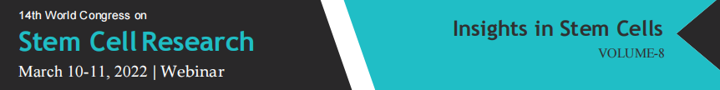
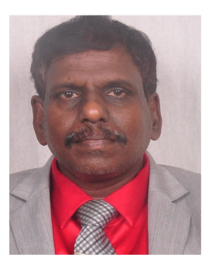
Stem cell therapy in cardiovascular research

Ramachandran Muthiah

Morning star hospital, Marthandam, Kanyakumari District,
India

The process of atherogenesis is beyond the mere accumulation of lipids, as it presents a series of responses characteristic to inflammatory disease .Repeated episodes of ischemia are a potential source of the inflammatory stimulus1, and the so-called “ inflammatory hypothesis ”is now a targeted, therapeutic area in clinical and experimental cardiology. Antiinflammatory agents have no benefit and associated with side effects.The rationale of stem cell therapy therapy is to improve blood supply to the ischemic areas of heart, promote cardiac cell regeneration by a direct or paracrine factors by stem cells, decrease cardiac fibrosis and cardiac muscle apoptosisThe stem cells studied in cardiovascular research ranged from bone marrow to adipose tissue to skeletal muscle stem cells.. These cells could potentially face rejection and it is possible to reprogram adult cells and transform these into pluripotent cells (similar properties as embryonic stem cells), termed as ‘induced pluripotent stem cells’ which can be auto-transplanted and therefore would not be rejected.. The bone marrow-derived monoclonal, mesenchymal stem cells are most readily available for transplantation in the body. Following injection of mononuclear stem cells in patients with myocardial infarctiom, there is improvement in LV ejection fraction within months, improve exercise capacity, decrease in scar tissue and a reduction in mortality in a 5-year follow up occurs..The heart possesses cardiac stem cells that could be responsible for the intrinsic regeneration and turnover throughout adult life and these cells are numerous in apices of the atrium and ventricles but their reparative potential is limited in extensive damage such as myocardial infarction. Cardiac stem cells could be beneficial in chronic ischemic patients and more recently, there has been an interest to develop and inject multiple stem cells that can communicate with each other termed as “cardiocluster”.These clusters are cocktails of cells that include cardiac progenitor cells, mesenchymal stem cells, endothelial progenitor cells and fibroblasts.. They have the potential to promote cardiac cell regeneration in disease states such as CAD (coronary artery disease) when cell function is reduced .Thus, stem cell therapy continues to be a promising treatment modality in both acute and chronic CAD.
Stem cells with extracellular matrix or extracellular matrix alone decrease fibrosis & inflammation in humans. Extracellular matrix in the form of humanamniotic membrane allograft reduces post-ischemic cardiac dysfunction, improve ischemic heart repair, increase blood flow recovery.and does not need to be donor-recipient matched, It has Antifibrotic & antiinflammatory properties when applied intraoperatively.Four human allograft membranes were topically placed over right atrium, right ventricle and left ventricle.in end-stage constrictive pericarditis. In postoperative cardiac MRI, septal bounce during Valsalva suggesting ventricular inter-dependance and biatrial enlargement with dilated IVC and hepatic veins were absent. After 5 week, post operative fat-suppression T2 weighted MRI revealed no inflammation and pericardial effusion. But long-term benefits of stem cell therapy is to be established on further studies and many recent trials showing not much beneficial effects and the transplanted cells may have arrythmogenic potentials in the heart due to lack of gap junctions and the viability of the transplanted stem cells is to be analysed on periodic assays.

Biography

Ramachandran Muthiah, Consultant at Zion hospital, Azhagiamandapam and Morning Star hospital, Marthandam, Kanyakumari District, India.. Completed primary education at Anaan vilai in keezhkulam and secondary education at Concordia Higher secondary school, Pootteti. MBBS in 1988 (Madurai Kamaraj), M.D. in 1996, D.M. in 2003 Dr.MGR Medical University, Chennai, 6 months course in Interventional cardiology at Batra Hospital, New Delhi in 2006 ( Ministry of health, Govt of India). Worked as medical officer in Rural health services for 5 years (keezhachekkarakudi,Aryappapuram Primary health centres, ESI hospital, Singanallur, coimbatore), teaching category as Assistant Professor at Madras, Coimbatore and Thoothukudi medical colleges. Published papers in Cardiosource, American College of Cardiology Foundation, Case Reports in Clinical Medicine (SCIRP) and Journal of Saudi Heart Association.

About the Institution
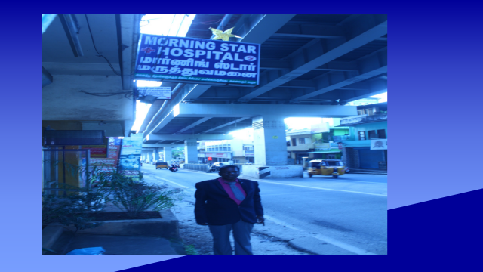

The morning star hospital is situated in southern pole of India, at marthandam in kanyakumari district of Tamil nadu state. It is founded by a poor, orphan girl, R.Russulsy and established in a rented building at this region and further help & upgrade of this institute is requested through this girl to Congress supremo R. Rahul Gandhi in presence of vilavancode MLA, S. Vijayadharani during their election compaign at kuzhithurai in 2021 and looking forward with much more expectations by their hands at present. But they ignored and requesting the world scientific forums to contribute some funds to the welfare of this hospital through the Presidents of all nations and also for my survival to do more research papers further.
References
- Wu JX, Li J, Zhang NN, Zhang CH. Stem cell-based therapies in ischemic heart diseases: a focus on aspects of microcirculation and inflammation. Basic Research in Cardiology. 2011;106:317–324
- Korf-Klingebiel M, Kempf T, Sauer T, Brinkmann E, Fischer P, Meyer GP, Ganser A, Drexler H, Wollert KC. Bone marrow cells are a rich source of growth factors and cytokines: implications for cell therapy trials after myocardial infarction. Eur Heart J. 2008;29:2851–8
- Kubal C, Sheth K, Nadal-Ginard B, Galinanes M. Bone marrow cells have a potent anti-ischemic effect against myocardial cell death in humans. Journal of Thoracic and Cardiovascular Surgery. 2006;132:1112–1118..
- Xu M, Uemura R, Dai Y, Wang Y, Pasha Z, Ashraf M. In vitro and in vivo effects of bone marrow stem cells on cardiac structure and function. J Mol Cell Cardiol. 2007;42:441–8
- Uemura R, Xu M, Ahmad N, Ashraf M. Bone marrow stem cells prevent left ventricular remodeling of ischemic heart through paracrine signaling. Circulation Research. 2006;98:1414–1421
- Schinkothe T, Bloch W, Schmidt A. In vitro secreting profile of human mesenchymal stem cells. Stem Cells Dev. 2008;17:199–206
- Mourkioti F, Rosenthal N. IGF-1, inflammation and stem cells: interactions during muscle regeneration. Trends Immunol. 2005;26:535–42
- Xu X, Xu Z, Xu Y, Cui G. Effects of mesenchymal stem cell transplantation on extracellular matrix after myocardial infarction in rats. Coron Artery Dis. 2005;16:245–55
- Nichols J, Smith A. Naive and Primed Pluripotent States. Cell Stem Cell. 2009;4:487–492
- Ebert AD, Diecke S, Chen IY, Wu JC. Reprogramming and transdifferentiation for cardiovascular development and regenerative medicine: where do we stand? Embo Molecular Medicine. 2015;7:1090–1103.

