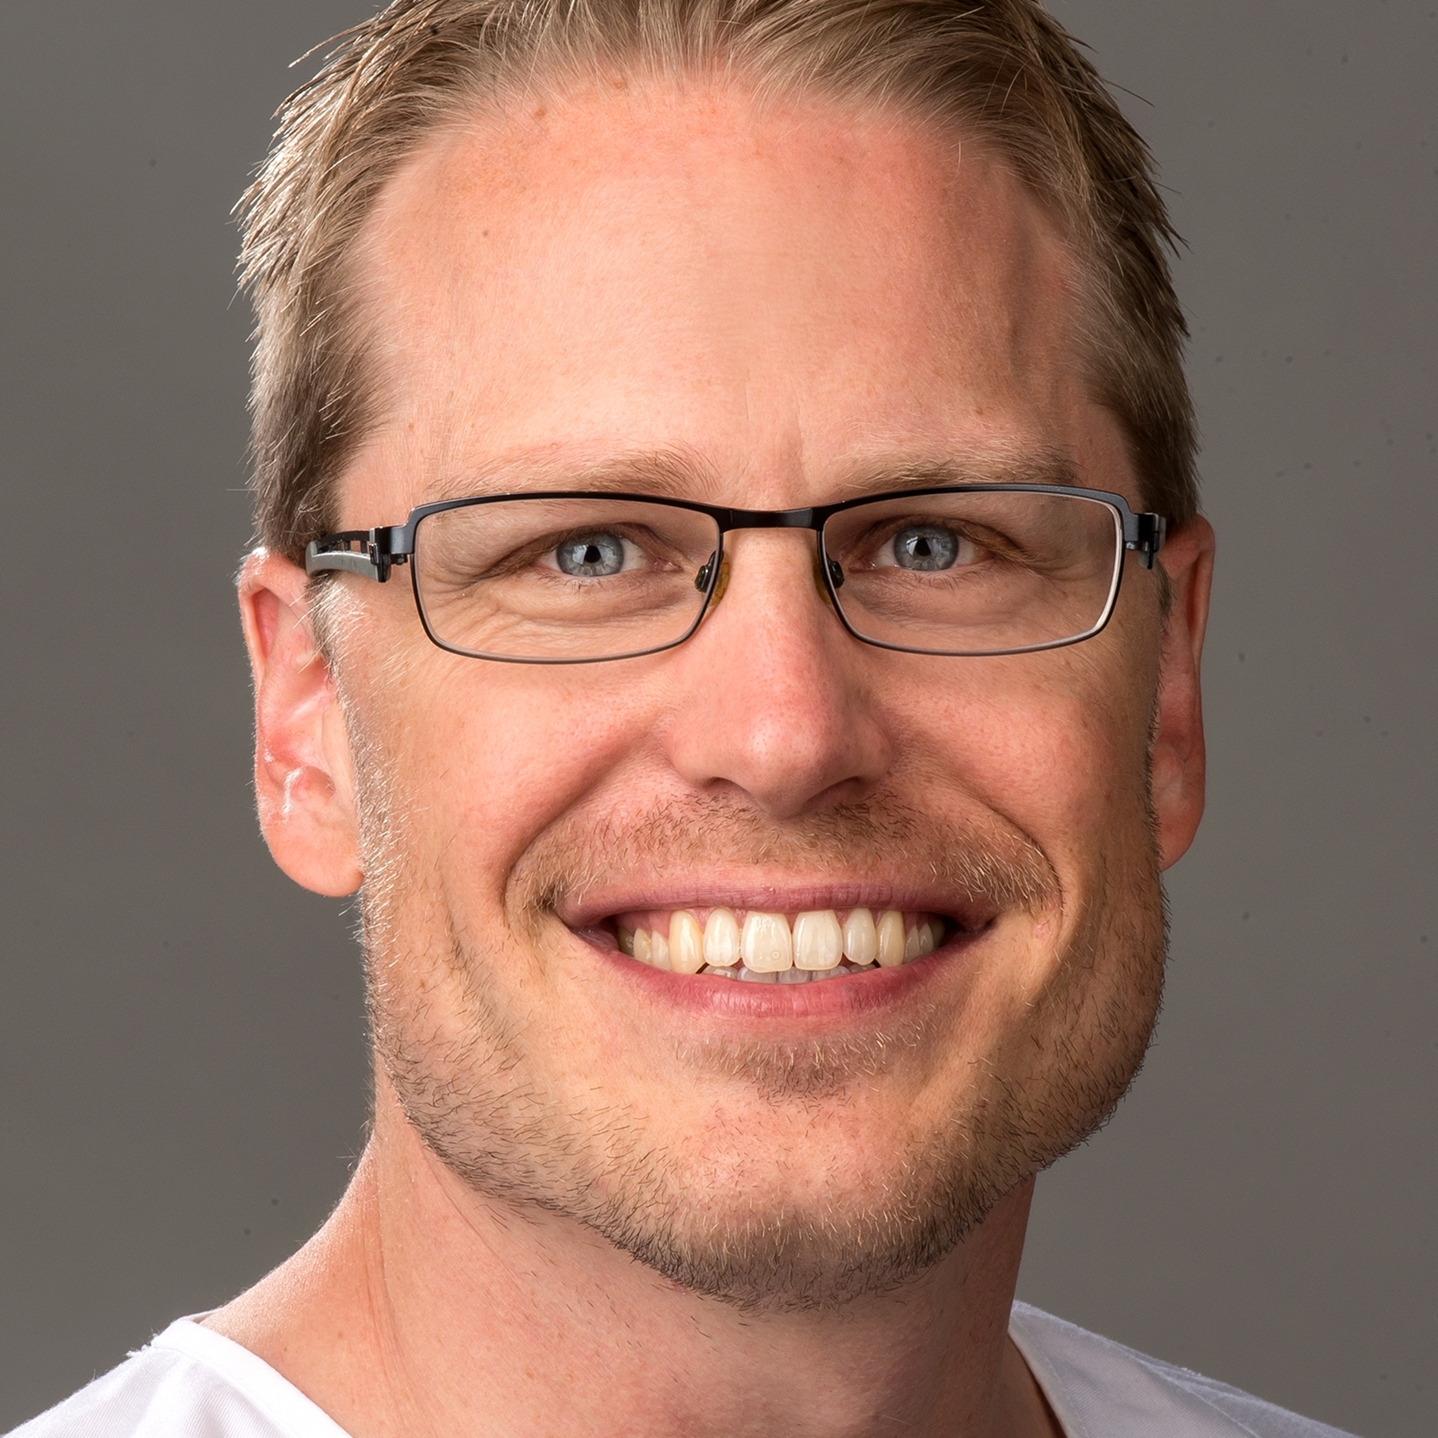

Title: How laws of nature should guide the development of 3D cell culture for regenerative medicine

Name: Patrick Kugelmeier
Kugelmeiers AG, Switzerland

Abstract
We are at a tipping point where nature is revealing us top secrets of life. We can reveal them when we look at life how it really is - in 3D.
3D cell culture systems reflecting real life processes thus provide not only sound scientific data, but they also enable regenerative medicine with stem cells.
Almost every life begins with cell clusters. 3D cell clusters are therefore an ideal scientific model that offers additional therapeutic options. But for full functionality, clusters need to be size-controlled in a physiological, “cosy” environment. Unfortunately, current technology is limited to either quality or scalability, and therefore many desired applications are not possible.
Because of this unmet medical need we therefore developed the Sphericalplate 5D, enabling the full translation from lab to clinics with freely scalable, size-controlled spheroids in clinical grade quality. A human multicenter trial for the treatment of Diabetes is beginning 2019.

Biography

Patrick Kugelmeier studied medicine and did his medical thesis in islet transplantation for the treatment of Diabetes. The joy of research led to an MD-PhD program for the early differentiation of stem cells. Cell culture technologies at that time didn't allow for good data reproducibility, because stem cells were cultured in 2D. Fueled by the clinical need of small, size-controlled cell clusters to improve islet transplantation and the insights from the sensitivity of stem cells, he began to develop what was later to become the Sphericalplate 5D.
After the MD-PhD program, he did his clinical training in visceral and transplant surgery followed by trauma surgery. Besides the clinical work, the Sphericalplate 5D was further developed. Finally, it became clear that this technology opens a new dimension in cell transplantation and regenerative medicine and Dr. Kugelmeier decided to quit surgery to fully live this vision within a startup-company, the Kugelmeiers AG.

