PrEP in the Southwestern United States: Patients’ experiences of optimal pre-exposure prophylaxis care
Ryan E. Flinn, Ph.D., Augusta University
Tania Valente, Ph.D., Psychological Counseling Consultants LLC
Cory J. Cascalheira, BA, LSAA, New Mexico State Univ.

Abstract
Statement of the Problem: Pre-exposure prophylaxis (PrEP) to prevent HIV transmission is an efficacious biomedical intervention that has yet to be brought to scale in many communities. The present qualitative thematic analysis analyzed a subset of qualitative responses generated during semi-structured interviewing with current and former PrEP users living in the Southwestern and Rocky Mountain regions of the United States. This region is medically underserved and many residents live in rural areas. The purpose of this study is to identify characteristics of PrEP care that current and former PrEP users identify as optimal. Methodology & Theoretical Orientation: The parent study from which these data are drawn utilized a deductive thematic analytic approach to investigate minority stress processes among PrEP users in the Southwestern U.S. The first author interviewed 19 adults living in this region, recordings were transcribed, and transcripts were analyzed by the second and third authors. Findings: The present analysis identified four characteristics of PrEP prescribers and health care encounters which participants view as central to optimal PrEP care: (a) informed and prepared; (b) culturally aware; (c) prompt and pragmatic; and (d) sex-positive and accepting of difference. Conclusion & Significance: PrEP users expect their prescribers to be able to offer PrEP as one approach to HIV prevention in an informed, flexible, and prompt manner. Educators can contribute to preparing prescribers by supporting their awareness of continued stigma associated with PrEP in many communities, increasing knowledge of reasons patients may wish to utilize PrEP (e.g., seropositive partners, open or polyamorous relationship, involvement in kink, desire for intimacy without barriers), and enhancing provider skill in moderating ways of approaching patients during clinical interviews by recognizing diversity in sexual identity development, outness, and anxiety. Psychologists and other health professionals can play a key role in supporting these outcomes among patients and prescribers.

Image
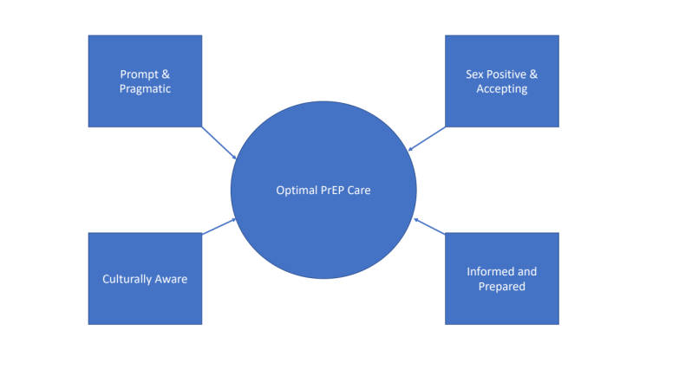
Recent Publications
- West et al. (2012) It’s supposed to be personal: Personal and educational factors associated with sexual health attitudes, knowledge, comfort and skill in health profession students. American Journal of Sexuality Education, 7(4): 392-354.
- Valente (2021). Understanding the development of sex positivity in psychologists (dissertation). New Mexico State University.
- Holloway et al. (2017). PrEP uptake, adherence, and discontinuation among California YMSM using geosocial networking applications. JAIDS, 74(1), 15.
- Calabrese (2020). Understanding, contextualizing, and addressing PrEP stigma to enhance PrEP implementation. Current HIV/AIDS reports, 17, 579-588.
5. Cascalheira et al. (2021). Curative kink: Survivors of early abuse transform trauma through BDSM. Sexual and Relationship Therapy. DOI: 10.1080/14681994.2021.1937599

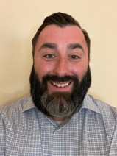

Dr. Ryan Flinn is the 2021-2023 HIV/LGBTQ+ Health Psychology Fellow at the Medical College of Georgia at Augusta University. They completed their predoctoral internship in Health Service Psychology at The Ohio State University’s Counseling and Consultation Service and received their doctoral degree in Counseling Psychology from New Mexico State University in 2021. Their areas of clinical and scholarly interest include well-being among people living with HIV, prevention and health promotion, mental health help-seeking, integrated behavioral health care, substance use disorder treatment, sexual health and wellness, and trauma-informed mental health care. They are also a 2021-2023 UCLA NIDA HA-STTP Scholar.
Email: rlinn@augusta.edu

Notes/Comments: The authors wish to acknowledge the analytic support of Mr. Christopher A. Evans and the transcription support offered by Counseling and Educational Psychology research practicum students at New Mexico State University. This work was funded by a grant provided to the first author by PFLAG Las Cruces.
Presenting author details
Full name: Ryan E. Flinn, Ph.D.
Contact number: (402) 575-7016
Mail id: rflinn@augusta.edu
Category: Poster presentation

