CURRICULUM VITAE (C.V)

RICHARD KASUBA

PERSONAL PROFILE
Highly motivated personable and organized, I am eager to apply my academic background and extensive volunteer and leadership experience, particularly in the field data collection. I have worked in the field of HIV/AIDS and community mobilization with one of the leading NGOs in Zambia -Centre for infectious Disease Research in Zambia, as a data clerk.

PERSONAL DETAILS
SURNAME: KASUBA
FIRST NAME: RICHARD
D.OB: 07/12/1996
N.R.C: 381571/10/1
NATIONALITY: ZAMBIAN
RELIGION: CHRISTIAN
STATUS: SINGLE
CONTACT: 0978352630
PHYSICAL ADDRESS: MATERO 4810A
EMAIL ADDRESS: richardrichmankasuba@gmail.com
LANGUAGE: BEMBA/ENGLISH

EDUCATION

2014-2016 Secondary level and acquired a certificate at Lusaka High School
2010-2011 Primary level and acquired a certificate at Matero Boys School
2003-2009 Basic level and acquired a certificate at Edwin Mulongoti School

WORK EXPERINCE
UNECEF Lusaka, Zambia
2016-2018
DUTIES
1. Data entry
2. Advocacy

CIDRZ Lusaka, Zambia
2018-2019

DUTIES
- Data entry
- Research
- Counseling
- Conducting HIV testing

PERSONAL ATTRIBUTE
- Computer Literacy
- Good communication skills
- Ability to work in a group of effective people
- Easy to adapt and learn fast (willing to learn new things)
- Zealous to work and bring fourth development ideas were need arises

INTEREST AND ACTIVATIES
- Reading
- Traveling
- Football

REFERENCE
Lusaka High School
Class Teacher
Mr. Bombwe
Contact: 0972431830
CIDRZ MANAGER
BELIA LONGWE
Contac: 0979790094

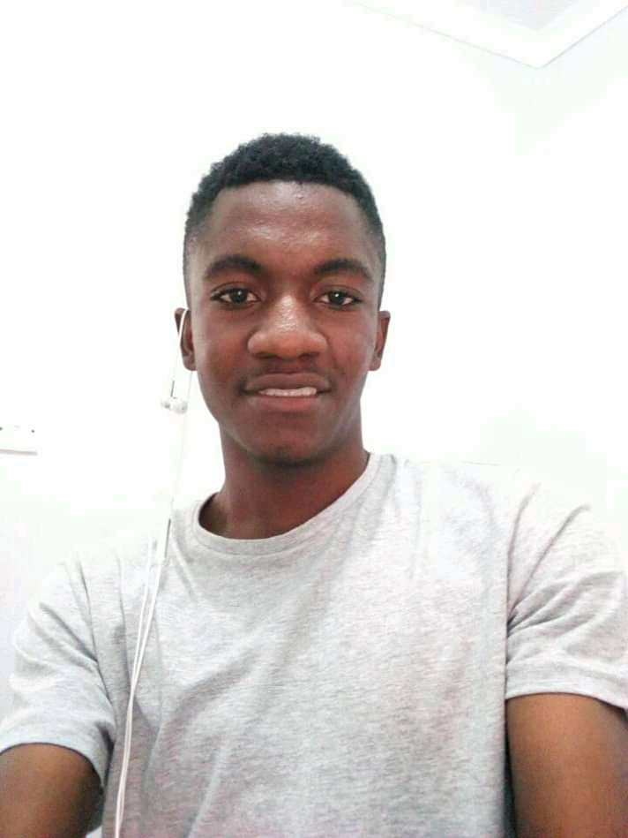
PERSONAL CREDENTIALS
SURNAME: Kasuba
FIRST NAME: Richard
D.O.B: 07/12/1996
NATIONALITY: ZAMBIAN
STATUS: SINGLE
RELIGION: CHRISTIAN
N.R.C NUMBER: 381571/10/1
PHYSICAL ADDRESS: MATER0 4810A
PHONE NUMBER: +260978352630

CURRENT ENGAMENTS
SELF EMPLOYEMENTS

PERSONAL ATTRIBUTE
- Computer Literate
- Excellent communication skills
- Ability to work in a group of effectively
- Easy adaption and learn fast (willing to learn new things)
- Zealous to work and bring fourth development Ideas were need arises

EDUCATION BACKGROUND

2002-2008 Basic level and acquired a certificate at chimuche
2009-2010 Primary level and acquired a certificate at Matero boys
2013-2016 Secondary level and acquired a certificate at lusaka Secondary

WORK EXPERIENCE
- 2011-2012 Worked with MTN Zambia as an agent

2016- 2018 volunteered at Matero main clinic
Duties
- Able to conduct counseling and HIV testing
- Conduct community outreaches
- Provide family services
- Able to refer clients to medical staffs

INTERESTS AND ACTIVITIES

- Reading novels
- Football

REFERENCE

Class Teacher
New Matero Secondary
Phone number 0972431830

