What sex does to a woman's brain lesson learn from power politics pharmacy institutions in Pune University

Rahul Hajare
Post Doc Fellow Indian Council of Medical Research
Abstract
A female mind reacts much more and is more stimulated than a male one when aroused. Turns out, a woman's mind is much more complex than a male's when it comes to intimacy; a female mind reacts much more and is more stimulated than a male one when aroused. In the study conducted on 20 men and 20 women, each of the individuals has seen erotic film clips while their brain vitals were scanned by two scanners. One of the scanners has an MRI machine that tracked stimulation in their brains. The other was a heat-seeking camera that measured levels of arousal through participant's genitals. While not massive, the recorded difference between stimulation levels between male and female brains highlighted the consistent disparity between the two counterparts. There has no brain region in men with stronger brain-genital correlations than in women. While interesting, the sample size for the study has too small, according to salary structure, love like and happiness. However, extended women’s nail complexity has directly approach to female arousal than men.
Note* Age and colour of female is not added in research because extended study has experiment on cerebellum base of different colours and weight of female.
Biography
Dr. Rahul Hajare has been a hard worker all his academic life. After his Ph.D in Pharmacy from VMRF Salem which he completed with flying colours, he is fortunate to work NARI primer HIV research Institute to complete Post Docunder the of World Renowned Scientist Respected Dr. R.S.Paranjape., Retired Director & Scientist ‘G’ National AIDS Research Institute Pune. Dr. Rahul Hajare has Associate Professor of Pharmaceutical Medical Chemistry to Pune University (until 2020), he has serviced three times AssociateProfessor in Pharmaceutical Science and Analytical Science. Graduated from Amravati University in 2003, after an assignment he worked as an M.Pharm Scholar in the Institute of Pharmaceutical Education and Research passed with distinction, he has Post Graduate Teacher for Master of Pharmacy, he has more than 30 scientific and methodological works, 3 patents of scientific research. Dr. Rahul Hajare now Principal of Ishwar Deshmukh Institute of Pharmacy affiliated combined Amravati University and All India Council of Technical education New Delhi.
Email ID: rahulhajare17@gmail.com
Presenter Name: Rahul Hajare
Type of Presentation: Speaker

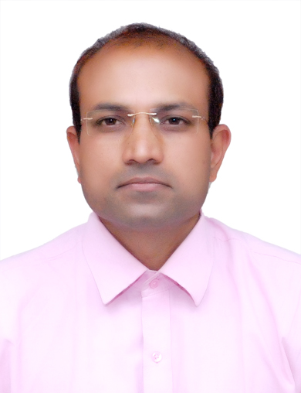
Contact Number: 9921707584

