The Effects of Contextual Factors and Dating App Usage on Sexual Risk Behaviors Among Young Adults
Chloe Chan, BA, New York University, USA
Jennifer Jennings, PhD, New York University, USA

Abstract
With the rise of social media and smartphones, millennials increasingly report meeting their romantic partners through mobile dating apps. Yet there is concern that this may also be the reason behind increases in sexually transmitted infection (STI) rates among young adults. This study examines whether contextual factors affect young adults’ perceived STI risk and engagement in sexual risk behaviors. In addition, we compare sexual histories among app users and non-users. We recruited our sample from 111 college Facebook groups over a 10-week period. Depending on their sexual orientation, participants were presented with 1 of 32 scenarios varying in levels of perceived risk. They answered questions pertaining to their sexual decision making, relationship status, dating app and sexual experience, condom usage, and STI testing experience. A total of 4,429 eligible participants between the ages of 18-24 completed the survey. Participants were more likely to believe that their partner had a greater number of sexual partners and engaged in casual sex if the scenario involved either a male partner, perceived high-risk location, or one-night stand. They were more likely to enforce condom usage if their partner was male. Lastly, they were more likely to ask about their partner’s STI status if the scenario involved a male partner or one-month dating. Among sexually active participants, dating app usage was associated with sexual experience and having casual relationships, more sexual partners, higher perceived STI risk, and STI testing. While over half of the sexually active participants had inconsistent condom usage and had not been tested for STIs, they generally reported low perceived STI risk. Dating app users are more likely to engage in sexual risk behaviors and to have had STI testing. Thus, dating apps can be a useful platform for increasing STI knowledge and reducing the incidence of STIs among their users.

Image
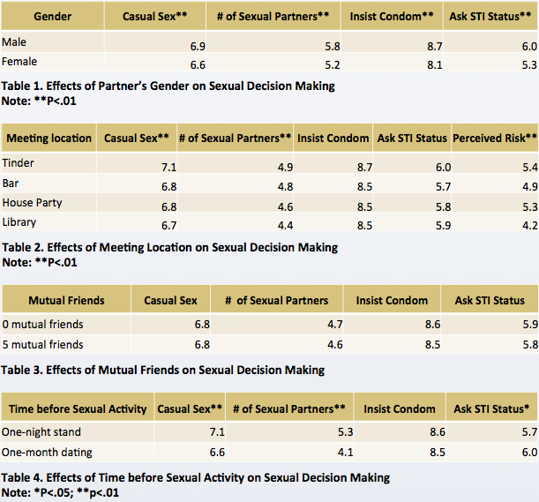

Biography
Chloe is a senior at NYU majoring in Psychology with a minor in Child and Adolescent Mental Health Studies. She is currently a program coordinator at Health Leads and a research assistant at Bellevue Hospital Center. Her research interests lie in health disparities and sexual decision making.

Email: cc3930@nyu.edu

Notes/Comments:

