Project Axshya –a civil society initiative in India pushing the agenda of END TB.

Ms Sajna S Nayak, International Union Against Tuberculosis and Lung Diseases (IUATLD), Dr Jaya Prasad Tripathy (IUATLD), Mr Subrat Mohanty (IUATLD), Mr Gayadhar Mallick (IUATLD), and Ms Pooja Agarwal(IUATLD)

Background:

Despite the progress made, India has the world’s highest burden of TB with 2.8 million new cases in 2015 according to WHO Global TB Report 2016. While moving towards the goal of eliminating TB, it’s imperative to reach the unreached population who remains undiagnosed, untreated and continue to transmit infection in the community. In this context, a major civil society initiative in TB care and control has been taken up through Project Axshya- A Civil Society Initiative to Strengthen TB Care and Control in India’ through the Global Fund Round 9 grant.

Project Implementation:

Supported by the Global Fund, it is implemented by The Union in 285 districts across 19 states of India including 40 urban cities through eight civil society organizations and over 1000 local NGOs and nearly 15000 community volunteers. During April’13 to December ’16, Axshya reached over 13 million households, facilitated identification and testing of over 935,000 TB symptomatics including sputum collection and transportation of nearly 752,000 cases, resulting in diagnosis and treatment initiation of 81,000 patients and notification of over 16,000 from private sector.

The key interventions of Project Axshya are outlined in Figure 1.

Conclusion:
Axshya has been able to leverage greater interest and community participation in TB care and control and has emerged as a key partner in supporting the National TB Control programme. Through the initiatives centred on community engagement and participation, Project Axshya adopts a holistic view of TB, not just from the programme and practitioner perspectives but also from that of the patient and the community.

Image
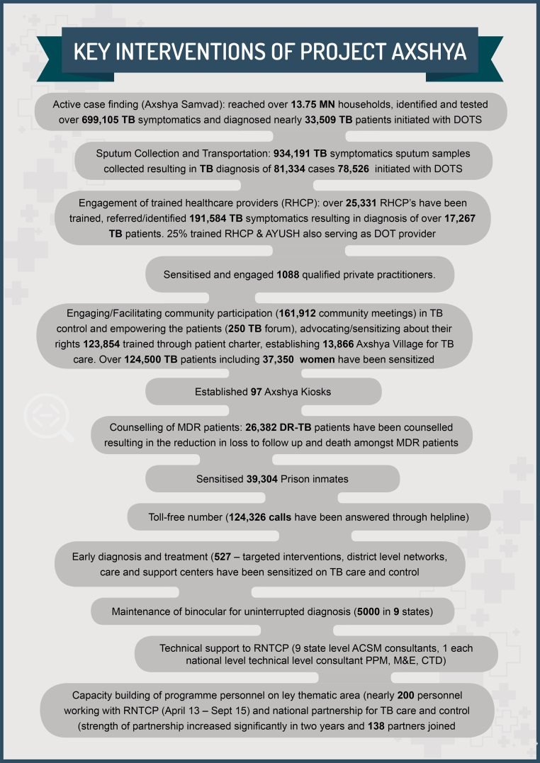
Recent Publications (minimum 5)
This abstract can be developed into a paper for publication along with my last year abstract which I have started. My interest in writing research and scientific paper and the fact that I have already represented The Union South East Asia office in the last two international scientific conferences ( Lung Conference 2015 at Cape Town and 2016 at Liverpool) despite having a HR background.

 Sajna Sarasita Nayak:
With a decade of rich experience and proven expertise in all aspects of human resource management and development with deep domain understanding of strategic HR, supports the overall strategic goals and objectives at the Union South East Asia Office at various levels, driving strategic HR initiatives to realize bottom line results and enhance employee engagement in the pursuit of organisational objective and professional excellence. Along with HR domain, love to write and take initiatives in spreading awareness against TB and Tobacco. Participated in international forums and presented her scientific/research papers on TB and Tobacco by building thought leadership and brining awareness on the new aspects of finding solutions to end TB and the effects of Tobacco. A Post graduate in HR management and holds a graduate degree in law and a masters degree in fine arts. She likes travelling and lives in New Delhi, India.
Email: snayak.hr@theunion.org

Notes/Comments:

