Prevalence, Pattern and Predictors of STIs, Symptoms and Treatment Seeking Behaviour among Reproductive Age Women in India

INTRODUCTION
Sexually transmitted infection (STIs) is an infectious disease that spreads from person to person during sexual contact. Sexually transmitted diseases, such as syphilis, trichomoniasis, and HIV infection are caused by bacteria, parasites, and viruses. The older terminology of "venereal diseases" (VDs) largely has been superseded in the past 50 years by "sexually transmitted diseases" (STDs), and more recently by "sexually transmitted infections" (STIs). The term sexually transmitted diseases more easily incorporate the many newly discovered sexually transmitted agents and syndromes. STD include diseases that are transmitted by sexual intercourse. Sexual transmission requires the agent to be present in one partner, the other partner to be susceptible to infection with that agent and that the sex partners engage in sexual practices, which can transmit the pathogen. STIs differs from STD in that STD conventionally includes infections resulting in clinical diseases that may involve the genitalia and other parts of the body participating in sexual interaction e.g., syphilis, gonorrhea, chancroid, donovanosis, nongonococcal urethritis, genital warts, herpes genitalis etc. STI, in addition, includes infections that may not cause clinical disease of genitals, but are transmitted by sexual interaction e.g., all STD and hepatitis B, human immunodeficiency virus (HIV), HTLV-1 etc. Nowadays, the term STI is preferred, since it covers all the diseases that can be transmitted by sexual intercourse. However, for all practical purposes, both STI and STD terms are used synonymously. STIs are more dynamic than other diseases prevailing in the community. Their epidemiological profile varies from country to country and from one region to another within a country, depending upon ethnographic, demographic, and socioeconomic and health factors. The clinical pattern is also a result of the interaction among pathogens, the behaviours that transmit them and the effectiveness of preventive and control interventions. Several STIs, particularly HIV and syphilis, can also be transmitted from mother to child during pregnancy and childbirth, and through blood products and tissue transfer. According to World Health Organization (WHO) more than 1 million people acquire a sexually transmitted infection (STI) every day globally. WHO estimates that worldwide 500 million new cases of one of four curable STIs (chlamydia, gonorrhoea, syphilis and trichomoniasis) occur each year. STIs/RTIs (reproductive tract infections) are an important public health problem in India. A community based STI/RTI prevalence study conducted during 2002-03 by the Indian Council of Medical Research (ICMR) has shown that 6% of the adult population in India has one or more STI/RTI. This amounts to occurrence of about 30-35 million episodes of STI/RTI every year in the country. Women often have more serious health problems from STIs than men, including infertility. In developing countries like India Bangladesh, Pakistan, Srilanka STI prevalence is very high among women. STIs are the third most common cause of healthy life years lost by women of reproductive age, exceeded only by maternal causes and HIV. Oomman in her review of studies on RTIs and other gynaecological morbidities has also noted variable prevalence rates for RTIs from studies conducted in different parts of the country [2000]. The variations in the studies based on different sources of data i.e. clinical, laboratory or self-reports may have been, in her view, due to different cultural perceptions of illness, inter-clinical\variations and different criteria adopted indifferent laboratory tests. Based on the review of evidence on the pattern of STIs in India, Ramsubban [2000] draws attention to relatively greater vulnerability of women to STIs and HIV as compared to men. The present study, therefore, aims to examine the prevalence of STI infection and symptoms and the treatment seeking behaviour among women and what are the factors associated with this.
LITERATURE REVIEW
Reproductive tract infection (RTI) is a global health problem among women, living in South East Asian Region (SEAR) countries. Studies have found the prevalence of RTI in India, Bangladesh, Egypt, and Kenya is in the range of 52–90 per cent. More than a million women and infants die of the complications of RTI every year. [UNFPA, 1999] Several community-based studies have brought to light important issues pertaining to reproductive and sexual health of women as well as men. A set of qualitative studies on gynaecological morbidities including RTIs highlighted aspects such as determinants of reproductive morbidity, women’s perception of their reproductive health and their treatment seeking behaviour. White discharge was reported to be the major complaint and women referred to the problem indirectly by using the terms such as "backache” and “weakness” for white discharge. [Bang, and Bang, 1992.] The study carried out in the state of Karnataka, South India showed high burden of RTIs. Bacterial vaginosis and mucopurulent cervicitis were found to be the two most common disorders followed by pelvic inflammatory disease, cervical ectopy, and fistula. STDs was found among ten percent of the women. [Bhatia, et.al. 1997] In yet another study of urban slum population in the two cities of Gujarat, India, 42 percent of the women and six percent of the men reported that they had ever experienced any symptom of RTI/STI. Among those who had such a symptom, 61 percent of the women and 99 percent of the men had not sought health care. Looking to the determinants and mechanisms that increase women’s vulnerability to a possible RTI/STI, the study has identified the role of various practices and behaviour associated with menstruation, childbearing, maternal health care, contraception and sexual behaviour of women and their husbands. [Das and Shah, 2007] A study carried out in urban slums of Baroda city, Gujarat, and the other carried out in the rural areas of three selected districts of the state revealed a very high prevalence (76 to 85%) of reproductive health problems among the studied women.[ Das and Shah, 2002.] Menstrual problems were the other commonly reported problem. The results of the studies on the prevalence of gynaecological morbidity conducted at four different Indian sites have reported unacceptably high levels of morbidity, considerable inter-study variation in the levels and patterns of morbidity and a common constellation of problems in all studies despite the variations. [Latha, K, Kanani, S. J. and Maitra, N .1997.] In a study conducted by Kosambiya, in Surat, the prevalence of RTI/STIs was higher in urban (69%) than rural area (53%). The higher prevalence among urban population was attributed to greater proportion of migratory population residing in urban areas of Surat [J. K. Kosambiya, 2010]. Oomman in her review of studies on RTIs and other gynaecological morbidities has also noted variable prevalence rates for RTIs from studies conducted in different parts of the country. The variations in the studies based on different sources of data i.e. clinical, laboratory or self-reports may have been, in her view, due to different cultural perceptions of illness, inter-clinical\variations and different criteria adopted indifferent laboratory tests. [Oomman, 2000] A study carried out in urban slums of Baroda city, Gujarat, and the other carried out in the rural areas of three selected districts of the state revealed a very high prevalence (76 to 85%) of reproductive health problems among the studied women.[ Das and Shah, 2002.] Based on the review of evidence on the pattern of STIs in India, Ramsubban draws attention to relatively greater vulnerability of women to STIs and HIV as compared to men. [Ramsubban, 2000] Working women had better treatment seeking behaviour than nonworking women in rural area. This finding is comparable to that found in a study done by Sabarwal and Santhya in which the greater proportion of the working women sought treatment as compared to the nonworking women. [Sabarwal, Santhya, 2012]. There is not so much variation is found on the basis of place of residence, rural and urban women but risk factors for the prevalence of STI infection varies from rural to urban areas, the treatment seeking behaviour and nature of treatment also varies from rural to urban areas. [Varma et. al. 2012]

CONCEPTUAL FRAMEWORK ON DETERMINANTS OF STI AND SYMPTOMS
OUTCOME
INTERMEDIETE
BACKGROUND
Preventive behaviour
STI Testing and treatment.
Advice taking
Behavioural factors.
No. of sexual partner.
Type of sexual partner.
Contraception use.
Abortion.
Forced sex.
Perception on STI infection
High risk
Medium risk
Low risk
No risk
NATIONAL LEVEL
Health policies
Policies on reproductive health.
Policies on education, gender, economy and employment.
Socio-demographical factors
Age at first sex
Marital status
Educational status
Working status
Age at marriage
INDIVIDUAL LEVEL
Age, Sex Ethnicity, and Religion,
COMMUNITY LEVEL
Socio-cultural beliefs and practices.
Gender attitude and roles.
Transport and communicational network.
Health and educational infrastructure.
Place of residence.

Psycho-social factors & knowledge factors.
Access to information on STI infection and symptoms.
Knowledge, attitude and beliefs of STI infection and symptoms.
Health care autonomy

NEED OF THE STUDY
Yearly, an estimated 448 million treatable sexually transmitted infections (STIs) occur worldwide. Over 80% of all new HIV infections are acquired through sexual transmission. The enormous burden of morbidity and mortality due to STIs impact directly on quality of life, sexual and reproductive health (SRH) and child health, and indirectly as cofactors for HIV transmission. Sexually transmitted diseases such as syphilis, chancroid ulcers and genital herpes simplex virus ulcers greatly increase the risk of acquiring or transmitting HIV and in some cases account for 40% or more of HIV transmissions. In addition, STIs are the third most common cause of healthy life years lost by women of reproductive age, exceeded only by maternal causes and HIV. So it is very important to know the socio demographic and behavioural characteristics that associated with STI infection and symptoms among women. In developing countries like India the condition of women become more vulnerable in terms of reproductive health problems, because of many social stigma and cultural tradition and superstition. Moreover women often do not go for treatment or advices about their reproductive health problem like STI infection. So it is very important to know the socio demographic and behavioural characteristics that are associated with treatment seeking behaviour for STI infection among women in India.
RESEARCH QUESTIONS
- Is there any relationship between socio-demographic and behavioural characteristics with STI infection and treatment seeking behaviour among women of India?
- Is there any geographic variation of STI, symptoms and treatment seeking behaviour among women of India?
OBJECTIVES
- To study the prevalence of STI and its socio-demographic and behavioural determinants among women of reproductive age in India.
- To understand the STI treatment seeking and its socio-demographic and behavioural determinants among women of reproductive age in India.

DATA AND METHODS:
Data source:
The data used for the study is taken from the IV round of National Family Health Survey (2015-2016) conducted by the International Institute for Population Sciences, Mumbai. The NFHSs are nationwide surveys conducted with a representative sample of household's Throughout the country. NFHS-4 is the largest household survey in India collects the data From 628,900 lakhs household and 723,875 women aged 15-49 for a response rate of 98%. It provides the estimate for all 29 states, 7 union territories and 640 districts of India Using the multistage sampling. The current study uses women file dataset from NFHS-4 data for analysis purpose, which has Information of 699686 women. From the perspective of research objectives information was collected from 93233 women who ever heard about sexually transmitted disease.
Variable description:
Outcome variables:
From the perspective of objectives of the study two dependent variables have been used. One is STI infection and symptoms and another is treatment seeking behaviour. The first dependent variable STI infection and symptoms is incorporate with three variable as had any STI/ abnormal genital discharge/ genital ulcer. Second dependent variable also incorporate with two different variable such as sought treatment/ advice and nature of treatment (public/ private/ others)
Predictor variables:
The study incorporates several predictor variables at different levels of hierarchy. At individual level various socio- demographic and behavioural factors (Age, parity no. of sexual partner, working status, marital status, contraception used and forced sex, health care autonomy that have been used as predictor variable in the analysis. Religion, caste and Wealth index as household characteristics. At community level-, place of residence, and different region (states) were included.
Methodology:
Objective 1: To show the prevalence of STI infection & symptoms and treatment seeking behaviour two quintile map has been drawn through ARC GIS software, where state wise variation is shown.
Objective 2: Binary logistic regression was done to examine the relationship between socio-demographic and behavioural characteristics with the prevalence of STI infection and symptoms among reproductive age women of India.
Objective 3: Binary logistic regression was done to examine the relationship between socio-demographic and behavioural characteristics with the treatment seeking behaviour among reproductive age women of India.
RESULTS:
Prevalence, pattern and predictors of STI
Table no.1: Shows the prevalence of STIs among reproductive age women in India. Overall prevalence of STIs is 8.9%. Having any STI is 2.5%, genital ulcer is 2.51% and abnormal genital discharge is 7% among reproductive age women.
Figure no.1: shows the state wise prevalence of STI and symptoms among women of India though quintile map in the range of low to very high values. Andhra Pradesh, Odisha, Sikkim, and Telangana has less prevalence of STI infection and symptoms (0-4.4%). Whereas Assam, Chhattisgarh, Goa, Jharkhand, Kerala, Karnataka, Nagaland, Delhi, Poduchery, and Uttarakhand has moderate prevalence of STI infection and symptoms (4.4%-8.4%). Arunachal Pradesh, west Bengal, Uttar Pradesh, Gujarat, Rajasthan, Himachal Pradesh, Manipur has high prevalence of STI and symptoms (8.4%-11.4). Very high prevalence of STI and symptoms (11.4-18.4) is found in state of Haryana, Jammu and Kashmir, Madhya Pradesh, Meghalaya, and Mizoram.
Table no.2: represents variation of STI infection and symptoms with socio-demographic and behavioural characteristics of women in India. This analysis shows that there is less prevalence of STI infection among women in the lower age group like 15-19 (1.5%) and 20-24 (6.8%), high prevalence in the higher age group like 25-29(10.7%), 30-39(12.6%) and 40-49(10.1) if we see on the basis of marital status never married women (0.4%) has less prevalence of STI infection and symptoms while married (11.6%)) and widow (10%) women has more prevalence. On the basis of working status those women's are currently working (10.4%) they have the higher prevalence of STI infection and symptoms than the not working women (8.4%). Those women are using (12.6%) contraception they have higher prevalence than those are not using (6.5%) and especially those are using modern methods of contraception (12.1%). On the basis of parity not so much variation is shown still those women have 0 parity (9.7%) they have less prevalence than those have 2+ parity (12.5%). Those women have more than 1 sexual partner (1.8%) they have less prevalence than those have only 1 sexual partner (11.5%). Those women are forced to sex by husband (10.5%) they have the more prevalence than those are not (7.0%). On the basis of religion Sikh (11.4%) and Muslims (9.5%) are more likely to have STI infection than Hindus (8.7%) and Christians (9.5%). On the basis of education those women are less educated (13%) they have the more prevalence of getting STI infection and symptoms than those are higher educated (6%). On the basis of wealth index those women are belongs to poorest (10.4%) they have the more prevalence than those are in the richest index (8.1%). On the basis of place of residence rural women (9.4%) have more prevalence than the urban women (8.1%). Whereas on the basis of caste there is no significance variation on the prevalence of STI infection and symptoms. Those women are having health care autonomy (14.2%) they have more prevalence than those are not having (8.3%).
Table no.3: represents binary logistic regression between socio-demographic, behavioural characteristics and prevalence of STI infection and symptoms among women of India. The analysis shows the chance of getting STI infection among older women (age 25-39) is 11%, (age 30-39), 12% and (age 40-49) 13% more than the younger women (age 15-19) and where as in the younger age group (age 20-24) is 9% less chances. Among never married women the chance of getting STI infection is 5% less than the married women whereas widow/ separated has 11% more chances. Compare to illiterate women those are primary educated they are 14% more chance of getting STI infection whereas those are in higher education they are 10% more chances. On the basis of poorest wealth index those are in the poorer category they have 11% more chances of getting STI infection whereas richest are 10% more chances. Those women are not working they are 9% less chances than those are working. Those women are in the parity 1 they are 6% less chances of getting STI infection As well as those are in higher parity (3 & 3+) 7 and 9% less chances whereas those are in parity 2 they are 11% more chances. The chances is 12% more among those women who are using contraception than those are not. Compare to rural areas urban women's are 9% less chances of getting STI infection and symptoms. Those women don’t have health care autonomy they are 12% more chances of getting STI infection than those are having. Those women are having more than one partner they are 9% less chances of Getting any STI infection and symptoms. There is no significant relation on the basis of caste.

Prevalence Pattern and predictors of STI treatment seeking
Table no.1: Shows the treatment seeking behaviour among those women who have prevalence of STIs. Overall 41% women are sought for treatment of STIs. But there is variation in nature of treatment seeking behaviour, out of the 41% women who are sought for treatment 40% are getting treatment in public health care and 55% women are getting treatment from private health care and remaining 5% getting treatment in home or NGO health care.
Figure no. 2: shows the state wise variation of treatment seeking behaviour among women (15-49) for STI infection and symptoms though quintile map in the range of low to very high values. All the north eastern states like Assam Manipur, Meghalaya, Mizoram, Nagaland, Sikkim, and Tripura has very less prevalence (0-0.8%) of treatment/ advice for STI infection and symptoms. Whereas Andhra Pradesh, Bihar, Dadra and Nagar Haveli, Himachal Pradesh, Jammu and Kashmir, Jharkhand, Delhi, Odisha, West Bengal, and Telangana has moderate prevalence (0.8%-3.1%) of treatment/ advice for STI infection and symptoms. Gujarat, Haryana, Karnataka, Kerala, Madhya Pradesh, Maharashtra and Punjab has high prevalence of treatment seeking behaviour. Very high prevalence (7.4%-14.1) of treatment seeking behaviour is shown in the state of west Bengal, Uttar Pradesh, and Tamilnadu,
Table no.4: Represents variation of treatment seeking behaviour for STI infection and symptoms with socio-demographic and behavioural characteristics of women in India. This analysis shows on the basis of age group those women are in lower age group they are less likely to getting treatment/ advice like 15-19 (34.5%)and 20-24 (36.1%) than those are in the higher age group like 25-29 (43.1%) , 30-39 (42.0%) and 40-49 (40.1). On the basis of parity those women are in the parity 0 (66.7) they have more prevalence of getting treatment than those in the parity 1 (37.1) and 2 (41%) and 2+ (40%). And on the basis of working status those women are currently working (43.0%) they are getting more treatment than those are not working (40.0%). While on the basis of marital status never married women (43.7%) are getting more treatment those are married (40.8%). Those women are not using (42.6%) any contraception they are more likely to get treatment than those are using (38.7%) contraception, out of them those are using traditional method (45.7) they are getting more treatment than those are using modern method (42.2). Those women are forced to sex by husband (39.6%) they are getting less treatment than those are not (42.2%).There is not so much variation on treatment seeking behaviour on the basis of no of sexual partner. On the basis of health care autonomy those women are taking decision health care (44%) they are more likely to get treatment than those don’t have (40%). On the basis of religion Sikhs are getting more treatment (61.2%) and there is no such variation in other religion like Muslims (45%) Hindus (40%) and Christian (35%). On the basis of education those are less educated (37) they are getting less treatment than those are higher educated (42). On the basis of wealth index those women are belong to poorest category (31.1%) they are most likely to have less treatment than those are in the highest index (46.1%). On the basis of residence there is not so much variation rural women (42.3) getting treatment and urban women are (40.1) getting treatment. On the basis of caste ST category (33%) has less prevalence of treatment other caste like SC (40%) and OBC (39%).
Table no.6: Represents binary logistic regression between socio-demographic, behavioural characteristics and treatment seeking behaviour for STI infection and symptoms among women of India. The analysis shows the chance of getting treatment among older women (age30-39) is 13% and (age 40-49) is 10% more than the younger age group(15-19) whereas in the younger age group ( age 20-29) is 8% less chances of getting treatment. Those women having one parity 22% more chances of getting treatment whereas parity 2 and 3 is 6% and 9% less chances of getting treatment. Compare to working women those are currently not working they have 9% less chances of getting treatment. Those women don’t have health care autonomy they are 12% more likely to getting the treatment than those are having. Those women are using contraception they are 12% more chances of getting the treatment than those are not using. Compare to only one sexual partner those women are more than one sexual partner they are 12% more chances of getting the treatment. Chances of getting treatment among Married women are 10% more than the never married women whereas widow/ separated women are 7% less chances of getting the treatment. Compare to illiterate women those are primary educated they have 9% less chances of getting the treatment whereas higher educated women have 13% more chances of getting the treatment. Rural women's are 9% less chances of getting the treatment than the urban women. On the basis of wealth index richest women are 11% more chances of getting the treatment whereas poorer women have 5% less chances. Christian and Muslim women are more likely to getting the treatment 14% and 12% whereas Sikhs are 9% less chances than the Hindus. There is no such relation is found on the basis of caste.

DISCUSSION AND CONCLUSION
From the overall analysis it is found that major socio-demographic and behavioural determinants like age, parity, working status, marital status, forced sex, educational level, wealth index, and religion are significantly associated with STI prevalence among women in India. It has been found that there is a huge variation across the states about STI infection and treatment seeking behaviour among women. There is high prevalence of STI infection in Jammu Kashmir, Haryana, Tamilnadu and Uttar Pradesh Similar kind of study support this result [Gayatri et.al. 2014]. Those women are in the lower age group prevalence of STI infection is very less among them than the women of higher age group, and those are in higher parity they are most likely to have STI infection than those are in lower parity a study on incidence of STI/RTI infection in India support this result [Gayatri et.al.2014]. The prevalence of STI infection is associated with education which decries significantly with increasing educational level, this finding is comparable to a study carried out in Rajasthan by Bansal et.al.[2001] The prevalence of STI infection is higher among those women who are using contraception, this findings also comparable to a study done by Rani et.al. in Gorakhpur [2009]. Those women are belongs to poorest or poorer wealth index they have more prevalence than those are in the richest category similar kind of findings was reported in a study done in Ludhiana by Philips et. al.[2013]. There is not so much variation of STI prevalence is found on the basis of caste. Those women are currently working they are most likely to have STI infection than those are not working although the proportion of working women is very less. Those women are forced to sex with husband they are most likely to have STI infection and symptoms than those are not forced this findings is also comparable to a study done in Delhi by Varma et. al. [2012]. On the basis of religion Sikh and Muslims women are more likely to have STI infection than Christian or Hindus. One contradictory findings is found from the study is those women are have more than one sexual partner they have less prevalence of STI infection than those are having only one sexual partner.
The analysis shows that in the study treatment seeking behaviour was found to be associated with older age as compared to younger women. This finding differs from study done by Ravi and Kulasekaranin [2014] Tamilnadu, in which it was observed that younger women were much more likely to receive treatment for their STIs than the older women. In present study, working women had better treatment seeking behaviour than nonworking women. This finding is comparable to that found in a study done by Sabarwal and Santhya [2012] in which the greater proportion of the working women sought treatment as compared to the nonworking women. With increasing education women are getting more treatment this findings also supported by a study done in Tamilnadu by Ravi and Kulasekaranin [2014]. Those women are exposed to contraception they are more likely to getting the treatment. Urban women are getting more treatment than the rural women similar kind of findings is done by Anjana varma et. al. [2012]. On the basis of wealth index those are in the richest category they are getting more treatment than those are in the poorest category. Sikh women are more likely to have STI infection but they are less likely to getting the treatment. On the basis marital status married women's are getting more treatment than the unmarried or widow women this findings also supported by a study done by Latha et.al. [1997]
India is witnessing an unprecedented epidemiological and demographic transition, with increased chronic disease burden on the one hand and declining mortality and fertility rates on the other. The spread of certain chronic and communicable diseases is posing a public health as well as a developmental challenge for the country. Hence, issues concerning health needs of the people, especially those impinging on women’s health have received significant policy and programmatic responses in the recent past through the National Population Policy 2000, National Health Policy 2002 and National Rural Health Mission, 2005 in keeping with the paradigm shift under the Government of India’s Reproductive and Child Health (RCH) Programme. But still infectious diseases like STI and RTI has high prevalence in India, so there is some policy and programme by Govt. is needed to educate women about the symptoms of RTI/STI, their prevention, and the importance of timely treatment as it can later effect on women's health. The availability of the RTI/STI treatment kits should be ensured in all the primary health centres to increase the usage of the government services.
To understand the STI infection and symptoms lots of data required on the type of infection and symptoms but as the study is based on the NFHS4 data there is less availability of data on type of infection. To understand the risk factors of getting STI infection among women lots of data is required on behavioural characteristics like abortion, pregnancy complication and type of sexual partner but there is a less availability of data on this risk factors.
In the study of reproductive health sexually transmitted infection and symptoms are very significant part of the study. Women are the centre part of the reproductive health, and Present study is try to explore the risk factors and prevalence of STI and symptoms among reproductive age women in India. Appropriate statistical techniques and cartographical software have been used to interpret the result to fulfil the objective of the study.

REFERENCES
[1] UNFPA, Top Level Push to Tackle Priorities in Sexual and Reproductive Health, United Nations Population Fund, New York, NY, USA, 2006.
[2] UNFPA, Common Reproductive Tract Infections, No. 9, 1999.
[3] WHO, Sexually Transmitted and Other Reproductive Tract Infections: Integrating STI/RTI Care for Reproductive Health, 2005.
[4] R. P. Ravi and R. A. Kulasekaran, “Care seeking behaviour and barriers to accessing services for sexual health problems among women in rural areas of Tamilnadu state in India,” Journal of Sexually Transmitted Diseases, vol. 2014, Article ID 292157, 8 pages, 2014.
[5] S. Sabarwal and K. G. Santhya, “Treatment-seeking for symptoms of reproductive tract infections among young women in India,” International Perspectives on Sexual and Reproductive Health, vol. 38, no. 2, pp. 90–98, 2012.
[6] K. M. Bansal, K. Singh, and S. Bhatnagar, “Prevalence of lower RTI among married females in the reproductive age group (15– 45),” Health and Population: Perspectives and Issues, vol. 24, no. 3, pp. 157–163, 2001.
[7] V. Rani, S. Seth, P. Jian, C. M. Singh, S. Kumar, and N. P. Singh, “Prevalence of reproductive tract infections in married women in association with their past reproductive behaviour in district Gorakhpur,” Indian Journal of Preventive & Social Medicine, vol. 40, no. 3, pp. 199–202, 2009.
[8] P. S. Philip, A. I. Benjamin, and P. Sengupta, “Prevalence of symptoms suggestive of reproductive tract infections/sexually transmitted infections in women in an urban area of Ludhiana,” Indian Journal of Sexually Transmitted Diseases, vol. 34, no. 2, pp. 83–88, 2013.
[9] Bang, R. and Bang, A. 1992. Why women hide the rural women's viewpoints on reproductive tract infections. MANUSHI, A Journal about Women and Society. 69.
[10] Latha, K, Kanani, S. J. and Maitra, N .1997. Prevalence of clinically detectable gynaecological morbidity in India: Results of four community based studies. The Journal of Family Welfare. 43(4):8-16.
[11] Oomman, N.A. 2000. Decade of research on reproductive tract infections and other gynaecological morbidity in India: What we know and what we don't know. In: Ramsubban, R. and Jejeebhoy, S.J. (ed.). Women's Reproductive Health in India. Rawat Publications, Jaipur and New Delhi.
[12] Ramsubban R. 2000. Women's vulnerability: The recent evidence on sexually transmitted infections. In: Ramsubban, R. and Jejeebhoy, S.J. (ed.). Women's Reproductive Health in India. Rawat Publications, Jaipur and New Delhi.
[13] Das and Shah, 2002. Understanding women's reproductive health needs in rural areas of Gujarat: In R.N.Pati (ed.) Reproductive and Child Health, A.P.H. Publishing Corporation, New Delhi, 2002, pp 191-214.
[14] Das and Shah, 2007. A study of reproductive health problems among men and women in urban slums with special reference to sexually transmitted infections. ICMR supported study. Population Research Centre, Baroda.
[15] Desai, G.S. and Patel, R.M. 2004. Health seeking behaviour of women suffering from RTIs in Gujarat: Some observations from RCH Survey Data. Paper presented at IASP conference, Annamalai University, 9-22 February.

APPENDIX
Table no.1: Prevalence of STI infection/ symptoms among reproductive age women in India:
characteristics | Prevalence of STI infection/ symptoms  n, (%)
Had any STI | 2346(2.5%)
Abnormal genital discharge | 6612(7.0%)
Genital sour or ulcer | 2356(2.51%)
An STI/abnormal genital discharge/Genital sour | 8282(8.9%)
Ever heard about STIs | 93677(100%)

Table no.2: Showing the variation of prevalence of STI infection, symptoms with socio-demographic and behavioural characteristics among women in India.
Characteristics | An STI | Abnormal genital discharge | Genital sour or ulcer | An STI/abnormal genital discharge/  Genital sour | Ever heard about sexually transmitted disease
Age  15-19  20-24  25-29  30-39  40-49 | 0.5  1.9  2.9  3.4  3.1 | 1.2  5.5  8.6  10.0  7.9 | 0.5  1.9  3.0  3.3  3.3 | 1.5  6.8  10.7  12.6  10.1 | 15634  17114  15887  25494  19548
Parity  0  1  2  3  3+ | 8.1  6.7  3.1  3.5  2.2 | 8.1  6.2  8.1  10.0  6.5 | 6.5  4.9  3.1  3.2  2.3 | 9.7  12.8  10.2  12.5  8.2 | 62  964  13206  7644  71800
Sexual partner  1  1+ | 3.2  0.8 | 9.2  1.4 | 3.2  0.7 | 11.5  1.8 | 66935  25906
Forced sex  Yes  No | 2.1  2.9 | 5.6  8.4 | 2.4  2.6 | 7.0  10.5 | 44874  48803
Working status  No  yes | 2.4  2.9 | 6.6  8.4 | 2.3  3.1 | 8.4  10.4 | 71539  22137
Current contraception use  Yes  No | 3.4  1.9 | 9.6  5.0 | 3.4  1.9 | 12.0  6.5 | 40241  53435
Type of contraception  No method  Traditional  Modern | 1.9  2.2  3.5 | 5.0  9.7  9.6 | 2.0  2.5  3.3 | 6.5  11.5  12.1 | 53435  4291  35951
Health decision  Women  others | 4.0  2.4 | 11.7  6.6 | 4.4  2.3 | 14.2  8.3 | 8364  85313
Residence  urban  rural | 2.6  2.5 | 6.2  7.6 | 2.4  2.6 | 8.1  9.4 | 38533  55143
Marital status  Never married  Married  Widowed/  Separated | 0.1  3.3  3.1 | 0.3  9.2  8.2 | 0.2  3.2  3.0 | 0.4  11.6  10.0 | 22355  67424  3898
Education  No education  Primary  Secondary  Higher | 3.5  3.1  2.1  2.4 | 10.0  9.2  6.3  4.4 | 3.2  3.6  2.2  2.0 | 12.2  11.3  7.9  6.5 | 17469  10379  49863  15966
Religion  Hindu  Muslim  Christian  Sikh  Others | 2.5  2.5  1.8  3.8  1.8 | 6.8  7.9  7.2  10.0  4.9 | 2.4  2.6  4.0  2.6  1.9 | 8.7  9.5  9.2  11.4  6.3 | 74753  13024  2815  1648  1438
Caste  SC  ST  OBC  Others | 2.4  2.6  2.5  2.6 | 7.5  7.5  0.7  6.8 | 2.3  3.2  2.4  2.5 | 9.2  9.3  8.8  8.6 | 17625  7321  40734  27997
Wealth index  Poorest  Poorer  Middle  Richer  Richest | 2.5  2.5  2.4  2.3  2.8 | 8.7  7.6  7.4  6.7  6.0 | 2.8  2.6  2.6  2.4  2.3 | 10.4  9.5  9.1  8.4  8.1 | 9491  15054  20053  23352  25726
Total |  |  |  |  | 93676

Table no. 3: Binary logistic regression showing the relation between prevalence of STI infection, symptoms and socio-demographic, behavioural characteristics of women in India.
Characteristics | Odds Ratio | 95% Confidence Interval |  | Characteristics | Odd Ratio | 95% Confidence Interval
Characteristics | Odds Ratio | Ul | LL | Characteristics | Odd Ratio | UL | LL
Age  15-19@  20-24  25-29  30-39  40-49 | .881  1.149**  1.284**  1.376** | 1.031  1.251  1.383  1.464 | .753  1.056  1.193  1.294 | Parity  0@  1  2  3  3+ | .659  1.103**  .756  .909 | 1.610  1.344  .816  .990 | .270  .904  .700  .834
Education  No education@  Primary  Secondary  higher | 1.130**  1.122**  1.033** | 1.244  1.238  1.117 | 1.027  1.016  .955 | Current Contraception Used  No@  Yes | 1.244** | 1.324 | 1.168
Marital status  Married@  Never married  Widowed/  Separated | .049  1.127** | .064  1.260 | .038  1.007 | Residence  Rural@  Urban | .933 | .987 | .883
Wealth Index  Poorest@  Poorer  Middle  Richer  Richest | 1.140**  1.067**  1.046**  1.010** | 1.264  1.166  1.132  1.084 | 1.029  .977  .967  .941 | Caste  SC@  ST  OBC  Others | 1.054**  1.030**  1.010** | 1.134  1.136  1.069 | .981  .934  .954
Working Status  Yes@  No | .882 | .931 | .835 | Health Decision  Women@  Others | 1.259** | 1.348 | 1.177
Religion  Hindu @  Muslim  Christian  Sikh  Others | 1.466**  1.751**  1.724**  2.068** | 1.826  2.201  2.223  2.707 | 1.177  1.393  1.337  1.580 | Sexual Partner  1@  1+ | .923 | .982 | .878
@- Reference category for expected beta in binary logistic regression.
** 95% Significance level

Table no.4: Treatment seeking behaviour among those women who have prevalence of STIs:
Characteristics | Number of women sought for treatment  n,(%)
Sought treatment/advice  Yes  No | 3394(41%)  4888(59%)
Treatment in public health care | 1358(40%)
Treatment in private health care | 1866(55%)
Others (home, NGO, ) | 170(5%)

Table no.5: variation of treatment seeking behaviour with socio-demographic and Behavioural characteristics among women in India.
Characteristics | Sought for treatment/ advice % | No. of women with an STI/abnormal genital discharge/  Genital sour | Characteristics | Sought for treatment/ advice % | No. of women with an STI/abnormal genital discharge/  Genital sour
Age  15-19  20-24  25-29  30-39  40-49 | 34.5  36.1  43.1  42.0  41.0 | 232  1168  1701  3203  1979 | Parity  0  1  2  3  3+ | 66.7  33.1  41.2  43.1  40.7 | 6  124  1349  952  5852
Education  No education  Primary  Secondary  higher | 35.6  40.3  44.2  40.4 | 2134  1177  3935  1037 | Wealth index  Poorest  Poorer  Middle  Richer  Richest | 31.8  35.0  41.9  43.6  46.0 | 987  1428  1821  1969  2078
Marital status  Never married  Married  Widowed/Separated | 44.8  40.7  45.2 | 96  7798  389 | Residence  Rural  urban | 42.3  40.2 | 3119  5164
Religion  Hindu  Muslim  Christian  Sikh  Others | 39.8  45.1  35.7  61.2  38.5 | 6505  1241  258  188  91 | Caste  SC  ST  OBC  others | 40.0  33.7  39.1  46.4 | 1620  679  3573  2412
Sexual partner  1  1+ | 42.1  41.1 | 7475  798 | Forced sex  No  Yes | 43.2  39.6 | 3158  5124
Working status  No  Yes | 40.0  43.3 | 5984  2298 | Health decision  Women  Others | 44.4  40.4 | 1187  7097
Current contraception use  No  Yes | 42.6  38.7 | 4825  3457 | Type of contraception  No  Traditional  Modern | 38.7  45.7  42.2 | 3457  492  4333
Total |  |  |  |  | 8282

Table no. 6: Binary logistic regression showing the relation between treatment seeking behaviour and socio-demographic, behavioural characteristics of women in India.
Characteristics | Odds Ratio | 95% Confidence Interval |  | Characteristics | Odd Ratio | 95% Confidence Interval
Characteristics | Odds Ratio | Ul | LL | Characteristics | Odd Ratio | UL | LL
Age  15-19 @  20-24  25-29  30-39  40-49 | .801  .844  1.135**  1.044 | 1.090  .998  1.308  1.177 | .589  .714  .985  .926 | Parity  0@  1  2  3  3+ | 2.398**  .628  .906  1.003** | 14.215  .934  1.050  1.180 | .404  .423  .781  .852
Education  No education@  Primary  Secondary  Higher | .990  1.143**  1.277** | 1.192  1.384  1.487 | .823  .944  1.097 | Current contraception Used  No@  Yes | 1.129** | 1.272 | 1.002
Marital Status  Never married@  Married  Widowed/  Separated | 1.055**  .787 | 1.699  .980 | .655  .632 | Residence  Urban@  Rural | .900 | 1.000 | .810
Wealth Index  Poorest@  Poorer  Middle  Richer  Richest | .587  .631  .838  1.113** | .716  .746  .970  1.245 | .482  .533  .723  .798 | Caste  SC@  ST  OBC  Others | .876  .781  .803 | 1.006  .948  .898 | .762  .644  .719
Working Status  Yes@  No | .837 | .929 | .754 | Health Decision  Women@  others | 1.121** | 1.276 | .984
Religion  Hindu @  Muslim  Christian  Sikh  Others | 1.209**  1.482**  .930  2.297** | 1.878  2.341  1.546  3.904 | .779  .938  .559  1.352 | Sexual Partner  1@  1+ | 1.121** | 1.276 | .984

@- Reference category for expected beta in binary logistic regression.
** 95% Significance level

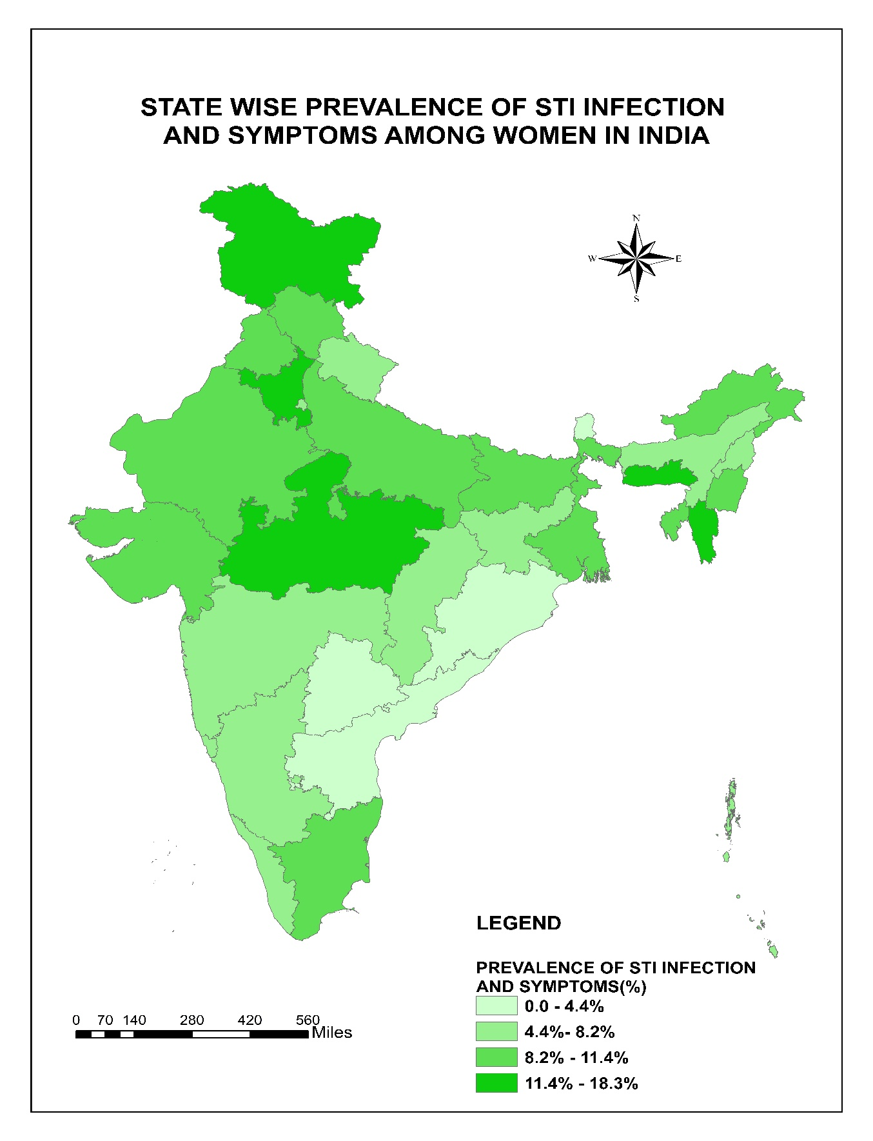Figure no.1: % of women age 15-49 having any STI by State, India, 2015-16.
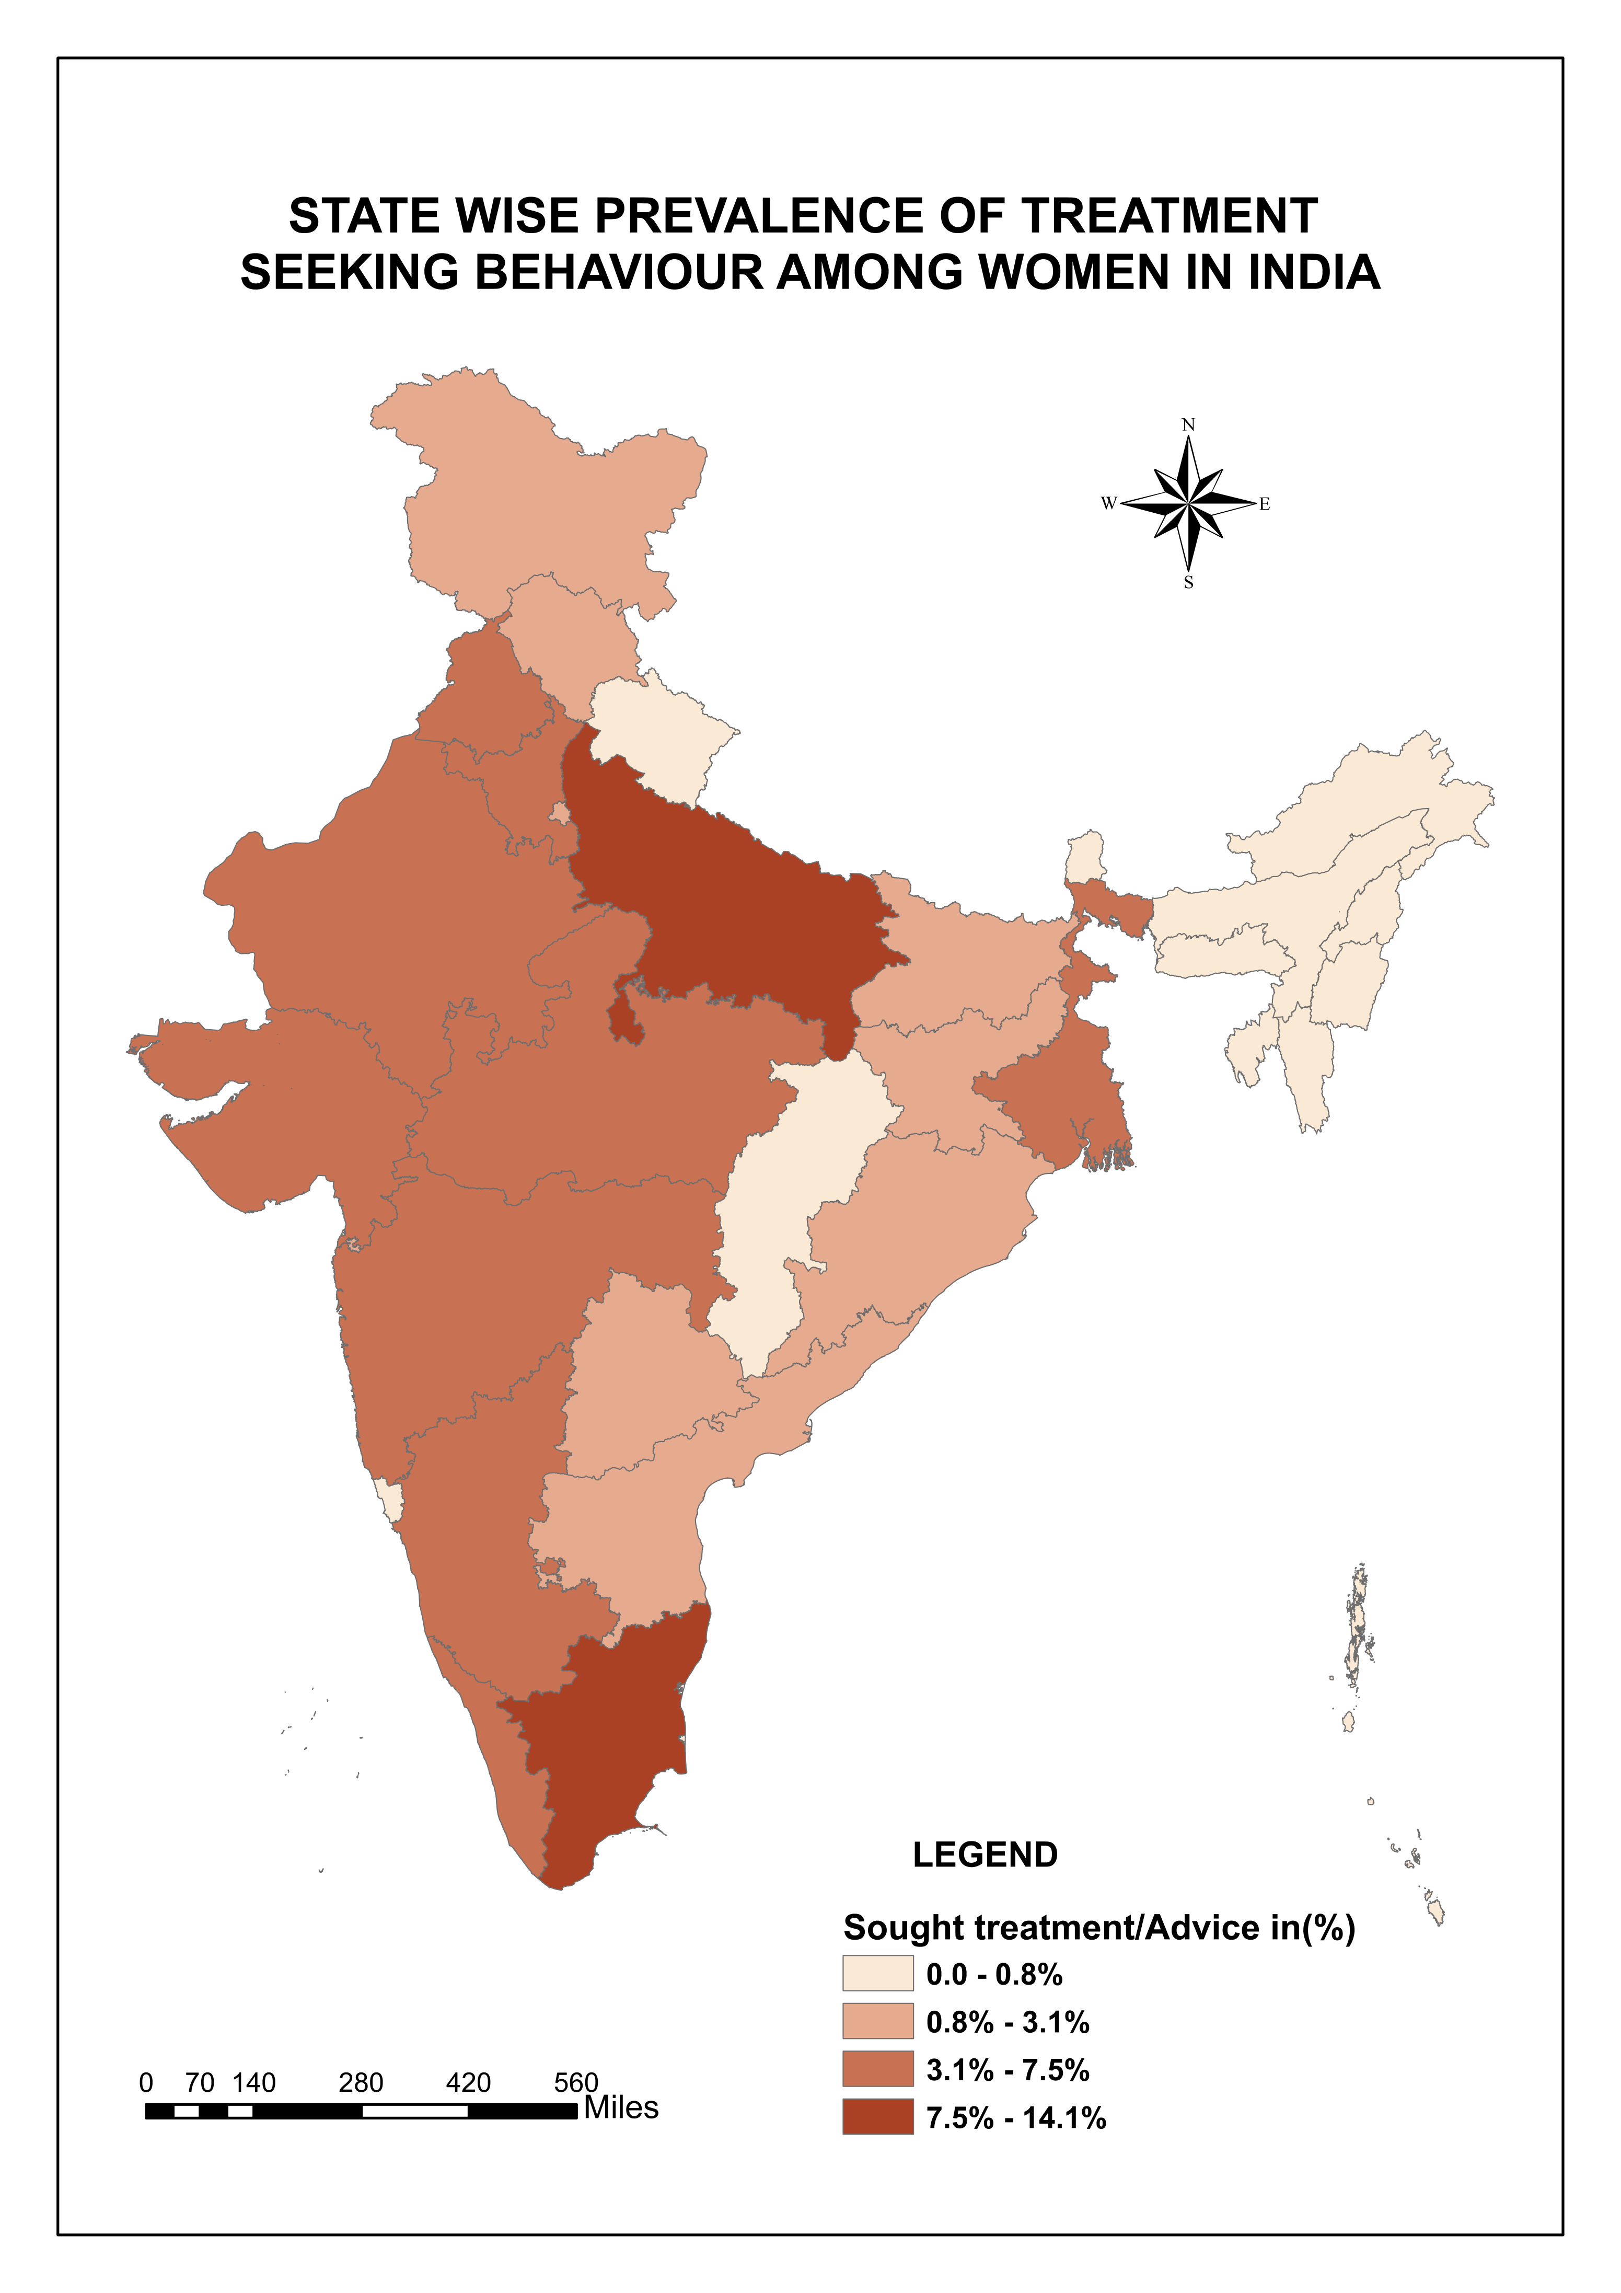
Figure no. 2: % of women age 15-49 having any STI sought treatment by State, India, 2015-16.

