Human testicular organoid system as a novel tool to study Zika virus pathogenesis
Saguna Verma¹ (Presenter), Daniel P. Strange¹, Nima Pourhabibi Zarandi², Goral Trivedi¹, Colin E. Bishop², Hooman Sadri-Ardekani^{2,3}

¹Department of Tropical Medicine, Medical Microbiology, and Pharmacology, John A. Burns School of Medicine, University of Hawaii at Manoa, Honolulu, HI, 96813 ² Wake Forest Institute for Regenerative Medicine (WFIRM), ³Department of Urology; Wake Forest School of Medicine, Winston Salem, NC 27101

Abstract

Zika virus (ZIKV) is an arbovirus belonging to the Flavivirus genus of the Flaviviridae family. The 2015-16 ZIKV epidemic in South America resulted in more than 1.5 million symptomatic cases. Traditionally associated with mild febrile illness, the recent outbreak was associated with neonatal microcephaly and sexual transmission as a new route of virus spread, not reported for other mosquito-borne flaviviruses. ZIKV has been detected in semen for up to 188 days after symptoms onset and has been demonstrated to potentially affect fertility, indicating that the virus establishes persistence in the testes. Our recent study demonstrated that ZIKV could efficiently infect human Sertoli cells (SC), important cell type responsible for immune privilege environment of the seminiferous tubules. However, due to lack of relevant animal models to study ZIKV pathogenesis and apparent limitations of monolayer cultures, an in vitro human model system which incorporates multiple testicular cell types is needed to investigate the pathogenic features of ZIKV infection in the human testes. Our recently developed human testicular organoid (HTO) culture system is composed of SC, Leydig cells, and spermatogonia that can be cultured long-term and also produce testosterone and support limited germ cell differentiation. Our data shows that HTO supported productive ZIKV replication over the time course of infection, which resulted in reduced survival and function. Our results also demonstrated induction of transcripts of key antiviral genes including type I Interferon and cytokines IL-6 following ZIKV infection. Collectively, our results indicate that HTO can be used as a relevant model to study ZIKV pathogenesis, including cellular targets, immune response, and potential effects on spermatogenesis.

Image
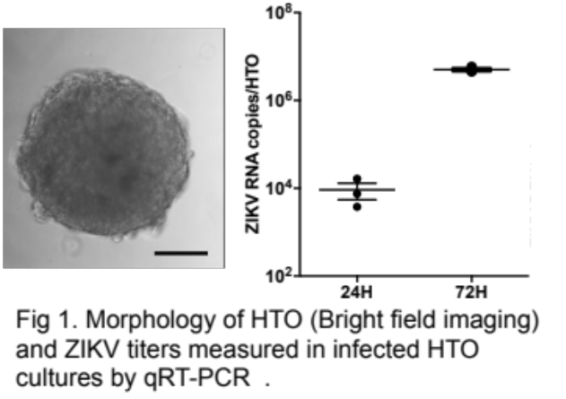
Recent Publications (minimum 5)
- Pendergraft, S. S., Sadri-Ardekani, H., Atala, A. & Bishop, C. E. Three-dimensional testicular organoid: a novel tool for the study of human spermatogenesis and gonadotoxicity in vitro. Biology of reproduction 96, 720-732, doi:10.1095/biolreprod.116.143446 (2017).
- Siemann, D. N., Strange, D. P., Maharaj, P. N., Shi, P. Y. & Verma, S. Zika virus infects human Sertoli cells and modulates the integrity of the in vitro blood-testis barrier model. Journal of virology, doi:10.1128/JVI.00623-17 (2017).
- Govero, J. et al. Zika virus infection damages the testes in mice. Nature 540, 438-442, doi:10.1038/nature20556 (2016).
- Joguet, G. et al. Effect of acute Zika virus infection on sperm and virus clearance in body fluids: a prospective observational study. The Lancet. Infectious diseases, doi:10.1016/S1473-3099(17)30444-9 (2017).
- Hastings, A. K. & Fikrig, E. Zika Virus and Sexual Transmission: A New Route of Transmission for Mosquito-borne Flaviviruses. The Yale journal of biology and medicine 90, 325-330 (2017).

Biography (150 word limit)
Saguna Verma (PhD) is a formally trained virologist and immunologist with expertise in the studies of RNA virus/host interactions in the immune privilege organs. The focus of her research is to analyze the molecular and cellular mechanisms associated with neuroinflammation and innate immune responses to RNA viruses including West Nile virus (WNV) and Zika virus. Her current interest is to characterize ZIKV infection and persistence in human testes. She has collaborated with Dr. Sadri-Ardekani for this study to develop their testicular organoids as a model to delineate ZIKV-associated immune events in human testes.
Email: saguna@hawaii.edu

