Immunohistochemical, histological and ultrastructural evaluation of protection provided by VCUSM21P vaccine

Abstract

In our previous study, complete protection was observed in rabbit immunized with 1×10¹⁰ CFU of live attenuated VCUSM21P vaccine against challenge with 1×10⁹ CFU V. cholera O139. In the present study, we investigated whether the vaccines can effectively protect immunized animals from any pathologic changes using histological, immunohistochemical and ultrastructural techniques. Severe pathology is evident in WT injected ileum in non-immunized, showing extensive villous destruction, edema, necrosis and inflammation with infiltration of large numbers of inflammatory cells, extensive damage to the villi and microvilli with pore formation. Histology of ileum injected with WT in immunized rabbit shows no significant pathological changes except for a few inflammatory cells in lamina propria with mild edema in mucosa and submucosa. immunohistochemical staining revealed O139 antigens of WT are seen in the lamina propria of edematous villi, muscularis mucosa and submucosa with weak presence in the muscle coat in non-immunized rabbit after challenged with WT in non-immunized rabbits, but in immunized rabbit localisation of the O139 LPS antigen is seen at the tips of the intact villi, within lamina propria and muscularis mucosa only. These observations suggest that the vaccine can effectively protect animals from any pathologic changes and eliminate V. cholerae O139 from the immunized animals.
ABSTRACT

Late of 1992 large outbreaks of cholera began in India and Bangladesh that were caused by a previously unrecognized serogroup of V. cholerae, designated O139, synonym Bengal (Murugaiah, 2011)(Basu et al., 2000). The disease then spread rapidly to other countries and has now been reported from l0 countries in South Asia (Faruque et al., 2003). Eltrastructural study showed that the V. cholerae O139 strain is the most dangerous strain, causing extensive damage to the intestine (Murugaiah et al., 2017). It is speculated that V. cholerae Ol39 has a potential to extend to other regions, and careful epidemiological monitoring of the situation is being maintained. As the use of safer live vaccine that can induce protective immunity against Vibrio cholerae O139 infection is a promising approach for immunization, we have designed VCUSM21P, an oral cholera vaccine candidate, which has ctxA that encodes A subunit of ctx and mutated rtxA/C, ace and zot mutations (Murugaiah et al., 2014).
VCUSM21P was found not to disassemble the actin of HEp2 cells. It colonized the mice intestine approximately 1 log lower than that of the Wild Type (WT) strain. In the ileal loop assay, unlike WT challenge, 1×10⁶ and 1×10⁸ colony forming unit (CFU) of VCUSM21P was not reactogenic in non-immunized rabbits. Whereas, the reactogenicity caused by the WT in rabbits immunized with 1×10¹⁰ CFU of VCUSM21P was found to be reduced as evidenced by absence of fluid in loops administered with 1×10²–1×10⁷ CFU of WT. Oral immunization using 1×10¹⁰ CFU of VCUSM21P induced both IgA and IgG against Cholera Toxin (CT) and O139 lipopolysaccharides (LPS). The serum vibriocidal antibody titer had a peak rise of 2560 fold on week 4. Following Removable Intestinal Tie Adult Rabbit Diarrhoea (RITARD) experiment, the non-immunized rabbits were found not to be protected against lethal challenge with 1×10⁹ CFU WT, but 100% of immunized rabbits survived the challenge (Murugaiah et al., 2014).
In the present study, we investigated the safety aspect and whether the vaccine can effectively protect immunized animals from any pathologic changes using histological, immunohistochemical. In addition, the safety and protection of the vaccine were checked by electron microscopy.

Histopathological and ultrastructural findings

Effect of the mutant on the intestine
In addition to the study of reactogenicity, light microscopic and scanning electron microscopic (SEM) analyses were performed to assess the effect of vaccine candidates on the rabbit’s intestine. 1x10⁶ CFU of strains was chosen as infective dose because at this dose the WT was confirmed to cause reactogenicity in non-immunized rabbits. In this analysis, histopathological changes as compared to the normal tissue were graded as follows: 0 for no changes, 1 for mild changes, 2 for moderate changes and 3 for severe changes. When analyzed by this technique, pathological changes caused by the WT were greater than that by VCUSM21P (Table 1). The gross pathology of ileum infected with WT showed severe hemorrhage that was not found in ileum injected with NS or infected with VCUSM21P and VCUSM22P. Detailed histopathological analysis revealed extensive polymorphonuclear leukocytes (PMN) infiltration, edema, loss of goblet cells and disruption of the intestinal villi caused by WT in non-immunized rabbits (Figure 1 B). The infection of WT also resulted in necrosis, disruption of the cells and alteration of epithelial integrity with pore formations. On the other hand, VCUSM21P and VCUSM22P induced no morphological changes as observed from the intact villi and absence of edema or focal PMN infiltrates in the lamina propria (Figures 3.32 C&D). Furthermore, under scanning electron microscopy, microvilli of rabbits infected with both of these vaccine strains were found architecturally normal (Figures 3.33 C&D). As a whole, rabbits exhibited no change upon infection with VCUSM21P.

Table 3.6. Histopathological and ultrastructural changes observed in intestinal tissue of non-immunized rabbits following infection with WT, VCUSM21P and VCUSM22P

Sign of changes | Severity of changes ª
Sign of changes | WT ^{b} | VCUSM21P ^{c}
Tissue hemorrhage | 3 | 0
Necrosis | 3 | 0
PMN infiltration | 3 | 0
Edema | 3 | 0
Congested blood vessel | 3 | 0
Loss of goblet cells | 3 | 0
Villous destruction | 3 | 0
Microvillus destruction | 3 | 0
Pore formation | 3 | n/s

ª Severity of pathological and ultrastructural changes as compared to the normal tissue (injected with normal saline), graded on a scale of 0 to 3 as follows: 0 for absent or none, 1 for mild, 2 for moderate and 3 for severe
^{b} Rabbit’s intestine infected with 1x10⁶ CFU of WT
^{c} Rabbit’s intestine infected with 1x10⁶ CFU of VCUSM21P
n/s not seen

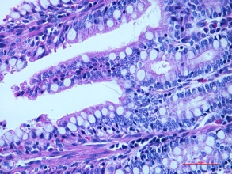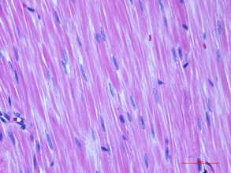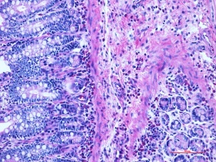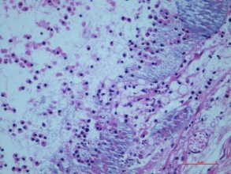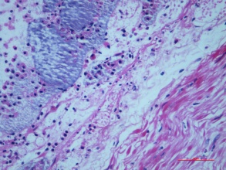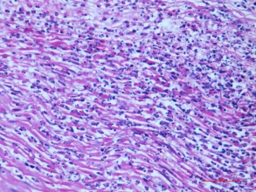
134
A.1
A.2
A.3
B.1
B.2
B.3

*
*

*
*
*
*
*
*

Figure 1 A&B: Histology of formalin fixed paraffin embedded sections of the intestine of non-immunized rabbit at 18 hours after inoculation of normal saline (NS) and 1x 10⁶ CFU of Wild Type (WT) respectively (H&E X400)
A.1-A.3: Control sections of ileum inoculated with NS. Scale bar, A.1-A.3 = 50 µm.
Histology of ileum loop injected with NS shows normal villi, mucosa, submucosa and muscle coat.
B.1-B.3: Sections of ileum injected with WT. Scale bar, B.1-B.3= 50 µm.
Severe pathology is evident in WT injected ileum, showing extensive villous destruction (white arrow; B1 & B2), edema (black arrow; B1, B2 & B3), necrosis (white asterisk; B1 & B2) and inflammation (thick white arrow; B2 & B3) with infiltration of large numbers of inflammatory cells (black asterisk; B1, B2 & B3).
135

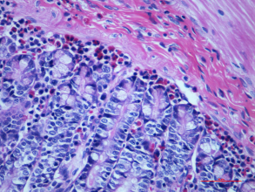
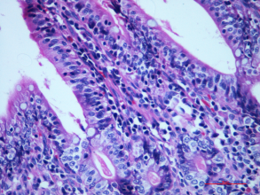
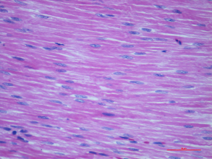
C.1
C.2
C.3

Figure 1 C: Histology of formalin fixed paraffin embedded sections of the intestine of non-immunized rabbit at 18 hours after inoculation of 1x 10⁶ CFU of VCUSM21P and VCUSM22P respectively (H&E X400)
C.1-C.3: Sections of ileum injected with VCUSM21P. Scale bar, C.1-C.3 = 50 µm.
Ileums injected with VCUSM21P show normal histology.

A.1
A.2
B.1
B.2

Figure 3.33 A&B: Scanning electron micrograph of the intestine of non-immunized rabbit at 18 hours after inoculation of normal saline (NS) and 1x 10⁶ CFU of Wild Type (WT) respectively
A.1-A.2: Control sections of ileum injected with NS. Scale bar, A.1= 100 µm; A.2 = 1 µm.
Ultrastructural morphology of ileum injected with NS showing normal villi and microvilli.
B.1-B.2: Sections of ileum injected with WT. Scale bar, B.1= 100 µm; B.2 = 1 µm.
SEM of WT injected ileum shows extensive damage to the villi (thick white arrow) and microvilli (black arrow) with pore formation (white arrow).

C.1
C.2

Figure 3.33 C&D: Scanning electron micrograph of the intestine of non-immunized rabbit at 18 hours after inoculation of VCUSM21P and VCUSM22P respectively
C.1-C.2: Sections of ileum injected with VCUSM21P. Scale bar, C.1= 100 µm; C.2 = 1 µm.
Villi and microvilli of ileums injected with VCUSM21P showing normal morphology.

3.2.13.2 Protection provided by the mutant against WT challenge
A better understanding of the protection provided by the attenuated vaccine candidates is needed as the WT causes extensive pathological changes in the intestine. It is of particular interest to determine whether vaccinated animals were able to resist the pathogenesis of WT infection. Therefore, the pathological changes induced by WT challenge were evaluated in rabbits vaccinated with 1x10¹⁰ CFU VCUSM21P and VCUSM22P. Table 3.6 shows the pathological changes caused by 1x10⁶ CFU of WT in rabbits immunized with both vaccine candidates. Unlike the WT infection in non-immunized rabbits, the effect of WT infection on the intestine of immunized rabbits were found to be greatly reduced, as evidenced in Figures 3.34, 3.35 A & B and 3.36 A & B. None of the rabbits vaccinated with either VCUSM21P or VCUSM22P actually had any observable changes in their intestine after the WT infection. Furthermore, it is worth highlighting that WT infection was not even accompanied by any detectable alteration of the microvilli. These findings reflect a better understanding of the level of immunological protection provided by both VCUSM21P and VCUSM22P against deleterious WT pathogen.

Table 3.7: Histopathological and ultrastructural changes observed in intestinal tissue of immunized rabbit after WT challenge

Sign of changes | Severity of changes ª
Sign of changes | VCUSM21P : WT ^{b}
Tissue hemorrhage | 0
Necrosis | 0
PMN infiltration | 0
Edema | 0
Congested blood vessel | 0
Loss of goblet cells | 0
Villous destruction | 0
Microvillus destruction | 0
Pore formation | n/s

a Severity of pathological and ultrastructural changes as compared to the normal tissue (injected with NS), graded on a scale of 0 to 3 as follows: 0 for absent or none, 1 for mild, 2 for moderate and 3 for severe
b Rabbits immunized with VCUSM21P challenged with 1x10⁶ CFU of WT

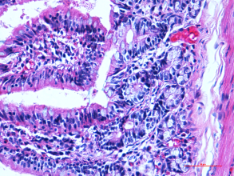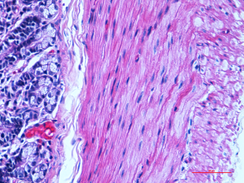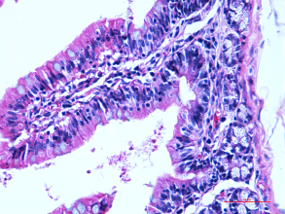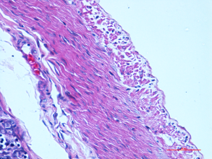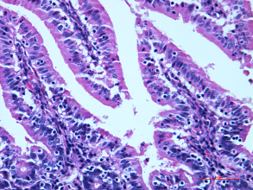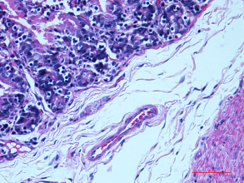
141
A.1
A.2
A.3
A.4
A.5
A.6
NS
NS
NS
WT
WT
WT
NS Ileum of rabbit injected with NS
WT Ileum of rabbit injected with WT

Figure 3.35 A: Histology of formalin fixed paraffin embedded sections of the intestine of rabbit vaccinated with VCUSM21P at 18 hours after inoculation of normal saline (NS) and 1x 10⁶ CFU of Wild Type (WT) (H&E X400)
A.1-A.3: Control sections of ileum injected with NS. Scale bar, A.1-A.3 = 50 µm.
Histology of ileum injected with NS shows normal villi, mucosa, submucosa and muscle coat.
A.4-A.6: Sections of ileum injected with WT. Scale bar, A.4-A.6= 50 µm.
Histology of ileum injected with WT shows no significant pathological changes except for a few inflammatory cells in lamina propria with mild edema in mucosa and submucosa.

A.1
A.2
A.3
A.4
NS
NS
WT
WT
NS Ileum of rabbit injected with NS
WT Ileum of rabbit injected with WT

Figure 3.36 A: Scanning electron micrograph of the intestine of rabbit immunized with VCUSM21P at 18 hours after inoculation of normal saline (NS) and 1x 10⁶ CFU of Wild Type (WT)
A.1-A.2: Control sections of ileum injected with NS. Scale bar, A.1= 100 µm; A.2 = 2 µm.
Ultrastructural morphology of ileum injected with NS shows normal villi and microvilli.
A.3-A.4: Sections of ileum injected with WT. Scale bar, A.3= 100 µm; A.4 = 200 nm.
SEM of WT injected ileum shows no obvious destructive changes.

3.2.14 Immunohistochemical findings

3.2.14.1 Effect of the vaccine candidate on the intestine
V. cholerae has evolved its strategy, like other bacterial pathogens, to cause disease following oral inoculation. V. cholerae initiates disease or infection by remaining primarily within the intestinal lumen, expressing enterotoxins, and colonizing the intestinal cells. In addition to infant mouse assay, immunohistochemistry (IHC) was performed to observe the interaction of VCUSM21P and VCUSM22P with the intestine (section 2.2.23). IHC staining was performed using anti-O139 LPS and polyclonal goat anti-mouse lgG-biotin. IHC would detect the O139 LPS antigen or possible V. cholerae O139 present in the intestinal tissue.
It was found that interaction of both vaccine strains with intestine differed from the WT (Table 3.7). The O139 LPS antigen of WT strain was detected in all layers of the intestinal tissue except serosa (Figure 3.37 A). However, localization of mutants’ O139 LPS antigen could be seen on the villous surface and lamina propria, with weak presence of WT antigens in the muscle coat, as it is not significant, and most probably is due to uptake of the antigens by inflammatory cells (Figures 3.37 B & C).
As shown in Figures 3.37 A.4 & A.5, WT was colonizing the destroyed/ blunted villi. It was found in the lumen and within the intestinal wall, including lamina propria, muscularis mucosa, submucosa, and muscularis propria (Figures 3.37 A.4 -A.6). Whereas, the mutants were found in the lumen and lamina propria of intact villi, not beyond the muscularis mucosa (Figures 3.37 B.4-B.6 & C.4 - C.6). These findings confirmed that the villous colonizer VCUSM21P and VCUSM22P had not penetrated and were not able to pass through the epithelial barriers afar as the WT.

Table 3.8. Localization of O139 LPS antigen in small gut of non-immunized rabbits

Gastrointestinal findings | V. cholerae strains ª
Gastrointestinal findings | WT | VCUSM21P
lumen | + | +
villous surface colonization | + | +
lamina propria | + | +
muscularis mucosa | + | +
submucosa | + | -
muscle coat | + | -
serosa | - | -

ª Rabbits’ intestine infected with 1x10⁶ CFU of V.cholerae strains
+ O139 LPS antigen present
- O139 LPS antigen absent
+ weak O139 LPS antigen present

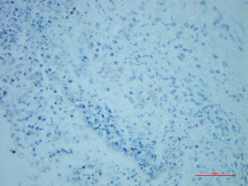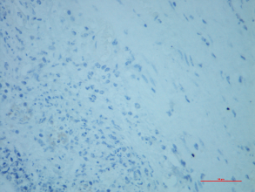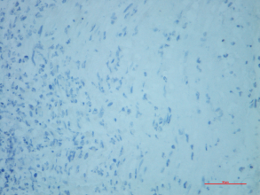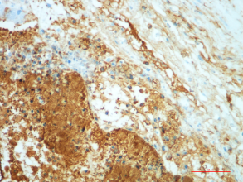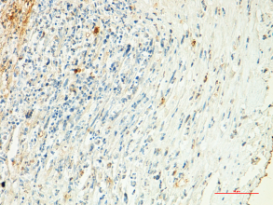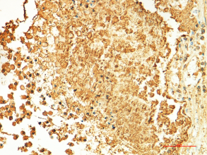
A.1
-ve
A.2
-ve
A.3
-ve
A.5
+ve
A.6
+ve
A.4
+ve
-ve Control section: Stain without anti-LPS monoclonal antibodies specific for O139
+ve Test section: Stain with anti-LPS monoclonal antibodies specific for O139

Figure 3.37 A: Immunohistochemical localisation of LPS O139 antigen of V. cholerae in the intestine of non-immunized rabbit at 18 hours after infection of 1x 10⁶ CFU of Wild Type (WT) (IHC X400)
A.1-A.3: Control sections of ileum injected with WT. Scale bar, A.1-A.3 = 50 µm.
A.4-A.6: Sections of ileum injected with WT. Scale bar, A.4-A.6 = 50 µm.
O139 antigens of WT are seen in the lamina propria of edematous villi, muscularis mucosa and submucosa with weak presence in the muscle coat.

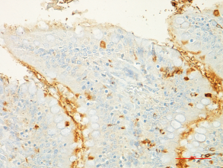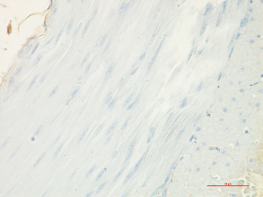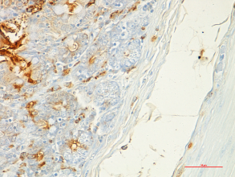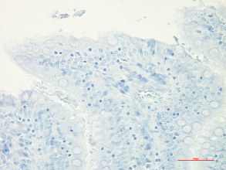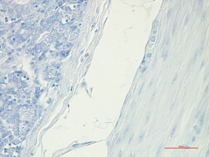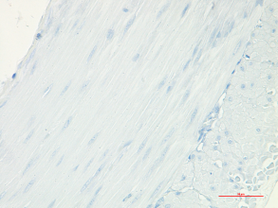
B.4
B.5
B.6
+ve
+ve
+ve
B.1
B.2
B.3
-ve
-ve
-ve
-ve Control section: Stain without anti-LPS monoclonal antibodies specific for O139
+ve Test section: Stain with anti-LPS monoclonal antibodies specific for O139

Figure 3.37 B: Immunohistochemical localisation of LPS O139 antigen of V. cholerae in the intestine of non-immunized rabbit at 18 hours after infection of 1x 10⁶ CFU of VCUSM21P (IHC X400)
B.1-B.3: Control sections of ileum injected with VCUSM21P. Scale bar, B.1-B.3 = 50 µm.
B.4-B.6: Sections of ileum injected with VCUSM21P. Scale bar, B.4-B.6 = 50 µm.
Localisation of the O139 LPS antigen is seen at the tips of villi, and weakly within lamina propria and muscularis mucosa.

3.2.14.2 Protection provided by the mutant against WT challenge
The next analysis was to compare the finding of WT challenge in rabbits vaccinated with 1x10¹⁰ CFU of VCUSM21P and VCUSM22P to that observed in WT infection in non-immunized rabbits. 1 × 10⁶ CFU of WT cells per ml that was used for WT infection in non-immunized rabbits were inoculated into rabbit intestines and the presence of O139 LPS of V. cholerae in gastrointestinal tract was analyzed by IHC (Table 3.8). WT inoculated into intestinal loops were mainly found colonizing the villous surface and within the lamina propia as shown in Figures 3.38 A.4-A.6 & B.4-B.6. However, they were not found in the submucosa and muscle coat unlike in the non-immunized rabbits. These data demonstrate that VCUSM21P and VCUSM22P possess the ability to prevent the transit of WT or its antigen from the lumen to muscularis propria.

Table 3.9. Localization of O139 LPS antigen in small gut of immunized rabbits

Gastrointestinal findings | O139 LPS ª
Gastrointestinal findings | WT : VCUSM21P ^{b}
lumen | +
Villous surface colonization | +
lamina propria | +
muscularis mucosa | +
submucosa | -
muscularis externa | -
serosa | -

ª Detection of O139 LPS antigen
^{b} Rabbits immunized with VCUSM21P challenged with 1x10⁶ CFU of WT
^{c} Rabbits immunized with VCUSM22P challenged with 1x10⁶ CFU of WT
+ O139 LPS antigen present
- O139 LPS antigen absent

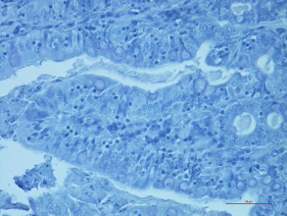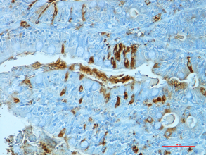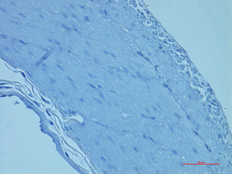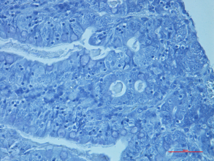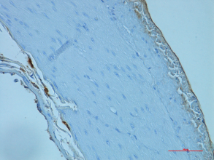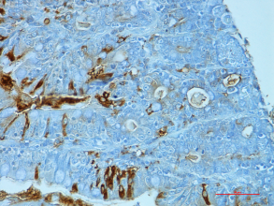
A.1
A.2
A.3
-ve
-ve
-ve
A.4
A.5
A.6
+ve
+ve
+ve
-ve Control section: Stain without anti-LPS monoclonal antibodies specific for O139
+ve Test section: Stain with anti-LPS monoclonal antibodies specific for O139

Figure 3.38 A: Immunohistochemical localisation of the LPS O139 antigen in the intestine of rabbit immunized with VCUSM21P at 18 hours of 1x 10⁶ CFU of Wild Type (WT) inoculation (IHC X400)
A.1-A.3: Control sections of ileum injected with WT. Scale bar, A.1-A.3 = 50 µm.
A.4-A.6: Sections of ileum injected with WT. Scale bar, A.4-A.6 = 50 µm.
Localisation of the O139 LPS antigen is seen at the tips of the intact villi, within lamina propria and muscularis mucosa only (black arrow).

Histologically, unlike VCUSM21P and VCUSM22P infections in non-immunized animal, WT caused acute pathological damages, including haemorrhage, necrosis, oedema, and infiltration of numerous polymorphonuclear cells, erosion of surface epithelium, coupled with blunting of villi and surface microvilli. According to Saha et al., the interaction of V. cholerae O139 with the intestine is not understood, especially their invasion and the histopathological alteration produced by it. The author reported that V. cholerae O139 in rabbit ileal loop model caused changes in the intestinal mucosa, with cell invasion and presence of bacteria in the lamina propria (Saha et al., 1997). Observable in IHC images, there is an uptake of WT in non-immunized rabbit intestine, and the bacteria primarily were identified in mucosal lamina propria and the O139 LPS antigen detected within the muscularis propria. The large number of inflammatory cells containing the bacterial antigen infiltrating the intestinal wall might be responsible for O139 LPS antigen detection within these layers. Apparently, interactions between bacteria and intestinal tissue were first fostered by the host as a strategy of defense for its own advantage. V. cholerae have now evolved strategies to enter the lamina propria. V. cholerae O139 is very closely related to the El Tor biotype O1 strains (Albert, 1994; Calia et al., 1994; Waldor and Mekalanos, 1994; Bhadra et al., 1995; Kaper et al., 1995). The mechanisms by which V. cholerae O139 produce severe intestinal damages and bloody stool in rabbits are not understood. When compared with O1, O139 strains are encapsulated and have clear differences in the surface polysaccharides (Calia et al., 1994; Losonsky et al., 1997). Qadri et al. (2004) found that eosinophil and mast cell numbers appeared to be more elevated at the duodenal site at the onset of disease in patients infected with V. cholerae O139 compared with O1 infected patients. However the author concluded that the presence of a capsule and/or antigens on O139 strains does not appear to give it added virulence (Qadri et al., 2004). The interactions between V. cholerae O139 and intestinal tissue are the subject of considerable research interest and need further investigation.
A somewhat surprising finding of SEM study was the intact villi and microvilli observed in the vaccinated rabbit after lethal WT challenge, in comparison with the non-immunized group. Consistent with this, it could also be seen from the IHC and H&E analysis that the WT virulence was highly reduced in both VCUSM21P and VCUSM22P vaccinated group of animals. The most likely hypothesis to explain this diminished pathogenicity is that in the presence of antibodies to eliminate the virulent protein and organism, the WT multiplication could not provide sufficient virulent antigen that would otherwise cause harmful consequences. The immunity developed actually had rendered WT unable to persist and its toxins unable to exert effect. V. cholerae by its ability to colonize the intestinal epithelium is expected to stimulate immune response (Owen et al., 1986; Kerneis et al., 1997). While in non-immunized rabbits, the persistence of exacerbated WT multiplication, and high level of their virulent antigen in the absence of antibodies had destroyed the villi, microvilli and the intestinal tissue. This hypothesis fits with the consensus that the excessive number of pathogen is the cause of the increased pathology in host.
It is noteworthy mentioning that, while these mutants are not causing undesired effect to the intestine, they possess the ability to initiate infection and induce the required immunity against cholera. According to Curtiss, a vaccine aiming at preventing bacterial infectious disease should be designed to minimize tissue damage that is not needed to induce an effective immune response (Curtiss, 2002). Although advances in rehydration therapy coupled with appropriate medical care have made cholera a treatable disease, certainly a considerable early pathological destruction following WT infection could not be avoided by this therapy. As other investigators have not studied the pathogenesis of WT infection in vaccinated animals in conjunction with the same experimental cholera model of non-immunized animals, this study has firstly reported the immunological assessment of live attenuated cholera vaccine in protecting the intestinal tissue against harmful V. cholerae infection.
To prevent cholera cases caused by V. cholerae O139, new vaccines are urgently required (Coster et al., 1995). Despite efforts taken, a fully effective vaccine is still to be obtained (Boris et al., 2007). It is important to realize that VCUSM21P vaccine carries the genes that encode the non-toxic CT A1 subunit and immune-enhancing CT B molecules. CT B is often envisaged and used as an immune stimulating agent in protocols for mucosal immunization (de Geus et al., 1997). Immunity against the toxic-active CT A1 subunit could greatly play a role in reducing cholera symptom and mortality; as the primary cause of cholera manifestation is the CT A. Vaccine providing immunity against CT A1 subunit may be even more effective at controlling cholera infection than vaccines that do not encode CT A1. V. cholerae O1 A–B– vaccine strain JBK 70 prepared by recombinant DNA techniques from pathogenic EI Tor Inaba N16961 did not confer 11 % protection on volunteers against experimental challenge with WT V. cholerae EI Tor. The 89 % protection conferred on volunteers was mainly due to antibacterial antibodies since JBK 70 elaborated neither the A nor the B subunit of CT (Levine et al., 1988). It has also been shown that the CTA is more immunogenic than the B subunit alone (Douce et al., 1997). In a randomized, placebo-controlled, double-blind trial of safety and immunogenicity, three of 12 vaccinees given a single dose of 5 x 10⁸ of attenuated A– B⁺ V. cholerae classical Inaba recombinant vaccine strain CVD 103-HgR had no significant rises in serum antitoxin (Migasena et al., 1989). In some vaccine construction designs, CT has been made to have lacked the 'toxic' ADP-ribosylating activity, by modifying the A1 subunit. However, a loss of toxicity has been matched with a corresponding loss of adjuvanticity, needed for additional immunostimulants for vaccination (Lawoyin et al., 1999; Pizza et al., 2001; Sanchez et al., 2002). A two-codon mutant of CT (CT-2*) lacking ADP-ribosylating activity and toxicity at concentrations as low as 50 ng was sufficient to induce antigen-specific cellular immune responses, suggesting high potency of CT-2* as a suitable mucosal adjuvant (Lomada et al., 2004). In the current study, IgA and IgG antibodies generated against CT A and CT B epitopes must have played the primary task of keeping the animals away from developing cholera disease and keeping the challenged rabbits alive and healthy in the RITARD experiment.

