The Contribution of the Private Sector in HIV Care and Treatment towards Attainment of the 90-90-90: A case Analysis for Kenya
Author: Stephen Mutuku, Programme Officer-HIV Investment, National AIDS Control Council
smutuku@nacc.or.ke

Introduction
The UNAIDS Global 90-90-90 target requires a change in strategy for achievement. A key strategy is the involvement of the private sector in HIV care and treatment, than includes private hospitals/clinics, laboratories both affiliated to hospitals and independent. The costs of care and treatment in the various institutions includes the traditional access to care and related costs. For a country transitioning from a Low Income Country (LIC) to a Low and Medium Developed Country (LMIC), over dependency from donor support is necessary while targeting to achieve the UNAIDS Global targets. To determine these costs, data from private sectors facilities in 5 major towns were involved in a cost of care and treatment as well as estimates from national prevalence’s were considered in the study.

Methodology
National Estimates were undertaken and analysed to establish probabilities of new infections and related costs of care. Additionally, Clinical and costing data for the year 2015 was collected using Questionnaires and population based data from the KNBS. The costing data was collected using manual questionnaires. Data estimates included, the national population, county prevalence rates and current costs of treatment. Data collected from questionnaires included fixed assets, medical equipment, time, staffing, total workload (utilization), and HIV care services specific workload. Analysis of the data included Multi-stage model and Activity Based Costing (ABC) model to the cost of treatment (2017-2060), estimate of current and future money cost of care and treatment as an ingredient-based approach to provide a service to one patient/ client at a facility.

Findings
Actuarial analysis of the current and future costs on treatment
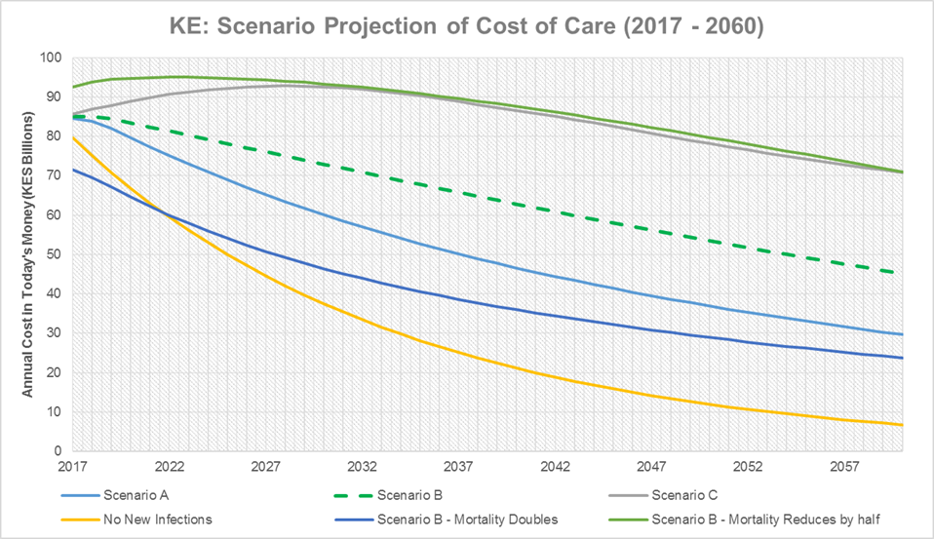
The model assumes 8% in new infection in the next 3 years, to achieve 90-90-90, the country requires USD.850 million in 2018 down to USD. 560 million in 2060. Other scenarios are assumed and provides similar trends unless new infection doubles.
Treatment Access
ART access for adults was noted in over 90.3% of the facilities especially in across tier 2 and 3 facilities, whereas service provision for children was low at 60.5%. About 67.3 % of the hospital-affiliated pharmacies reported to have sourced ARVS from the public sector. Majority of the independent pharmacies sourced from the commercial sector. Over 60% of the health facilities provided the HIV basic care package. Tuberculosis (TB) screening and cotrimoxazole preventive therapy was provided by 91.1% and 90.2% respectively

The estimated annual total cost of providing paediatric ART in private hospitals and clinics is Kshs 114,881 (US$ 1,148.8). The direct cost per visit for paediatric ART is Kshs. 13,563 (US$ 135.6), with an average of seven (7) visits per year. The annual cost of providing Adult ART was Kshs. 107,301 (US$ 1,073). The direct cost per visit for Adult ART was Kshs. 12,668 (US$ 126.7), with an average of seven (7) visits per year. For pregnant mothers, ART provision was estimated to cost Kshs. 85,199 (US$ 852) per year, where the direct cost per visit was Kshs. 10,059 (US$ 100.6). In all cases, the major cost drivers in HIV care and treatment were laboratory tests and ARVs. The costs vary by the level of the sampled hospitals and clinics and the number of stages that a patient has to go through. The high costs in Tier 3 and 4 hospitals were driven by laboratory diagnostic tests related to HIV services, whereas in Tier 2 clinics, the main cost driver was ARVs. The study also revealed that 57.6% of the hospitals and clinics clients/patients’ paid for HIV services through out-of-pocket payments.

Conclusions
Inflation remains key risk in the achievement of 90-90-90, more than double HIV infection across the period. The private sector has the opportunity to bring in the efficiencies and help achieve the 90-90-90. Dispensing costs of ARVs across the pharmacies revealed a range similar to dispensing costs in Tier 2 clinics and Tier 3 hospitals; Tier 4 hospitals’ dispensing costs were twice that of independent pharmacies. Independent laboratories also conducted HIV-related tests. Some of the Tier 3 hospitals outsourced laboratory services from the independent laboratories. Overall, the average costs of diagnostic tests in independent laboratories were comparable to those of Tier 2 clinics.

