Prevalence of HIV/STD infection and correlated factors among Vietnamese cross-border female sex workers in a border region of Yunnan Province, China
Jing Zhu, PhD, Key Laboratory of Environmental Medicine Engineering, Department of Epidemiology and Bio-statistics, School of Public Health, Southeast University

Abstract (300 word limit)
Background: Female sex workers (FSWs) are vulnerable to human immunodeficiency virus and sexually transmitted diseases (HIV/STD) infection and serve as a bridge in HIV transmission from the high-risk population to the general, low-risk population. Little is known about the characteristics and risk factors for HIV/STD infection among Vietnamese cross-border FSWs in Hekou County, Yunnan Province in southwestern China bordering with Vietnam recently. Methods: To examine the factors of Vietnamese FSWs that correlate with the prevalence of HIV/STD infection in the China-Vietnam border region, a cross-sectional survey was conducted in 2015 in Hekou county of Yunnan province, China. We performed a questionnaire survey to collect data on demographics, sexual behavior, and drug use. Blood and urine samples were collected for testing of HIV/STD and drug use. Results: Totally 594 female participants were recruited in our study. We found that the prevalence of HIV and herpes simplex virus (HSV-2) infection among Vietnamese FSWs were 1.85% (11/594) and 45.29% (269/594). In addition 6 Vietnamese FSWs (1.01%) were Syphilis positive. Multivariate logistic regression analysis revealed that HSV-2infection was a risk factor of HIV infection, further more age, monthly income, has no-commercial sexual partners, and Positive urinalysis result for amphetamine-type stimulants were correlated factors of HSV-2 infection of Vietnamese cross-border FSWs. Conclusion: Prevalence of HIV infection was decreased but HSV-2 prevalence was still alarmingly high among Vietnamese cross-border FSWs in Hekou County. The correlation between HIV and HSV-2 infection among Vietnamese FSWs suggesting the increased role of sexual transmission in the HIV epidemic in the China-Vietnam border region. Positive urinalysis result for amphetamine-type stimulants was observed in Vietnamese FSWs with HSV-2 infection, confirming that drug use is an important target in future HIV/STD related interventions. Moreover, non-commercial sexual partners of Vietnamese FSWs may be a potential bridge for HIV/STD transmission that need further research.

Image
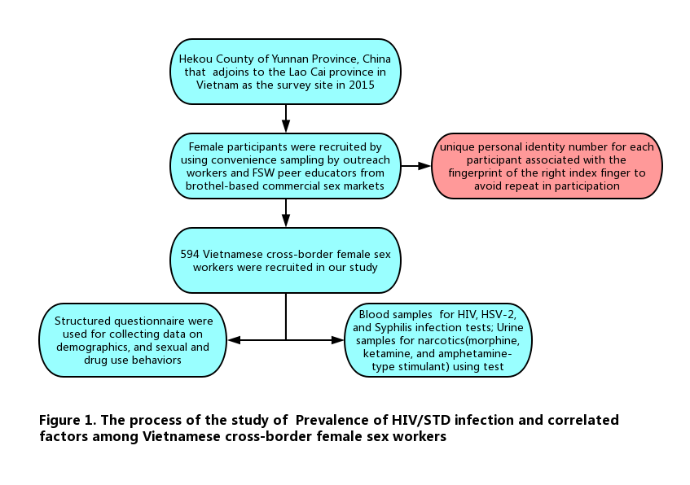
Recent Publications (minimum 5)
- Wang JJ, Ding GW, Zhu ZB, et al.(2015) Analysis of HIV Correlated Factors in Chinese and Vietnamese Female Sex Workers in Hekou, Yunnan Province, a Chinese Border Region. PLoS ONE, 10(6): e0129430.
- Xu JJ, Smith MK, Ding GW, et al.(2013) Drug Use and Sex Work: Competing Risk Factors for Newly Acquired HIV in Yunnan, China. PLOS ONE, 8(3): e59050.
- Yu YJ, Li XM, Tam CC, et al.(2016) Demographic and behavioral correlates of HIV/STI among Vietnamese female sex workers in southwest China. Aids Care, 28(11):1455-1460.
- Wang JJ, Zhu ZB, Yang X, et al.(2012) Herpes Simplex Virus Type 2 Risks in Female Sex Workers in the China-Vietnam Border County of Hekou[J]. Biomed Environ Sci, 25(6):706-710.
- Zhang C, Li XM, Liu Y, et al.(2015) Human immunodeficiency virus, syphilis and hepatitis C virus prevalence trends among cross-border migrant Vietnamese female sex workers in Guangxi, China. BMC Public Health, 15:1223.

Biography (150 word limit)
Dr. Jing Zhu is majoring in epidemiology of infectious disease. He has been engaged in research on HIV/STD prevention and intervention for high-risk population who are vulnerable to HIV/STD in border regions of Yunnan Province, China for many years. In the last 5 years his studies were focus on HIV/STD prevention for female sex workers and their male clients in the China-Vietnam border region
Email: zhujingseu@hotmail.com

Notes/Comments:

