Title: School-based high-intensity interval training (HIIT) programs for promoting physical activity and fitness in children and adolescents: a systematic review

Name: André Bento¹, Armando Raimundo¹, Luis Carrasco²
Affiliation: ¹Comprehensive Health Research Center, Universidade de Évora, Portugal; ²BIOFANEX, Universidade de Sevilha, Spain

Abstract (300 word limit)
Background: HIIT is a powerful stimulus in improving body composition and cardiometabolic risk in adults, and preliminary data in adolescents are also promising. HIIT is presented as a time-efficient alternative in comparison to aerobic training, that leverages the impact on the number of practitioners of Physical Exercise that results in health outcomes improvements, mainly from adolescents.
Objectives: evaluate the utility of a HIIT program integrated in High-School Physical Education classes, on Physical Condition, Physical Activity (PA) and Motivation for Exercise.
Data sources: Search through electronic databases PubMed, MEDLINE, SPORTDiscus, CINAHL, MEDICLATINA, COCHRANE and Web of Science, was carried out during March 2019, considering only studies since 2008.
Study eligibility criteria: (i) adolescents aged 10-19 years, (ii) HIIT program in a school environment, (iii) outcomes on physical condition, PA and motivation for exercise (iv) at least 4 weeks, (v) randomized controlled trials.
Results: of the 5872 studies found a total of 14 studies were included in the review. All works present significant improvements in, at least, 2 of the dimensions evaluated: physical condition and PA. There does not seem to be any great advantage in protocols that last in total more than 10 minutes per session. Improvements in body composition registered, at most, a moderate Effect Size. HIIT is presented as a powerful stimulus in improving physical fitness, mainly on CRF in most protocols, and in power and speed when modality is plyometries. Improvements in PA registered a moderate and large Effect Size.
Conclusions: This review suggests that the introduction of HIIT in the school context has great potential in improving physical fitness and PA, and a moderate effect on improving body composition in adolescents. HIIT efficiency (10minutes), reflect the wide applicability that these protocols can have in PE classes, and great adaptation to the facilities (including classrooms)
Registration Number: CRD42019138771
.

Recent Publications (3 TO 5)
- Bento, A. & Loureiro, V. (2018). High-Intensity Interval Training: Monitoring and Effect Between Genders. The Journal of Strength & Conditioning Research, 32(9), e42-e43. doi:10.1519/JSC.0000000000002820
- Galhardas, L., Sardica, H., Bento, A., Mendes, F., Bravo, J., & Pereira, C. (2019). Identifying the main risk factor for falling in community-dwelling older adults. European journal of public health, 29(Supplement_1). doi:10.1093/eurpub/ckz034.035


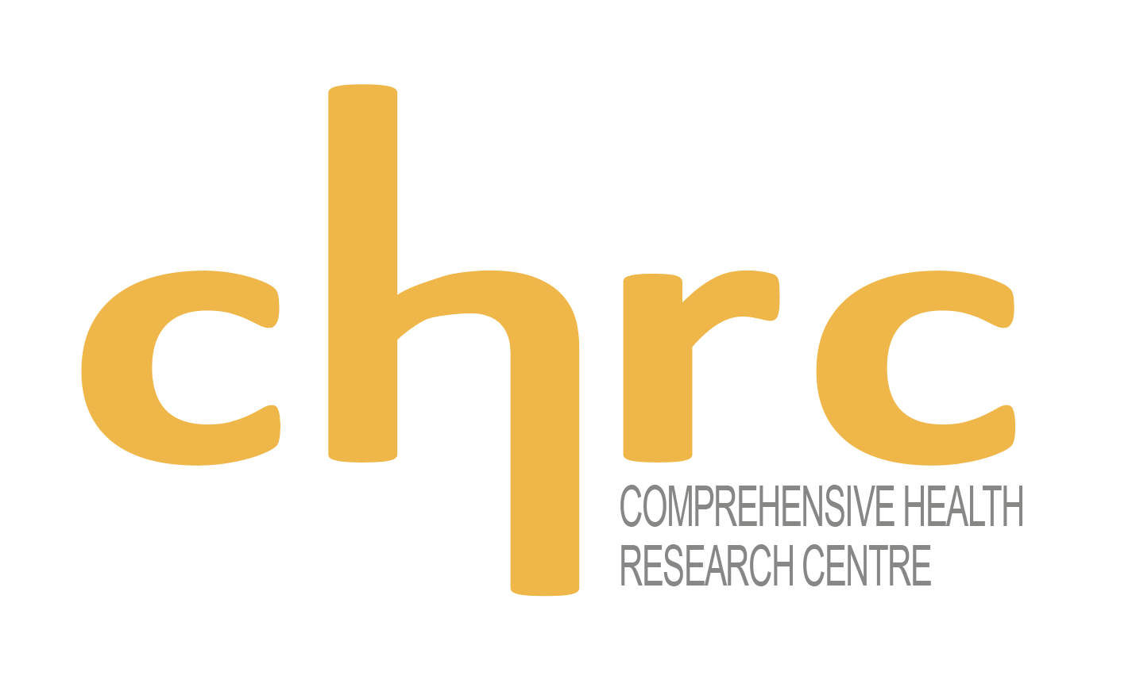

Paste your Photograph Here
Biography (150 word limit)
Invited Lecturer in the areas of Exercise and Health. More than 10 years of professional experience in the Sport area, developing commitment in the field through impactful projects in the community, that combine scientific with empirical knowledge from a decade, as well as applications for funds, which have created and remodel sports facilities. Trainer in Exercise Medicine area with national accreditation, and with international accreditation at the National Academy of Sports Medicine and Athletics and Fitness Association of America. Participation in dozens of congresses, conferences and seminars with communications on Exercise and Health, more specifically: elderly people, diabetes and entrepreneurship.
Email: andresbento@uevora.pt
Contact Number: 00351964422125
Presentation Type Oral
Gender: male

Notes/Comments:

