Title: Effect of Kinesiology Taping on Balance in ACL ruptured patients

Name: Dovile Kiele
Affiliation: Lithuanian Sports University

Abstract

Knee joint injuries are the second most common musculoskeletal disorder (Filbay & Grindem, 2019). Many of the untreated knee ACLs subsequently become the onset of degenerative lesions. After ACL rupture clinics in different countries have different rehabilitation programs. Usually, conventional physiotherapy (CP) is used (Grinsven et al., 2010). Only recently the application of kinesiology tape (KT) (Kase te al., 2003; Howe et al., 2015) have started in clinical practice, therefore, there is insufficient data on their acute and long-term impact on knee joint function in the presence of ACL rupture.

32 subjects were randomly allocated to control (CP) or experimental (CP and KT) group. The CP program was designed on the basis of Grinsven et al.’s (2010) rehabilitation protocol – was applied 4 w, 3 t/w, 60 min. The KT technique was chosen on the basis of K. Kase et al. (2003) recommendations. KT was applied to the injured leg using muscular and functional-corrective techniques on the quadriceps femoris and the hamstring muscle. There were 6 KT procedures per participant in the experimental group. The CON group received KT only during the baseline and final assessment to assess short-term (1 hour after application) effect of KT.

We found, that during one leg stance and after one leg hop on injured leg with KT sway displacement (Fig. 1A, 2A) and velocity (Fig.1B, 2B) change in experimental group was significantly (p < 0.05) higer than CON group. After physiotherapy postural sway Ax and Ay direction and sway velocity during one leg stance and after one leg hop on injured leg were significant lower in experimental than in CON group.

The results of the the study indicate that there were no immediate KT effect on balance for subjects with ACL rupture. However, prolonged KT improved balance during stance on injured leg.
Image

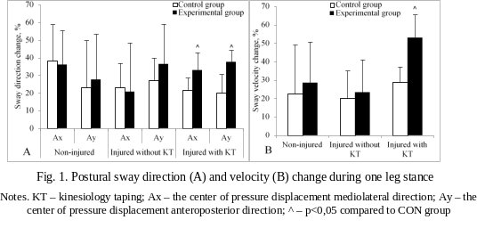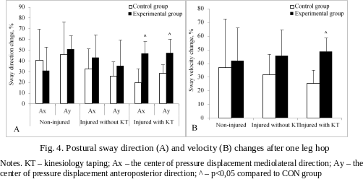
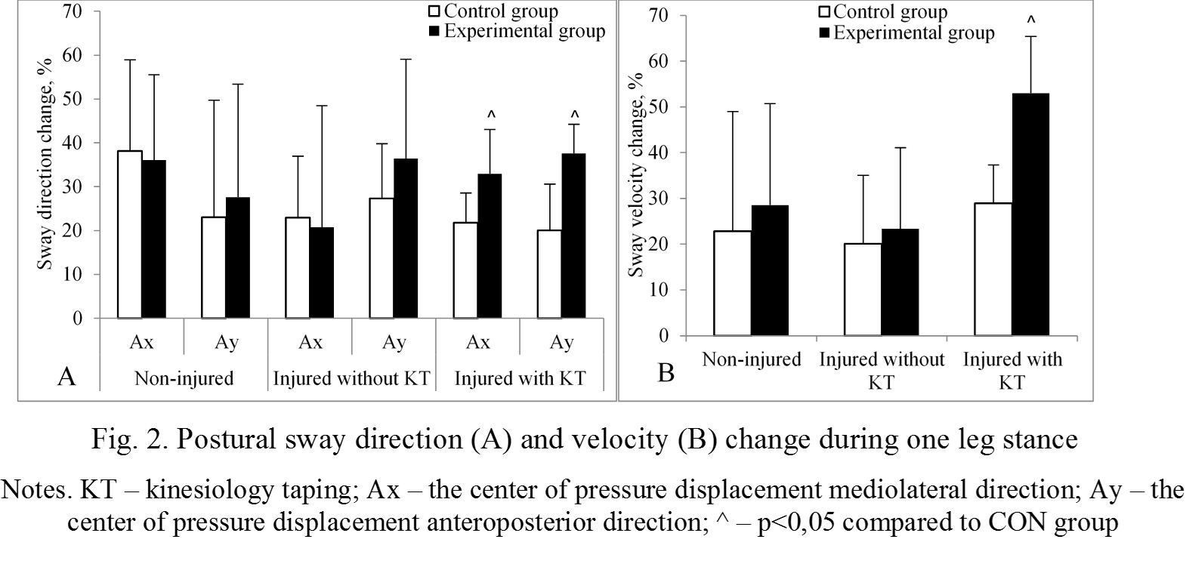Recent Publications
- Filbay S R, Grindem H (2019). Evidence-based recommendations for the management of anterior cruciate ligament (ACL) rupture. Best Practice & Research Clinical Rheumatology, 33 (1), 33 – 47.
- Howe A, Campbell A, Ng L, Hall T, Hopper D (2015). Effects of two different knee tape procedures on lower-limb kinematics and kinetics in recreational runners Scandinavian Journal of Medicine & Science in Sports, 25, 517–524.
- Grinsven S, van Cingel R E H, Holla C J M., van Loon C J M (2010). Evidence-based rehabilitation following anterior cruciate ligament reconstruction Knee Surgery, Sports Traumatology, Arthroscopy, 18, 1128–1144.
- Kase K, Wallis J, Kase T (2003). Clinical therapeutic applications of the kinesio taping method. Tokyo: Japan.




Biography
Dovile Kiele received his Ph.D. in Biology from the Lithuanan Sports University in 2020. She has 10 years’ experience as a lecturer and researcher in Physiotherapy field. Her research area is physiological aspects of physiotherapy and rehabilitation. Researches data reveal changes in physiological parameters during rehabilitation. Understanding neuromuscular dysfunction after lesions enhances theoretical knowledge and allows for more effective modification of rehabilitation programs. The findings of the studies will be useful to rehabilitation practitioners at various stages of patient treatment.
Email: dovile.kiele@lsu.lt
Contact Number: +37060844558
Presentation Type (Oral/Poster): Poster
Gender: Femail

Notes/Comments:

