Outcome of the Influence of Remplissage Repair on Shoulder Range of Motion after Arthroscopic Bankart Repair

Dr Mohit Dua, MBBS, FAGE, DNB, FIAA, FIPO

Abstract
Recurrent shoulder dislocation can predispose to Hill-Sach’s lesion.Failure to address humeral osseous defects during arthroscopic stabilization surgery leads to an increased rate of recurrence.This procedure is not much studied in terms of Range of Motion. To further study it we have done aprospective study of 2 patient populations (arthroscopic Bankart repair alone vs Bankart and remplissage).Main clinical outcome was the range of motion within Minimum follow-up was 2 years whileTotal Patients in each Group taken was 50. In arthroscopic remplissage, the posterior capsule and infraspinatus are sutured into the humeral head. The rate of recurrence was identical in both groups (6.25%) while the range of movement were significantly more in patients where remplissage repair was done along with bankart repair. When compared with Walch-Duplay score we got excellent result in 45 patients where remplissage repair was done out of 50 patients whereas with remplissage excellent range of movement was only 42 patients out of 50 patients. Our study to have some limitation like Sample size was small.All procedures were performed by the same surgeon.Study included postoperative care and follow-up assessments, ; therefore, the results of this study may not reflect general surgical outcomes of the procedure. The same operative indications and consistent surgical technique were applied in all patients.The conclusion of the study was its always better to do remlissage along with bankart repair for better result in term of range of movement.

Image
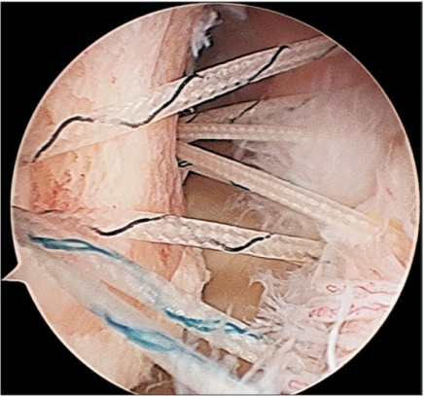
The anchor is placed in the center area of the Hill-Sachs lesion
Recent Publications
- Argintar E, Heckmann N, Wang L, Tibone JE, Lee TQ. The biomechanical effect of shoulder remplissage combined with Bankart repair for the treatment of engaging Hill-Sachs lesions. Knee Surg Sports Traumatol Arthrosc. 2016 Feb;24(2):585-92. doi: 10.1007/s00167-014-3092-4. Epub 2014 Jun 10.
- Buza JA 3rd, Iyengar JJ, Anakwenze OA, Ahmad CS, Levine WNArthroscopic Hill-Sachs remplissage: a systematic review. J Bone Joint Surg Am. 2014 Apr 2;96(7):549-55. doi: 10.2106/JBJS.L.01760.
- Zhu YM, Lu Y, Zhang J, Shen JW, Jiang CY. Arthroscopic Bankart repair combined with remplissage technique for the treatment of anterior shoulder instability with engaging Hill-Sachs lesion: a report of 49 cases with a minimum 2-year follow-up.Am J Sports Med. 2011 Aug;39(8):1640-7. doi: 10.1177/0363546511400018. Epub 2011 Apr 19.
- Camus D, Domos P, Berard E, Toulemonde J,Mansat P, Bonnevialle N (2018) . Isolated arthroscopic Bankart repair vs. bankart repair with Remplissage for anterior shoulder instability with engaging Hill-Sachs lesion: A meta analysis. Owthop Traumatatol surg Res. 2018 oct;104(6):803-809.
5. Hughes JL, Bastrom T, Pennock AT, Edmonds EW(2018) Arthroscopic bankart repairs with and without Remplissage in recurrent Adoloscent anterior Shoulder Instabily with hill-sachs deformity. Orthop J Sports Med. 2018 Dec 14;6(12);2325967118813981.

Photograph

Biography
Dr Mohit Dua has his expertise in evaluation and treating all orthopaedic problems and improving the health and wellbeing. His contextual evaluation model based on response from the patients and measurement by range of movement . he has built this model after 2 year of experience in research,evaluation and administration both in hospital and education institutions. The foundation is based on fourth generation evaluation, which is a methodology that utilizes the previous generations of evaluation: measurement, description and judgment. It allow the researcher to go varies questions and get the valuable knowledge.
Email: mohitdua29@gmail.com

