Traumatic Posterior Atlanto-axial Dislocation: Grand round presentation of an atypical C1-C2 dislocation With A Anterior Arch Fracture Of C1.
Mohammad A. Alsofyani MD, Vincent Pointillart MD, PhD, Olivier Gille MD,PhD, Soufiane Ghailane MD

Abstract
Introduction: The combination of posterior atlantoaxial joint dislocation and anterior arch fracture of C1 is uncommon: an epidemiological review found no case out of 116 was upper cervical spine injuries. A review of the English literature found one similar case but with posterolateral dislocation and managed by closed reduction followed by Magerl C1–C2 transarticular screw fixation coupled with modified Brooks fusion. We report an atypical case of a traumatic posterior C1-C2 dislocation with a anterior arch fracture treated conservatively.
Materials and method: An 89-year-old male, with no history, was admitted to our unit and was managed following a domestic accident. Upon examination, we found no loss of consciousness or respiratory difficult. The rest of the neurological physical examination was strictly normal. Cervical spine radiography and Two-dimensional reconstructed computed tomography (CT) scans demonstrated Posterior dislocation of the atlantoaxial joint with anterior arch fracture of C1. The distance between two fragments of anterior arch of C1 is less than odontoid diameter, these findings suggest that, the odontoid is passed just below the anterior arch of C1. Under general anesthesia, the patient was treated conservatively by a moderate traction in hyperextension with a halo frame while a second senior orthopedic surgeon pushed the odontoid via trans-oral method in hyperextension position then flexion of the tracted neck under C- arm fluoroscopy
Results: At two months follow-up, the clinical picture was accepted and cervical spine radiography and two-dimensional reconstructed CT found a well-reduced atlantoaxial articulation, dynamic X-rays demonstrated good range of motion in flexion and extension; the patient had no major functional trouble
Conclusion: Based on the Grand Round case and relevant literature, we present a first case of an unusual lesion of the upper cervical spine

Image

Recent Publications
1. Gleizes V, Jacquot FP, Signoret F, Feron JM. Combined injuries in the upper cervical spine: clinical and epidemiological data over a 14-year period. Eur Spine J Off Publ Eur Spine Soc Eur Spinal Deform Soc Eur Sect Cerv Spine Res Soc. 2000 Oct;9(5):386–92.
2. Howard JJ, Duplessis SJ. Posterolateral dislocation of the C1-C2 articulation associated with fracture of the anterior arch of C1: a case report. Spine. 2004 Dec 15;29(24):E562-564.
3. Amirjamshidi A, Abbassioun K, Khazenifar M, Esmailijah A. Traumatic rotary posterior dislocation of the atlas on the axis without fracture. Report of a case and review of literature. Surg Neurol. 2009 Jan;71(1):92–7; discussion 98.
4. Schneider RC, Schemm GW. Vertebral artery insufficiency in acute and chronic spinal trauma, with special reference to the syndrome of acute central cervical spinal cord injury. J Neurosurg. 1961 May;18:348–60.
5. Wasserman BR, Moskovich R, Razi AE. Rheumatoid arthritis of the cervical spine--clinical considerations. Bull NYU Hosp Jt Dis. 2011;69(2):136–48.
6. Klimo P, Rao G, Brockmeyer D. Congenital anomalies of the cervical spine. Neurosurg Clin N Am. 2007 Jul;18(3):463–78.
7. Moreau PE, Nguyen V, Atallah A, Kassab G, Thiong’o MW, Laporte C. Traumatic atlantoaxial dislocation with odontoid fracture: A case report. Orthop Traumatol Surg Res OTSR. 2012 Sep;98(5):613–7.
8. Autricque A, Lesoin F, Villette L, Franz K, Pruvo JP, Jomin M. [Fracture of the odontoid process and C1-C2 lateral luxation. 2 cases]. Ann Chir. 1986 Sep;40(6):397–400.
9. Minyu Z, Shiyang W, Suraj C, Kelun H, Chaowei L, Honglin T. Traumatic Posterolateral C1-C2 Dislocation Complicated with Locked Lateral Mass and Type II Odontoid Fracture-5-Year Follow-up. World Neurosurg. 2018 Jun;114:330–4.
10. He D-W, Huang W-J, Sheng X-Y, Wu L-J, Fan S-W. Atlantoaxial Joint Interlocking Following Type II Odontoid Fracture Associated with Posterolateral Atlantoaxial Dislocation: a Case Report and Review of Published Reports. Orthop Surg. 2016 Aug;8(3):405–10.
11. Koç RK, Akdemir H, Oktem IS, Kurtsoy A, Menkü A. Posterolaterally displaced type IIA odontoid fractures. Neurosurg Rev. 2001 Jul;24(2–3):143–6.
12. Riouallon G, Pascal-Moussellard H. Atlanto-axial dislocation complicating a type II odontoid fracture. Reduction and final fixation. Orthop Traumatol Surg Res OTSR. 2014 May;100(3):341–5.
13. Zhang K, Xu J, Wang Q, Wang G, Wu Z, Xia H, et al. Treatment of dens fractures with posterior atlantoaxial dislocation with transoral atlantoaxial reduction plate surgery: case report and introduction of a novel treatment option. Spine. 2012 Apr 1;37(7):E451-455.
14. Fuentes S, Bouillot P, Palombi O, Ducolombier A, Desgeorges M. Traumatic atlantoaxial rotatory dislocation with odontoid fracture: case report and review. Spine. 2001 Apr 1;26(7):830–4.
15. Hopf S, Buchalla R, Elhöft H, Rubarth O, Börm W. [Atypical dislocated dens fracture type II with rotational atlantoaxial luxation after a riding accident]. Unfallchirurg. 2009 May;112(5):517–20.
16. Lenehan B, Guerin S, Street J, Poynton A. Lateral C1-C2 dislocation complicating a type II odontoid fracture. J Clin Neurosci Off J Neurosurg Soc Australas. 2010 Jul;17(7):947–9.
17. Oh JY, Chough CK, Cho CB, Park HK. Traumatic atlantoaxial rotatory fixation with accompanying odontoid and c2 articular facet fracture. J Korean Neurosurg Soc. 2010 Nov;48(5):452–4.
18. Spoor AB, Diekerhof CH, Bonnet M, Oner FC. Traumatic complex dislocation of the atlanto-axial joint with odontoid and C2 superior articular facet fracture. Spine. 2008 Sep 1;33(19):E708-711.
19. Jeanneret B, Magerl F, Ward JC. Overdistraction: a hazard of skull traction in the management of acute injuries of the cervical spine. Arch Orthop Trauma Surg. 1991;110(5):242–5.

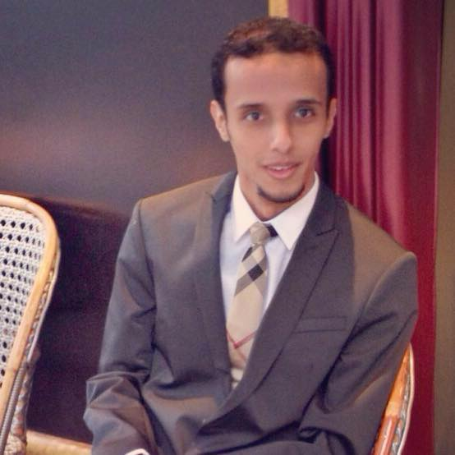Biography
Mohammad Alsofyani is a faculty member at college of Medicine - University of Hail in Kingdom of Saudi Arabia (KSA). He is a graduate of Taif University School of Medicine in KSA. He is in scholarship program for orthopedic residency in France since November 2014. Currently Dr.Alsofyani is 5th year resident at Bordeaux University Hospital, Department of Spine Surgery (Professor Jean-Marc Vital and Professor Olivier Gille).

Full name you wish to be printed: Mohammad A. Alsofyani
Email: mohd.alsofyani@gmail.com
Contact Tel No: 0033673559917
Twitter account: @mohamad_sofyani
Session of Interest: clinical trials and case reports
Category (Oral/poster presentation): oral

Notes/Comments:

