Single Lung Anesthesia and Video Assisted Thoracoscopic Surgery (VATS) To Thoracic and Thoracolumbar Spine in Prone Position: Report on 7 Cases and literature review
Professor Hesham. EL Saghir, Dr.Kareem Mahmoud Ateba. Dr. Mohamed Eltayeb Osman .
Abstract
Background: A common method to restore the sagittal alignment, decompression, and stabilization of spinal column is a dorso-ventral spondylodesis especially when the anterior column is mainly affected in conditions of severe vertebral fractures , spondylodiscitis, tumor , and other diseases ⁽¹⁾ . The main concerns of those patients are disabling back pain and neurological manifestation with or without systemic symptoms ⁽²⁾ .When surgery is indicated, several procedures can be done ⁽³⁾, with variable benefits and drawbacks. Following the early trails of Mack et al of VATS in several spine conditions using the lateral decubitus position on 1993 ⁽²⁾ . Boehm introduced the VATS technique in the prone position on 1996 that allows the procedure to be accomplished along with posterior instrumentation in same position and session. The unique point in our series is the use of single lung ventilation as new modification of Boehm's technique.
Objectives: To report the results of using VATS in prone position in a setting of single lung anesthesia for 3 cases with dorsal spine discitis and 4 cases of compression fractures .
Study Design / setting: Observational hospital base prospective case series report.
Methods: all patient in a setting of single lung anesthesia underwent open posterior instrumentation and anterior VATS surgery for debridement in cases of infections , and removal of loose bony fragments which compresses the cord in fractures , followed by reconstruction ,and anterior tricortical bone graft interbody fusion. The operative and postoperative follow up events were recorded.
Results: No operative and postoperative complications recorded, intraoperative bleeding between 1400cc to 2000cc, operation time 110-150 minutes, hospital stay 4 -6 days. All patients achieve successful fusion to the affected level.
Conclusion: The technique of VATS and posterior instrumentation for thoracic and thoracolumbar spine for fractures and spondylodiscitis is a safe in the setting of single lung anesthesia, and the procedure is performed easily in prone position which in favor of better ventilation and exposure.

Introduction:
When the pathology in thoracic and thoracolumbar region affects the anterior column structurally, a combination of anterior decompression, reconstruction and posterior instrumentation is considered as optimal solution. And this is mainly because of the phenomena of dynamic weight bearing load of the spine which described a major load bearing shift between the anterior and the posterior columns under different static and dynamic conditions of the body for instance, at T12 the posterior column carries the least proportion of load passing through the spine in contrast to anterior column while at L5 level about 23%of that weight is carried out by the posterior column alone ⁽³⁾ .
The anterior thoracic and thoracolumbar Spine pathologies are approached in many ways. The classical access is the formal thoracotomy, which provide the best exposure, but however the main drawback against this procedure is the morbidity as a result of more tissue aggression leading to more blood loss , longer hospital stay and potential wound risks in addition to post thoracotomy neuroma , therefore the literature reported various minimal invasive techniques which tend to mitigate those approached related risks . Video Assisted Thoracoscopic surgery (VATS) is one of these minimal invasive technique that allows the classical thoracotomy to be accomplished in less tissue aggression while tackling the pathology in the anterior spine column satisfactory , in sense of anterior release , debridement, ,decompression , corpectomy , fusion , and reconstruction furthermore , restoration and maintenance of the sagittal alignment ^{( 2,4)} . The evidence is growing around the utility of( VATS ) in spinal conditions and , this is reflected by the increased number of publication about this Theme , the literature state that , the procedure has underwent several modifications since, it was reported for the first time by Mack et al on 1993 as a acceptable minimal invasive technique for several anterior column diseases in lateral decubitus position along with single lung ventilation for more better view ⁽²⁾ . On 1996 Boehm introduced the VATS technique in the prone position that allows the procedure to be accomplished along with posterior instrumentation in same position and session. And in this series we introduced the single lung ventilation as new modification of Boehm's technique.
Lung Isolation anesthesia, include many varieties of techniques and tubes. The Double lumen Tubes are easier to place cost less and can collapse on either side of the lung to support surgeon options whether to operate in the left side for lower thoracic and thoracolumbar junction levels or to collapse the right side for upper thoracic levels . Moreover Single lung ventilation in prone position particularly facilitate good surgical exposure as the posterior mediastinum get away from surgical field, and this is due to the tendency of the structures of anterior mediastinum not only falling away from surgical field under the effect of gravity but also not falling on the side of the ventilating lung. In comparison to single lung ventilation in lateral decubitus position, the weight of the abdominal contents, the deflated lung and mediastinum fall on the working lung putting more compressive effect during its expansion.

However, the main drawback of single lung ventilation is the development of hypoxia (arterial oxygen saturation <90%) as a result of poor oxygenation and, compromised ventilation. The incidence of this complication is about 5% during the prone position as most the pathophysiological derangements related to the lateral decubitus is avoided during the prone position. The hypoxia if occurred, can be managed by checking the DLT for position change, clearing the airway from secretions, increasing PEEP up to 10 cm of water, increasing FiO2 to 100% if lesser is used, applying intermittent lung recruitment maneuvers to the deflated ipsilateral lung, optimizing Hb level and cardiac output, and double lung ventilation may be used if the previous measures failed to restore oxygenation ⁽⁵⁾ .

Material and methods:
Inclusive criteria:
Any patient in all age and sex has thoracic or thoracolumbar junction anterior pathology that confirmed to be either spondylodiscitis or fracture.
Exclusive criteria:
Any patient has spine pathology in any region of the spine rather than , thoracic or thoracolumbar junction anterior column or his pathology is neither spondylodiscitis nor fracture.

Technique:
Anaesthesia: The practice at our center for VATS is to use a DLT in general anesthesia and continue ventilating both lungs till a lung collapse was asked for or in emergency clinical situation warrants it , the capability of patient to maintained a single lung ventilation required perioperative carful clinical and laboratory Cardiopulmonary assessment , intraoperative monitoring and management of hemodynamic shifts .

Patient positioning:
After conduction of anesthesia the patient was placed in prone position the chest, pelvis and dorsum of the feet were elevated from the table on three bamboo pillows allowing abdomen to hang free and genital off pressure and hips and knees to kept in flexion this position allows all bony prominence to be well-padded. The face is supported anteriorly with foam cushion to protect facial structure. The upper limbs were kept on abduction in side arm board in good padding conditions.

Operating room setup and equipment needed:
The thoracoscopy console system ( monitor, fiber optic light source and imaging system attached to the camera used in arthroscopy with its trocars and cannula (10mm 30-45 degree ) . long dissectors , long graspers , long suction tools, long bipolar instruments ,tubular self-retaining retractor ,basic spine surgical set ,the basic spine decompression set ,fixation sets and chest tube system .

Surgical procedure:
Draping:- after formal draping from the back of the neck to the buttocks and the right side of the chest sterile covers was applied with off sides on the planed working surgical field ,mid back for instrumentation , right side of the chest for introduction of camera and tubular retractor ,and right posterior iliac crest for harvesting bone graft .

Procedure: - stages
Stage 1 :-the level was identified, and posterior instrumentation is carried , the aims are to stabilize , do some release , to fuse posterolateral and initial deformity correction the wound is closed in layers under suction drain.
Stage 2:- caudal on the same position right posterior superior iliac crest are identified and tricortical structural bone graft was harvested and preserved and the wound was closed meticulously.
Stage 3: corresponding to intercostal space level to the disc space , or two above, or over 10th rib in cases of lower thoracic and thoracolumbar junction levels are identified and 2 cm incision was done in layers till the chest cavity to introduce the tubular retractor on the upper border of ribs at mid axillary line. The cannulated trocar for the camera was introduced on upper border of another rib tangentially in a way that facilitate adequate triangulation ,the pathological disc space level was confirmed under C- arm x-ray image , the dissection was carried out from front to the back removing the fibrous tissue , controlling segmental bleeders around , removing the remnant of the disc and necrotic bone in case of infection or removing fragmented bony element in cases of fracture in tiny pieces till the rib head after identification of the limit of spinal canal using suitable size and length instruments , while monitoring the thoracoscopic screen. After radical debridement, and anterior decompression the bed was prepared for tricortical structural bone graft and fusion. Chest tube was inserted and fixed through the camera hole and the tubular retractor was closed in layers.

Post-operative care : on day one the patients are admitted to surgical ICU for close monitoring. Then the patient are transferred to the general ward when their conditions allowed and got mobilized the same day , the chest tube and drains are removed in day 2 the total hospital stay was reported and forward up carried out regularly after discharge .

Case sample from the series:
a 65 year old male known D.M ,HTN,IHD and heavy smoker, merchant ,presented to us with a history of debilitating midline upper back pain and axial chest discomfort for 8 month his pain was changing with the position despite that he found it difficult to find a relieving position . He additionally reported axial chest sharp pain and marked reduction in his walking distance to only few meters because of pain .he denied any lower limbs weakness or change in his bladder and bowel function. There was no history of systemic symptoms or bone and joint ache. His past medical history is remarkable for 10 month history of multiple complicated lower back surgeries.
On examination he was ambulated with assistance of walker frame and there was obvious thoracic hyper kyphotic deformity. Neurological examination was within normal limits (motor power of the lower limbs was graded as 5/5 bilaterally; sensations to light and sharp touch were intact and so did reflexes including abdominal reflexes and per rectal examination).

Image studies:
X-ray showing sever disc narrowing at T 9 -8 with significant bony erosion and destruction of upper border of T 9 and sclerotic appearance of both vertebrae.

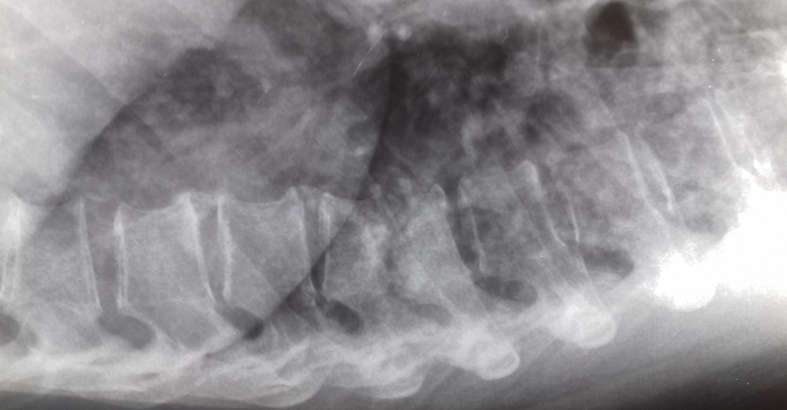
LATERAL PREOPERATIVE X-RAY 1

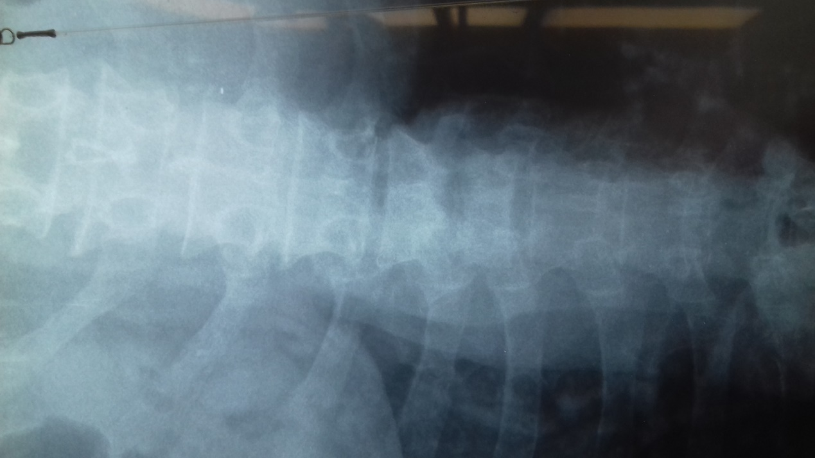
AP X-RAY PREOPERATIVE 1

Finding of MRI, the contrast enhanced T1 axial and sagittal showed well enhanced lesions at T9 & T 8 vertebral body and disc space without evidence of enhancement of epidural and paravertebral region with carful compression of this finding with T2 this is constant with discitis and vertebral osteomyelitis.

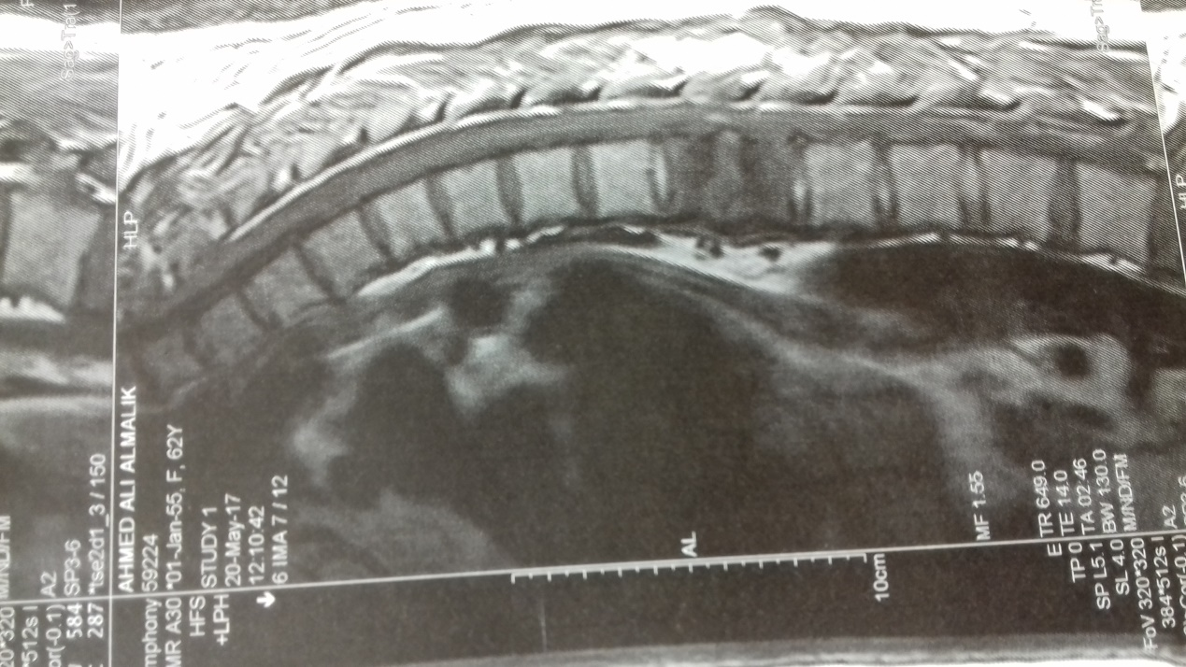
SAGITTAL T1 MRI 1

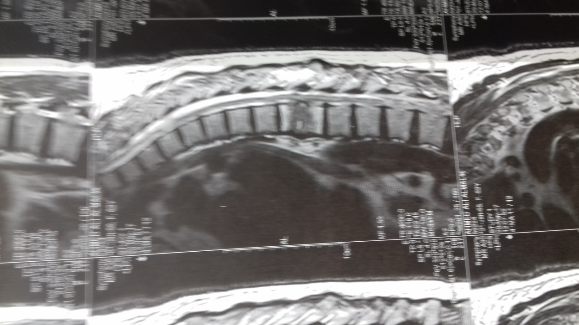
sagittal T2 MRI 1

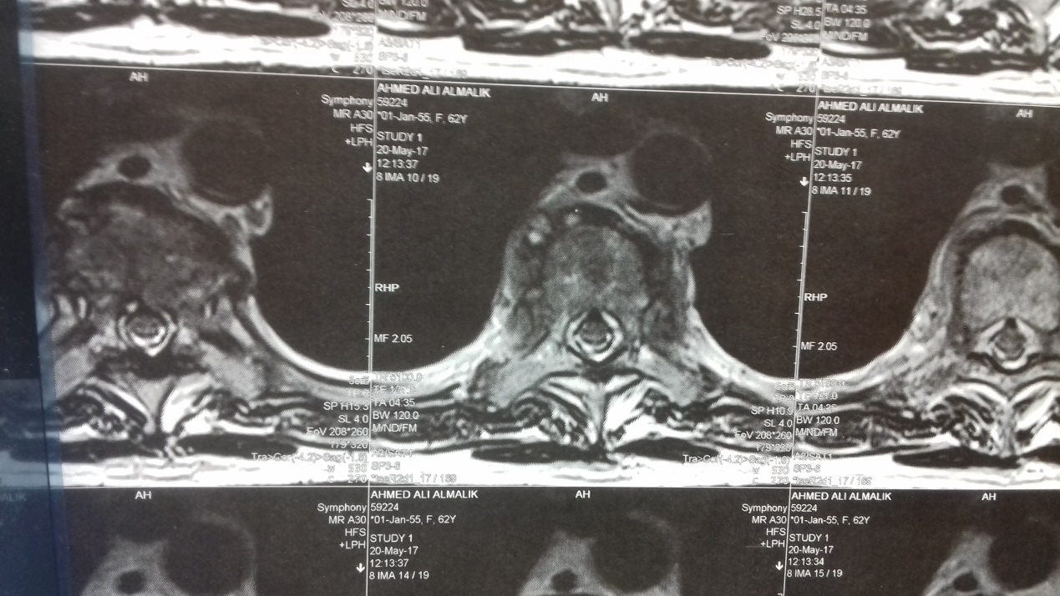
axial MRI 1

Bloods: inflammatory marker, CBC, RFT, LFT and glycemic status are within normal limits.
Considering this presentation and associated co- morbidities , he was elected to undergo posterior instrumentation achieve adequate stability and deformity correction in combination with anterior debridement and fusion using VATS for radical removal of potentially infected tissues and restoration of the disc height by harvesting structural bone graft from the pelvis . The removed tissue was sent for tissue C/S and histopathology the operative time was 110 minutes and the blood loss was around 1500 cc. He was mobilized on day 3 after removal of chest tube and discharged on day 5 free of pain and serious complication on empirical oral antibiotics and thoracolumbar brace. On the first follow up first visits ,there was marked improvement in sense of ability to ambulate free of pain and posture correction in addition to the result of histopathology that excluded the granulomatous infections conditions , malignancy and other mimickers .

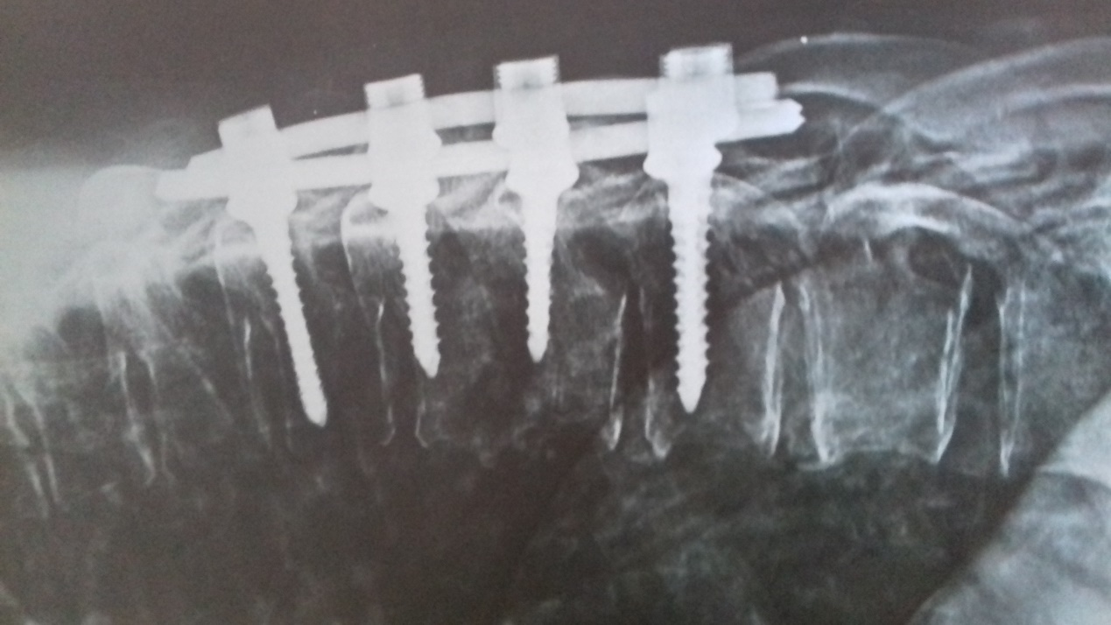
Postoperative lateral view X-ray

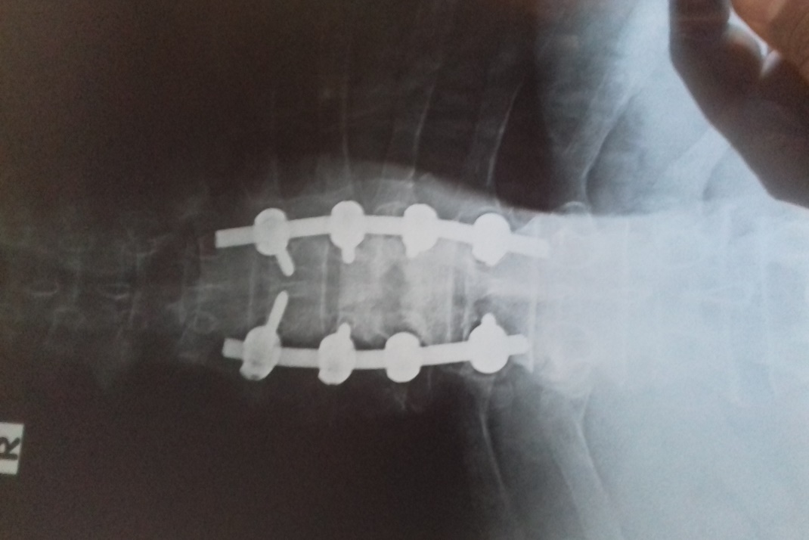
postoperative AP view X-ray

Discussion
In this series in addition to 4 cases of wedge fracture we reported 3 cases of thoracic thoracolumbar spondylodiscitis that deserve surgical intervention. The treatment of spondylodiscitis is a bit unique. As the combination of medical treatment and surgery is best option to be offer as it associated with excellent prognosis in such like patients according to literature ^{(9 , 10)} , in contrast to cases of fractures the decision of appropriate type of the surgical intervention of spondylodiscitis is not an easy task as it influenced by many host factors pursuing the operation tolerance , response to medical treatment , surgeon experiences and availability of certain setup tools , in this field many algorithms set by various centers were proposed to guide the treatment options , and below is one of these algorithms or protocols ⁽⁹⁾ .
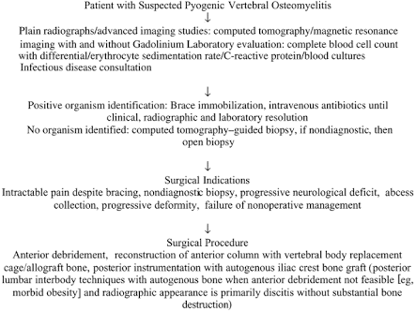
Even though, no doubt that the successful outcome strategies in a patient with discitis and co morbidities are influenced by sufficient decompression ,fusion , fixation in addition to performance in minimal invasive fashion , as much as it could address all the required tasks , Michael et al , reported a fatal outcome after insufficient spine fixation for thoracic spondylodiscitis despite the formal thoracotomy for anterior decompression and stabilization, which performed by vertebral body replacement using expandable titanium cages and anterolateral locking plate , thus he reported a catastrophic failure and he advise the need for posterior fixation with anterior fusion⁽¹¹⁾ .

KMC Cheung et al ,conducted literature review on approach- related complications of open versus thoracoscopic anterior exposures of the thoracic spine and they concluded that VAST has several advantages over open thoracotomy such as less postoperative pain, morbidity earlier mobilization leading to shorter hospital stay and small scars , and they recommend it for high- risk patients to avoid open thoracotomy ⁽¹²⁾ .
Tan et al, recommend traspadicular approach for debridement of disc space as a minimally invasive technique in patients with discitis in thoracic spine but in dorsally located pathologies rather than ventral one which deserve anterior exposure according to his recommendation ⁽¹³⁾ .
Khan SH et all , stated that primary spine infections is best treated surgically whereas secondary can be managed surgically or conservatively meanwhile the lesion site need to be considered as the width of thoracic neural canal relative to lumbar region is suggesting surgical intervention in most of cases dorsal discitis⁽¹⁴⁾ .
Karikari et al, evaluated clinical, radiographic ,operative ,postoperative ,and functional outcomes in a series of 22 elder patients with various thoracic spine disorder , including discitis /osteomyelitis treated by extreme lateral interbody fusion (XLIF) as minimal invasive technique and the authors conclude that it was feasible and save treatment option for elderly co- morbid patient with minimal complication ,although traditional open approaches achieve a higher degree of deformity correction ⁽¹⁵⁾ .
Mickael J Mack et al conducted a study of a series of 44 patient approached to their anterior thoracic spine from T2 to L1 through VAST , and we found that their conclusions were fitting our early results, as they mentioned that VAST is less morbid anterior thoracic spine approach ,although it mandate a significant longer learning curve period ⁽¹⁶⁾ .
The review of current status of VATS use , and the reported outcome was concluded by Verdu and Beisse , as they stated that the good clinical results of VATS in spine surgery is supported by growing experience reflected in a large number of articles, and the main concern was the benefit of decreased morbidity and fast recovery rather than the possibility of complications incidence as the degree of complications in thoracoscopic surgery is comparable to open surgery .
Results No operative and postoperative complications recorded, intraoperative bleeding between 1400cc to 2000cc, operation time 110-150 minutes, hospital stay 4 -6 days. All patients achieve successful fusion to the affected level. We have achieved complete wound healing in around 15 days and nearly complete recovery in 20 days, as patients were able to perform all indoor activity independently.

Conclusion: the technique of VATS with posterior instrumentation for thoracic and thoracolumbar spine fractures and spondylodiscitis is a safe in the setting of single lung anesthesia, and the procedure is performed easily in prone position which in favor of better ventilation and exposure.

References:

1-D.Kubosch L et al .Relationship between autologous bone graft osteointegration and correction loss after anterio-posterior spondylodesis of traumatic vertebral body fracture : Revue de chirurgie Orthopedique et Traumatologique April 2015 ; 101(2):150.

2-Mack et al . application of thoracoscopy for diseases of the spine. The Annals of Thoracic Surgery . 1993; 56(3):736-738.doi .

3-G.P . Pal, R.V. Routal . Transmission of weight through the lower thoracic and lumbar regions of the vertebral column .J.Anat 1987 ;152 pp 93-105 .

4-Deepak Kumar et al. Thoracolumbar fracture : Three column stabilization through posterior only approach . june 2016 ; (4):1-5 .
5- Atul Purohit et al ,lung Isolation ,one lung ventilation and hypoxaemia during lung isolation ,Sep 2015;59(9):606-17.

6-Saad B et al. Postoperative spinal wound infections and post procedural Diskitis. J Spinal Cord Med.2007; 30(5):441-51.

7-Hadjipavlou et al. hematogenous pyogenic spinal infections and their surgical management .Spine (phila Pa1976).2000;25(13):1668-79.

9-Huang et al .Complications in thoracoscopic spinal surgery .Surg Endo. 1999;13:346.

10-Wei-Hua et al .Surgical treatment of pyogenic vertebral osteomyelitis with spinal instrumentation. Eur spine J . 2007sept;16(9):1307-16.

11-Rui M. Duarte and Alexander R. Vaccaro . Spinal infection: state of art and management algorithm .Eur spine J.2013Dec;22(12):2787-99.

12-Dong-Geun et al . A clinical Analysis of Surgical treatment for Spontaneous Spinal Infection . J Korean Neurosurg Soc.2007Oct;42(4):317-25.

13-Michael et al .Fatal outcome after insufficient spine fixation for pyogenic thoracic spondylodiscitis: imperative for 360degrree fusion of infected spine . Patient Saf Surg.2009;3:4.

14-KMC Cheung, and S Al Ghazi .Review article: Approach- related complication of open versus thoracoscopic anterior exposures of the thoracic spine . Journal of Orthopedic Surgery 2008;16(3):343-7.

15-Tan LA al . Minimally invasive transpedicular approach for evacuation of epidural abscess and debridement of disc space in patient with discitis in thoracic spine . Nuro Surg Focus.2013; 35 (2 Suppl) Video 6.

16-Khan et al .Comparison of primary and secondary spinal epidural abscesses: a retrospective analysis of 22 cases .Sur Neurol 2003;59:28-33.

17-Karikari et al .Extreme lateral interbody fusion approach for isolated thoracic and thoracolumbar spine disease: initial clinical experience and early outcome .J Spinal Disord Tech.2011;24(6):368-75.

18-Mickael J Mack et al. VATS Surgery for the anterior Approach to the Thoracic spine .Ann Thorac Surg 1995;59:1100-6.

19-Verdu and Besse . Current status of thoracoscopic surgery for thoracic and lumbar spine .Part2: treatment of thoracic disc hernia spinal deformities ,spine tumors, infections and miscellaneous. Neurocirugia2014;25(2):62-72.

