Title:
Preoperative C4/5 foraminal diameter as a predictor of C5 palsy after laminoplasty
Department of Orthopaedic Surgery Chungnam National University Hospital, Daejeon, Republic of Korea

Abstract
Statement of the Problem: Laminoplasty is frequently performed in cervical myelopathy patients. However, unexpected postoperative C5 palsy occurs incidentally. Methodology & Theoretical Orientation: Between January 2014 and April 2016, 100 patients who underwent laminoplasty for cervical spondylotic myelopathy were included. C5 palsy was deﬁned as a weakness (change MMT score 1 or 2) of deltoid muscle. The patients were divided into 2 groups: group A that had experienced C5 palsy and group B that had not. We evaluated the incidence of C5 palsy, the preoperative C2-7 Cobb’s angle, and the Pavlov ratio at C4, C5 level using simple radiograph, and also using CT scan, the existence of OPLL, the transverse diameter of C4/5 foramen, and the increase of AP diameter of spinal canal at C4 and 5 level after surgery. In addition, preoperative high signal intensity on T2 weighted image of the cervical spinal cord was evaluated. Findings: Postoperative C5 palsy occurred in 8 patients (8%). There was no signiﬁcant difference in sex, age, the existence of OPLL, and preoperative high signal intensity on T2 weighted image of the cervical spinal cord. Also the preoperative C2-7 cobb’s angle, the Pavlov ratio at C4, C5 level, the increase of AP diameter of spinal canal at C4 and 5 level were not significantly related with postoperative C5 palsy. However, the average diameter of the C4/5 foramen of affected side was 2.51mm in group A and 3.88mm in the group B (p=0.004), and the smaller diameter of the C4/5 foramen especially less than 2mm was significantly related with C5 palsy in binary logistic regression test (p=0.000). Conclusion & Significance: The diameter of C4/5 foramen was the only reliable parameter to predict C5 palsy after laminoplasty. The results suggest that C4/5 foraminal stenosis is one of most important etiology of C5 palsy.
Image
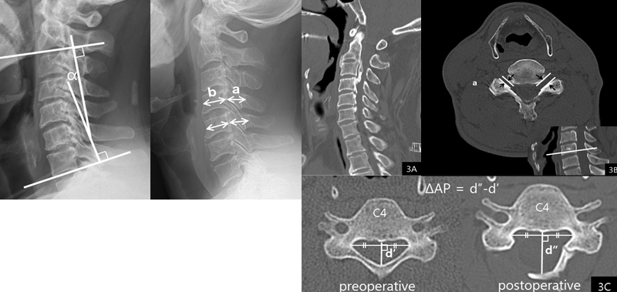
Recent Publications
- Kaneyama S, Sumi M, Kanatani T, Kasahara K, Kanemura A, Takabatake M, Yano T (2010) Prospective study and multivariate analysis of the incidence of C5 palsy after cervical laminoplasty. Spine 35(26): E1553-E1558.
- Katsumi K, Yamazaki A, Watanabe K, Ohashi M, Shoji H (2012) Can prophylactic bilateral C4/C5 foraminotomy prevent postoperative C5 palsy after open-door laminoplasty?: a prospective study. Spine 37(9):748-754.
- Nassr A, Eck JC, Ponnappan RK, Zanoun RR, Donaldson III WF, Kang JD (2012) The incidence of C5 palsy after multilevel cervical decompression procedures: a review of 750 consecutive cases. Spine 37(3):174-178.
- Sakaura H, Hosono N, Mukai Y, Ishii T, Yoshikawa H (2003) C5 palsy after decompression surgery for cervical myelopathy: review of the literature. Spine 28:2447–2451.
- Imagama S, Matsuyama Y, Yukawa Y (2010) C5 palsy after cervical laminoplasty. J Bone Joint Surg [Br] 92B:393–400.

Biography


- Professor of Orthopaedic Surgery of Chungnam National University Hospital
- General Secretary of PASMISS
- Vice Dean of School of Medicine Chungnam National University
- BOARD CERTIFICATION
Medical doctor (1985)
Korean Board of Orthopaedic Surgery (1991)
- Society Membership
Korean Medicine Association (1985)
Korean Orthopaedic Association (1991)
Korean Society of Spine Surgery (1993)
Korean Society of Fractures (1993)
Korean Bone Metabolism Association (1993)
International Bone Mineral Research (1998)
National Delegate AO spine Korea (2000)
SICOT (1999)
Asian Pacific Orthopaedic Association (1999)
Committee Member of Pacific Asian Society for Minimal Invasive spinal Surgery ( 2001)
Board Member of Cervical spine research Society of Korean Spine Surgery
Faculty Member of AO Spine Society of Korean AO spine
Asia Pacific region Representatives WENMISS
General Secretary PASMISS
Representatives Korea PASMISS

Email: : jsahn@cnu.ac.kr

