Assessment of ecological conditions of soil, plant and water recourses of Shirvan territory of Azerbaijan

Tubukhanim Gasimzade , Institute of Dendrology of ANAS, Azerbaijan

Abstract (300 word limit)
Statement of the Problem: Ecological assessment of soils, plant, rivers of Shirvan zones (territory of East and West part of Great Caucasus, Steepe plateau, Kur plain, Kur-Araz lowland and Gobustan) of Azerbaijan is interested from scientific theoretical and practical urgency. The total area of flat and mountain part of Shirvan-748 thousand hectares. The basic anthropogenous factors of biogeocenosis changes are drainage and flooding of territories; agricultural land development, set of agrotechnical actions for increase of soils fertility, cutting down of woods and bushes, building of roads and industrial targets. The region climate is non-uniform: climate is damp in high-mountainous and middle-mountainous parts, in foothill-hilly - droughty, warm, in low-flat – dry and warm. The mountain zone is rich by mineral waters of medical and resort value. 7 basic rivers proceeding in region: Kur, Goycaychay, Turyanchay, Girdimanchay, Agsuchay, Pirsakhatchay, Gozluchay, their chemical, bacteriological structure influences an ecological condition of a soil-vegetative cover of Shirvan. Pollution of the rivers occurs both superficial and sewage where get a waste and products of live ability of the person. 215 soil cuts are pawned by separate landscape complex with provision for structured-top soil and are selected sample of soils and plants for laboratory studies.14 types,52 subtypes of soils: alpine/subalpine meadow and meadow steppesmezophile woodxerophyle woodshrubbery and dry mountain steppesdry subtropical steppes and subdesertsflood plains and low-lying wood, so from blazed-meadow till saline soil types. Besides, wood-working enterprises functions in Ismayilli district, stone open-cast mines, brick-works, the enterprises for agricultural machinery repair in Shamakhi, Gobustan districts. Instability of Shirvan ecosystems negatively affects on it biogeocenose and there is actual a working out of measures on its preservation. Constant monitoring of soil and vegetative cover gives the chance monitoring of ecological condition of region. The full and all-round information is necessary for decision-making on protection of Shirvan environment.
.

Image
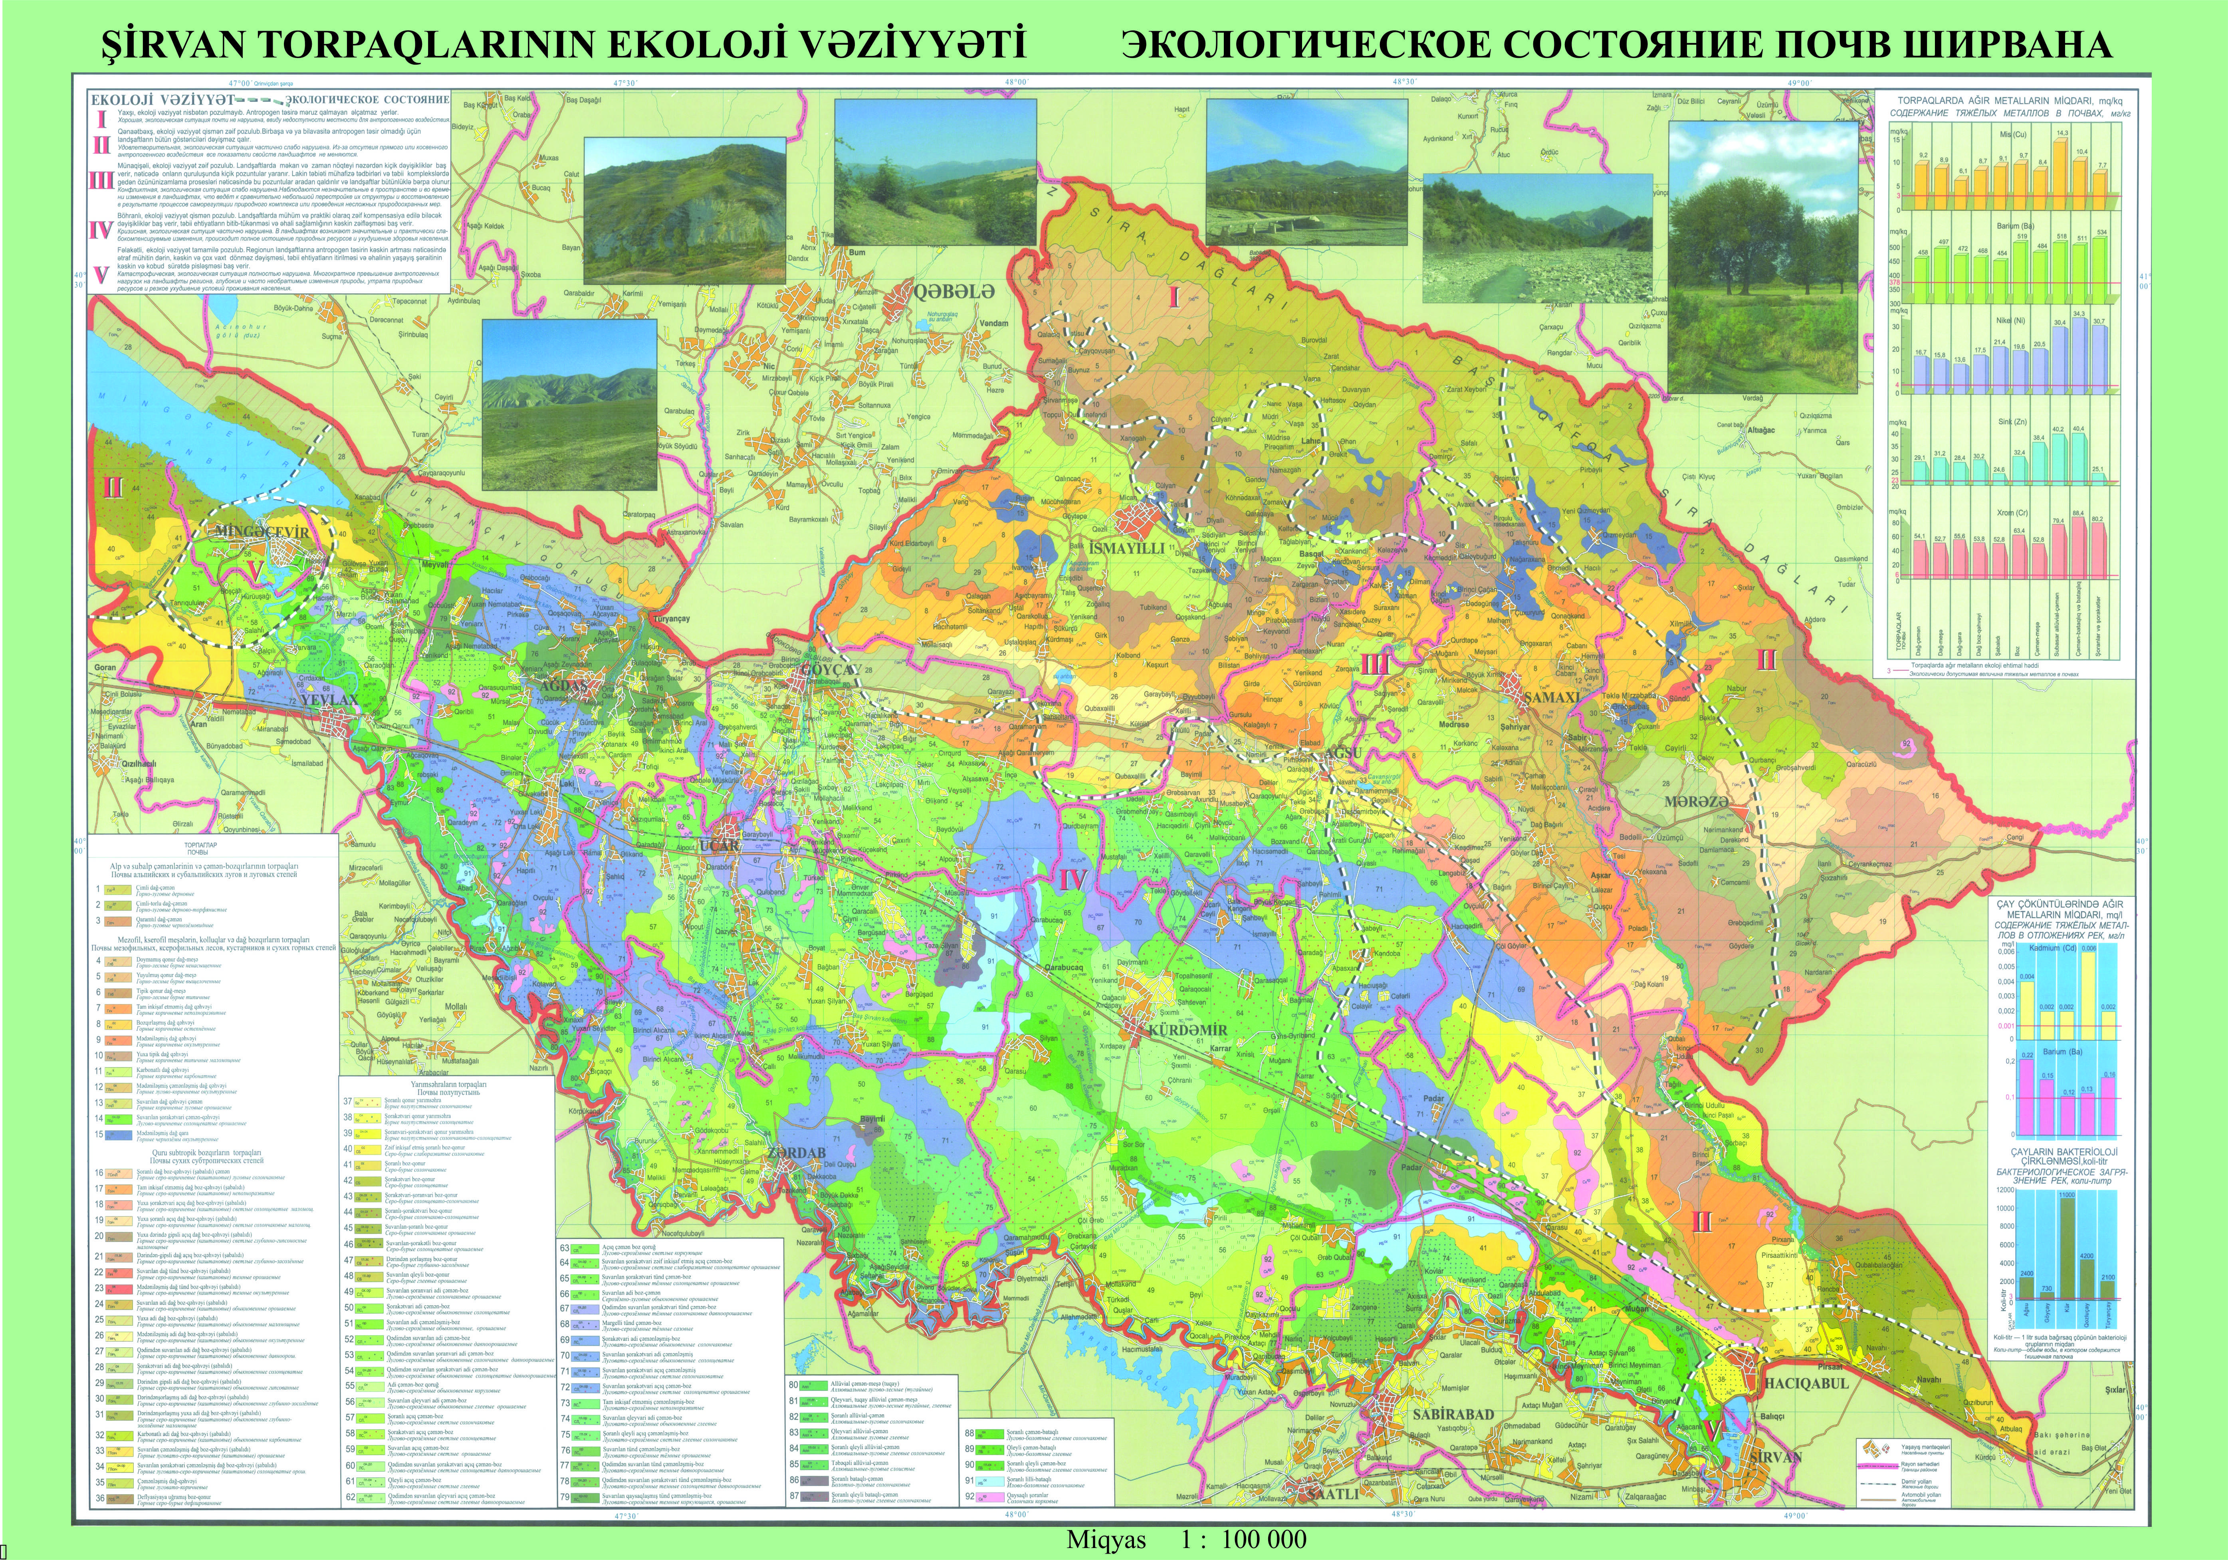

Figure 1: Map of ecological conditions of Shirvan soils and diagrams of heavy metall contents in soil and conditions of river water of Shirvan region of Azerbaijan

Recent Publications (minimum 5)
- Mammadov G.Sh. Ecological assessment of the soil of Azerbaijan and its importance, Baku, AzNIINTI, 1992, 26 P.
- Motuzova G.V., Bezuglova OS Ecological monitoring of soil.M .: Academic project; Gaudeamus, 2007, 237 P.
- Lal R. Sustainable soil management and ecosystem services. In: Sustainable, including ecological agriculture - results, problems and perspektives. Conf. Intern. 21-22 july, 2007, Baltsi, Moldova, 120-122
- BakurovaK.B., Yuferev V.G. Ecological-economic assessment of the degradation of agricultural landscapes based on remote monitoring. Vestnik ISU, series: geography, geoecology, 2009, №1, pp. 79-83
- 3. Balgabaev N.N., Bekbaev R.K., Bekbaev V.K. and etc. Ecological - meliorative factors affecting on the productivity of irrigated land in the basin of the Asa - Talasriver. Kazakh Research Institute of Water Management, Baku, 2012, pp. 668-671

Biography (150-word limit)
Dr., Assistant prof. Tubukhanum Gasimzade for many years has been exploring one of the largest regions of Azerbaijan - the Shirvan region, which includes the mountain and lowland parts. She conducted a study of the ecological state of the soil, vegetation and river waters of the region. Comparative ecological assessment, taking into account each of the environment contributors, made it possible to formulate recommendations for improving the state of soils, vegetation and river waters, as well as to prepare proposals for the rational use of pastures with which the region is rich.
Email: nushana_kasimova@yahoo.com

Notes/Comments:

