Assessment of biophysical and economic benefits of grass barriers in cassava plantations on steep slopes of Vietnam’s northern mountain region

Bui Le Vinh, Vietnam National University of Agriculture, Vietnam

International Center for Tropical Agriculture (CIAT)

Bui Le Vinh, Vietnam National University of Agriculture, Vietnam

International Center for Tropical Agriculture (CIAT)

Abstract (300 word limit)

Cassava cultivation on steep slopes in northern Vietnam indicates the last cropping pattern since forest clearance and how degraded soils are given the crop’s low nutrient requirements compared to other crops. In 2002, Van Yen district’s department of agriculture launched an initiative on conservation agriculture on sloped land, introducing forage grass barriers to mitigate soil erosion and improve soil fertility. After 16 years in practice, over 7000 hectares of cassava monocropp has been converted to this practice. Great benefits have been observed from this campaign; however, they have not yet been fully quantified. The study aims at assessing the improvement soil fertility, crop yields and household incomes from this measure. Three types of fields have been investigated, including (i) cassava monocrop (zero grass barrier), (ii) 8 years of grass barriers, and (iii) 16 years of grass barriers. The research was conducted in 3 locations within a radius of 15 km. At each location, soil samples were collected at the 0-20cm depth for each of the field type and five fields for each type. 45 fields were investigated with a total number of 90 soil samples (2 samples at upper and lower slope positions). The team conducted surveys of 200 households for all three sites to capture an overall picture of how household income has changed with this initative, especially with the linkage of the cut-and-carry livestock practice to forage grass. Statistical analyses show that parameters of total organic carbon, total nitrogen, soil pH, soil porosity are best in type (iii) and lowest in type (i). Cassava yields follow the same trend. Farmers in type (ii) and (iii) gain more incomes from cut-and-carry system due to availability of nutritious forage grass collected from the barriers and overcoming the constraint of limited space and low natural grass quality for natural grazing.
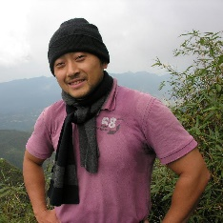
Image
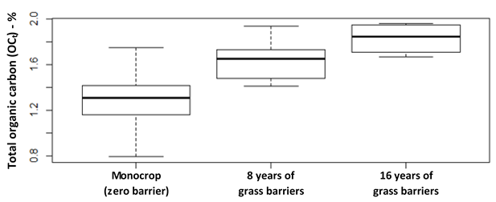
Figure 1. Differences of total organic carbon in 3 types of management practice of cassava plantations in Van Yen district (n=90)
Recent Publications (minimum 5)
- Bui, Le Vinh; Wyckhuys, Kris; Nguyen, Duc Tung; Nguyen, Tuan Cuong; Doan, Thanh Thuy (2018). Triple advantage of intercropped legumes: restored degraded soils, increased crop yields and dampened population build-up of herbivorous mites in cassava plantations. Near submission to Agriculture, Ecosystems and Environment.
- Bui, Le Vinh; Doan, Thanh Thuy; Nguyen, Duc Hung; Nguyen, Hai Nui; Nguyen, Tuan Cuong (2018). Assessment of biophysical and economic benefits of grass barriers in cassava plantations on steep slopes of Vietnam’s northern mountain region. Near submisison to Catena.
- Suwimon Wicharuck, Le Vinh Bui, Ulrich Schuler, Mattiga Panomtaranichagul, Karl Stahr (2018). Impact of Different Types of Land Use on Soil Fertility in North-Western Thai Highlands. Submitted to Catena.
- Bui, Le Vinh; Stahr, Karl; Clemens, Gerhard (2017). A fuzzy logic slope-form system for predictive soil mapping of a landscape-scale area with strong relief conditions. Catena 155: 135-146.
5. Wyckhuys, Kris; Burra, Dharani; Tran Dang, Hoa; Graziosi, Ignazio; Walter, Abigail; Nguyen, Giang; Hoang Trong, Nghia; Fonte, Steven; Bui Vinh, Le; Le Thi Tuyet, Nhung (2017). Trophic cascades and biotic resistance vary in strength along a soil fertility gradient. Agriculture, Ecosystems and Environment 249: 38-49.

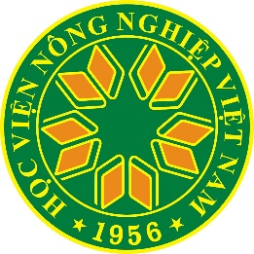

Biography (150 word limit)

Dr. Bui Le Vinh is a soil scientist with interests in digital soil mapping, soil restoration anc conservation agriculture, climate-smart agriculture, and ecosystem services and sustainable landscapes. He has extensive experience of research for development in Vietnam’s northern mountain region. He works as a lecturer at Vietnam Naitonal University of Agriculture (VNUA) and a researcher at International Center for Tropical Agriculture (CIAT). These two organizations share a same mandate, which is to work to serve the poor and marginalized in rural areas of Vietnam and Southeast Asia. Dr. Bui Le Vinh leads a research group at VNUA in collaboration with CIAT in soil-based sustainable development for rural Vietnam.
Email: bui_le_vinh@yahoo.com; v.bui@cgiar.org

Notes/Comments:

Presenting author details
Full name: Bui Le Vinh
Contact number: +84989928671
Mail id: bui_le_vinh@yahoo.com; v.bui@cgiar.org
Category: Oral presentation

