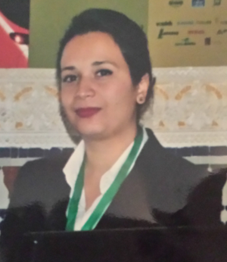
Peroxidase extraction from radish fertilized by wastewater and sugar lime sludges composts
S. RIDA, K. KOHAICH, N. Saadaoui, O. SAADANI HASSANI, M. BAAZIZ et K. Fares
Caddi Ayyad university, Faculty of Sciences Semlalia, Biologie Department, BP 2390, Marrakesh, Morocco.
Laboratory of Biotechnology, Biochemistry, Plant Protection and Valorization.
Soukaina.rida@gmail.com
The study aims to show that wastewater and sugar lime sludge co-compost can be can be used to fertilize soil with a low organic matter quantity.
With wastewater sludge from Marrakesh and lime sludge from Sugar industries des Doukkalas; three composts were formed; the first contains only sludge and green waste, the second and third composts contains wastewater sludge and lime sludge in an amount to achieve 20% and 30% of lime and a pH equal to 7.5 and 8, respectively, The C/N starting ratio is achieved with the addition of green waste. The humidified composts were followed for 100 days; the temperature is measured daily during the first two weeks while the water content is determined weekly. The compost is used safely to amend the soil with organic matter, and therefore, an agricultural test was done using compost as an organic fertilizer for Radish. Peroxides were extracted by progressive solubilization from the leaves of radish plans fertilized by different concentrations of our composts and horse manure as witness.
This study demonstrated that the compost produced from wastewater sludge and sugar lime sludge may safely be used as an organic fertilizer since it allows us to get interesting results concerning the technical quality of radish and the soil behavior in addition to the reduction of N fertilizer amount. Peroxides activity is shown in soluble and ionic fractions. Thus, this compost constitutes a sustainable solution in order to improve soil composition and to reduce the harmful effects of the chemical fertilizer.
Keywords: Composting, Peroxidase, wastewater lime sludge, Organic fertilizer
Biography:
Soukaina Rida is a PhD student, age 29 years from Cadi ayyad university, has eshtablished one year scholarship at university politecinca of valencia to do a reaserch about phytohormones in wastewater and sugar lime sludges composts, one publication is submitted to publication, currently writting her thesis.
Presenting author details
Full name: Soukaina RIDA
Contact number: +212610738674
Twitter account:
Linked In account:
Session name/ number:
Category: (Oral presentation/ Poster presentation): oral presentation

