Identification of Hydrologic-Landscape Regions in Piracicaba, Capivari and Jundiaí Rivers basins, Brazil
Matheus H Mortene, BEng, FT-UNICAMP, BRAZIL
Ronalton E Machado, BEng DR, FT-UNICAMP, BRAZIL

Abstract
Today, hydrology faces the challenge of finding a hydrological classification model of river basins that can be complete, comprehensive and at the same time efficient, collaborating in the elaboration of hydrological studies and the identification of favorable areas to water storage. The Hydrologic Landscapes classification method, which summarizes in a single layer the factors that affect the hydrological cycle, have been applied in the Piracicaba, Capivari and Jundiaí Rivers basins, located in the state of São Paulo - Brazil. Were used as evaluation units, data on climate, soil and aquifer permeability and relief, in order to prove the efficacy of the method in identifying favorable areas to water storage. Each pixel has received a value of HLR - Hydrologic Landscape Region, which summarizes hydrological characteristics of the site. To evaluate the usefulness of this approach, the annual water yield in the sub-basins was calculated using flow data from the main river basins. This value is necessary to identify the factor "m" (from Fuh’s equation), parameter associated with watershed characteristics, such as slope and water retention capacity. The values found for "m" collaborate with studies, proving that the parameters chosen as evaluation units are effective for identifying water storage areas. The favorable and unfavorable areas for water storage were identified and overlapped with the land cover map to evaluate the conditions of protection and management. Highlights the high occurrence of pasture and sugarcane crops in favorable areas to soil water infiltration and also the high occurrence of urban in unfavorable areas. The classification in Hydrological Landscapes has proved to be an effective tool to identify areas of soil water infiltration and it can also collaborates with projects to increase production and storage water in watersheds.

Image
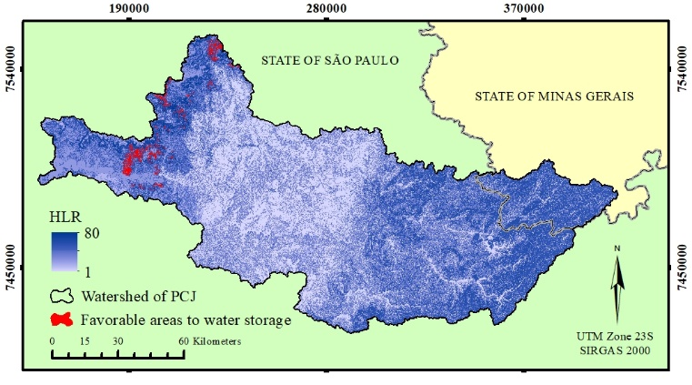
Figure 1 – Hydrologic-Landscape Regions (HLR) identification and favorable areas to water storage in Piracicaba, Capivari and Jundiaí Rivers basins.
Recent Publications
- Wigington, Parker J., Jr., Scott G. Leibowitz, Randy L. Comeleo, and Joseph L. Ebersole, 2012. Oregon Hydrologic Landscapes: A Classification Framework. Journal of the American Water Resources Association (JAWRA) 49(1): 163-182.
- Winter, T.C., 2001. The Concept of Hydrologic Landscapes. Journal of the American Water Resources Association 37:335-349.
- Wolock, D.M., T.C. Winter, and G. McMahon, 2004. Delineation and Evaluation of Hydrologic-Landscape Regions in the United States Using Geographic Information System Tools and Multivariate Statistical Analyses. Environmental Management 34(Suppl. 1):S71-S88.
- Zhou, G. et al., 2015. Global pattern for the effect of climate and land cover on water yield. Nat. Commun. 6:5918
- Olden, J.D., M.J. Kennard, and B.J. Pusey, 2012. A Framework for Hydrologic Classification With a Review of Methodologies and Applications in Ecoyhydrology. Ecohydrology 5:503-518
- Fuh, B. P. On the calculation of the evaporation from land surface. Sci. Atmos. Sin. 5, 23–31 (in Chinese with English abstract) (1981).

Biography


Matheus Mortene is an Environmental Engineer with experience in the use of Geographic Information Systems - GIS. Works on the development of techniques for watershed management and studies on the impact of climate change on agriculture. The present study was developed as a master's thesis at the School Technology of State University of Campinas, Brazil and collaborates with the management of water resources in the watersheds of the Piracicaba, Capivari and Jundiaí Rivers.
Email: mat_hm@hotmail.com

Presenting author details
Full name: Matheus Henrique Mortene
Contact number: +5519996641455
Mail id: mat_hm@hotmail.com
Category: Poster presentation

