Critical factors driving soilborne root disease epidemics in clovers revealed and explained
Ming Pei You, Michael Renton, Kelly Rensing and Martin J. Barbetti, School of Agriculture and Environment, University of Western Australia, Crawley, WA 6009, Australia

Abstract

Subterranean clover (Trifolium subterraneum) is a critical pasture legume in Mediterranean regions of southern Australia and regions with Mediterranean-type climates in Europe, Africa, Asia, Australia, North America, and South America. Damping-off and root disease, caused by a complex of pathogens, particularly Pythium irregulare, Phytophthora clandestina, Aphanomyces trifolii and Rhizoctonia solani, is devastating across most of 20m ha of clover pastures in southern Australia. Studies were conducted to define how environmental factors (viz. temperature, soil type, moisture and nutrition) as well as host variety, influence the severity of damping-off and root disease and consequent productivity in clover pastures under challenge by these pathogens. Relationships were statistically modelled using linear and generalized linear models and boosted regression trees. Modelling found complex relationships between explanatory variables and the extent of damping-off and root rot for each of the four pathogens. Linear modelling identified high-level (4 or 5-way) significant interactions for each response variable (emergence, tap and lateral root disease index, dry shoot and root weight). Furthermore, all explanatory variables (temperature, soil, moisture, nutrition, variety) were found significant as part of some interaction within these models. A second approach to modelling using boosted regression trees provided support for and helped clarify the complex nature of the relationships found in linear models. All explanatory variables showed significant relative influence on each of the five response variables. In particular, all models indicated differences due to soil type, with lowest weights, least emergence, as well as most disease for loam soil compared with a sand-based soil. Modelling helped reveal the complex nature of how fluctuating soil temperature, moisture and nutrition conditions, along with soil type and variety, all interact to determine damping-off and root disease severity in clover pastures and the consequent poor persistence and lack of productivity of subterranean clover pastures. For the first time, these studies explain the variations occurring across seasons, soils, geographic locations and varieties in terms of the severity and impact of soilborne root diseases.

Image

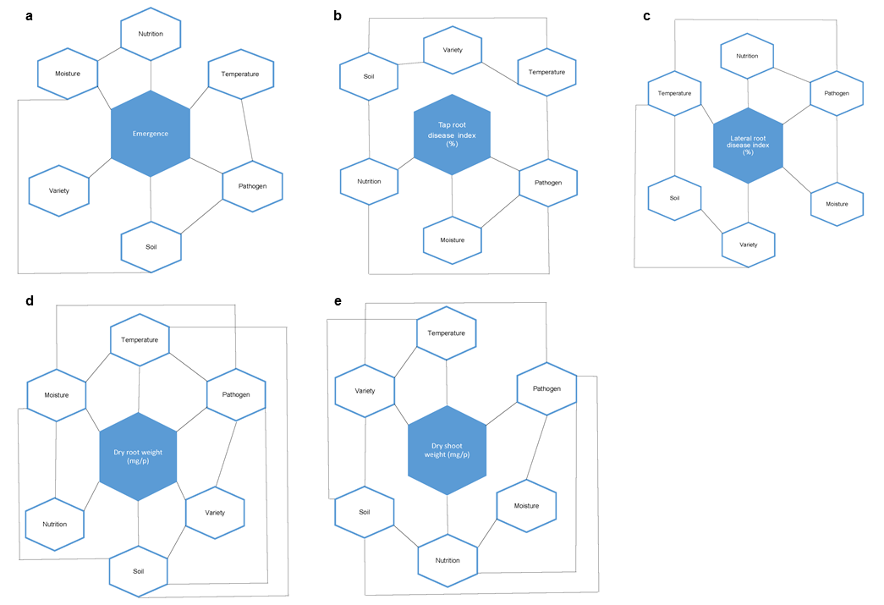
Figure 1 a-e. Example of effect of environment factors (moisture, temperature, nutrition, soil type, variety) and their interactions on: a) clover emergence rate, b) tap root disease, c) lateral root disease, d) dry root weight, and e) dry shoot weight in presence of soilborne pathogens.

Recent Publications
- Almasurdy, A., You, M.P. and Barbetti, M.J. (2015). Influence of fungicidal seed and soil treatments and soil type on severity of root disease caused by Rhizoctonia solani AG-8 on wheat. Crop Protection 75: 40-45.
- You, M. P., O’Rourke, T. A., Foster, K., Snowball, R., Barbetti, M. J. (2016). Host resistances to Aphanomyces trifolii root rot of subterranean clover: first opportunity to successfully manage this severe pasture disease. Plant Pathology 65: 901–913.
- Foster, K., You, M.P., Nietschke, B., Edwards, N., Barbetti, M.J. (2017). Widespread decline of subterranean clover pastures across diverse climatic zones is driven by soilborne root disease pathogen complexes. Crop and Pasture Science 68: 33-44.
- You, M.P., Barbetti, M.J. 2017. Severity of Phytophthora root rot and pre-emergence damping-off in subterranean clover is driven by moisture, temperature, nutrition, soil type, cultivar and their interactions. Plant Pathology (Online at: Doi: 10.1111/ppa.12655).
- You, M.P., Barbetti, M.J. 2017. Environmental factors determine severity of Rhizoctonia damping-off and root rot in subterranean clover. Australasian Plant Pathology (Online at: Doi 10.1007/s13313-017-0495-y).
- You, M.P., Guo, K.M., Nichol, D., Kidd, D., Ryan, M., Foster, K., Barbetti, M.J. (2017). Cultivation offers effective management of subterranean clover damping-off and root disease. Grass and Forage Science 72: (Online at Doi: 10.1111/gfs.12282).



Biography
Ming Pei You has wide areas of expertise across soilborne fungal and oomycete pathogens, their aetiology, epidemiology, disease control by identification and application of host resistance and of cultural and chemical methodologies and in integrated disease management in relation to forages, broad-acre crops and horticultural crops. She also has conducted research in China on several fungal pathogens currently exotic to Australia. She has particularly strong experience and understanding in pathogen epidemiological drivers, in fungal taxonomy, in defining the nature of soilborne complexes, particularly in relation to characterizing pathogen sub-specific variation within pathogen populations.
Email: Mingpei.you@uwa.edu.au

Presenting author details
Full name: Ming Pei YOU
Contact number: +61-8-6488 7194
Mail id: mingpei.you@uwa.edu.au
Category: (Oral presentation)

