BUILDING CROSS-COUNTRY NETWORKS FOR LABORATORY CAPACITY AND IMPROVEMENT

Miriam Schneidman, MA, MPH^{a,*,} Martin Matu, PhD, MSc, MBA^{b,}
John Nkengasong, PhD, MSc^{c}, Willie Githui, PhD^{d},
Simeon Kalyesubula-Kibuuka, MD, MPH^{e},
Kelly Araujo Silva, MBA, MPH^{f}

ª World Bank, Health, World Bank, 1818 H Street, NW, Washington, DC 20433, USA; ^{b} East,
Central and Southern Africa Health Community, Plot 157, Olorien, Njiro Road, PO Box 1009,
Arusha, Tanzania; ^{c} Africa Centers for Disease Control and Prevention, African Union Headquarters,
PO Box 3243, Roosvelt Street (Old Airport Area), W21K19, Addis Ababa, Ethiopia;
^{d} Mycobacteriology Research Laboratory, Centre for Respiratory Diseases Research, Kenya
Medical Research Institute, Kenyatta National Hospital Grounds, PO Box 47855, Nairobi
00200, Kenya; ^{e} Uganda National Health Laboratory Services, Plot 1062-106 Butabika Road
Luzira, Kampala, Uganda^{; f} Lacliv – Laboratorio de Analises Clinicas de Valenca, Travessa
Silva Jardim, Centro 13 Valenca, Bahia, Brazil

Abstract
Cross-country laboratory networks have historically played a critical role in supporting epidemiologic surveillance, accelerating disease outbreak response, and tracking drug resistance. One of the nascent laboratory networks is the East Africa Public Health Laboratory Network. The network is currently supporting 41 laboratories that serve as centers of excellence in 5 countries in East Africa (Uganda, Rwanda, Tanzania, Burundi and Kenya). These laboratories have benefitted from state-of-the art investments, capacity building, essential and specialized equipment & supplies, training and mentorship with more than 13,000 experts trained. Key results include: improvements in quality systems towards accreditation with four laboratories having reached ISO 15189 accreditation, including the Uganda Supranational TB Regional Laboratory, which is now providing specialized services and technical assistance to more than 20 National TB Reference Laboratories across the continent; roll out of new diagnostic technologies, such as the GeneXpert machines that have improved access to more accurate testing for underserved populations in cross-border areas with 956 MDR-TB cases confirmed out of 3847 MDR-TB cases detected; support for operational research to promote an evidence-based approach; and enhanced disease surveillance and outbreak preparedness capacity stemming from the upgraded facilities, novel technologies, staff training, and modern information and communication systems. Some of the key lessons learned that may be of relevance to other stakeholders include: the importance of establishing well-defined governance structures, clear mandates, and concrete deliverables; the potential to strengthen regional cooperation, facilitate peer learning, and foster mutual accountability; and the need for consolidating and sustaining achievements of cross-country networks.

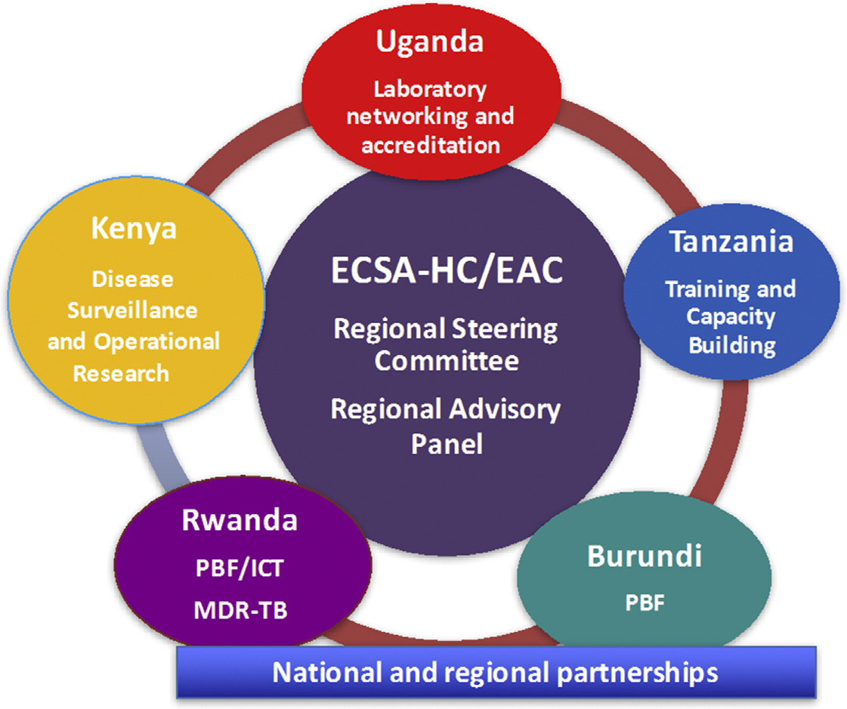
Fig. 1. East Africa Laboratory Network governance structure and model with countries technical leadership and regional coordination EAC, East Africa Community; ECSA-HC, East Central and Southern Africa Health Community; ICT, information communication technology; PBF, performance-based financing.
Recent Publications (consider if you only have or ignore)

 Biography: TBD
Email: mschneidman@worldbank.org

Keywords: public health laboratories, cross-country networks, quality assurance systems towards accreditation

Desired Presentation : _ Oral /_ Poster /X_ either

Topic : According to the list of topics provided on the web site

Corresponding Author Details: Miriam Schneidman, MA, MPHª
World Bank, Health, World Bank,
1818 H Street, NW, Washington, DC 20433, USA

Author Name
Organization/University
City, State, Country
Telephone Number & Fax Number

Abstract Submission Guidelines for Social Sciences 2018:

RULES FOR SUBMISSION OF ABSTRACTS:

The abstract submission guidelines of the Social Sciences 2018 are intended to provide clear instructions before submitting an abstract. You are kindly requested to carefully read the guidelines stated below.

- You may submit as many abstracts as you like
- The presenting author is required to ensure that all co-authors are aware of the content of the abstract before submission.
- All abstracts should be submitted and presented in clear English with accurate grammar and spelling of a quality suitable for publishing in conference proceedings, no other language abstracts will be considered for review
- Please note the submitting author will receive all correspondence about the abstract so we advise that the submitting author details that are entered are the same details as those of the presenting author.
- Please ensure that if you are submitting an abstract to be considered for the Young Researcher Forum that you send us supporting documents like Valid Student ID Card issued by your university
- Poster presenters will be informed about the date of the poster session and will receive guidelines for their presentation
GUIDELINES FOR SUBMISSION

Before you begin, please prepare the following information:
- Abstract body must not exceed a 250 words. The word limit relates only to the body of the abstract and does not include title, authors, qualifications, affiliations and institutions as these will automatically populate on the final abstract document based on the details entered into the relevant sections in the abstract submission site. (See above for abstract template)
- Underline the name of the presenting author
- The abstract title must not exceed 150 characters
- It is the author’s responsibility to ensure the title, author and affiliation details entered in the abstract submission site are correct and exactly as they should be published on the abstract and all conference materials.
- Font type must be Times New Roman or Computer Modern font 12pt and 1.5 line spacing.
- Abstracts must be free from typographical and grammatical errors.

- Standard abbreviations may be used for common terms. Otherwise, abbreviations should be given in brackets after the first full use of the word/s. Abbreviations may be used in the title, provided the full name/term is contained in the body of the abstract.
- Along with abstract you should provide your recent head-shot photograph of good resolution and short biography (up to 100 words) with your submission.
- You will be asked to nominate your preference for an oral, workshop or poster presentation. You will also be asked if you have a second preference should you first preference be unsuccessful.
- It is recommended to submit the abstract in electronic form via conference website (http://socialsciences.conferenceseries.com/abstract-submission.php)
- The submitted abstract must be a Microsoft Office Word file (*.doc, *.docx). or you can send us your abstract to socialsciences@healthconferences.org
- Computer geneated abstracts will be automatically rejected and the submitted autor’s email address will be black listed.

All submitted abstracts will be referred by the Local Organizing Committee / International Scientific Committee. Based on their scientific quality and relevance to the conference topics, the abstract will be either accepted for publication in the Conference Proceedings or rejected. The Conference Proceedings will distributed to the participants at the registration both in hard-copy and electronic versions. The abstract will not be published, unless the registration fee of the registered author is received.

