HEALTH, SOCIAL INTEGRATION AND SOCIAL SUPPORT AMONGST YOUNG MIDDLE-EASTERN REFUGEES LIVING IN MELBOURNE, AUSTRALIA

Pranee Liamputtongª*, Hala Kurban^{b}

ªSchool of Science and Health, Western Sydney University, Locked Bag 1797, Penrith, New South Wales, Australia 2751
^{b}School of Psychology and Public Health, College of Science, Health and Enginerring, La Trobe University, Bundoora, Victorai 3086

Abstract
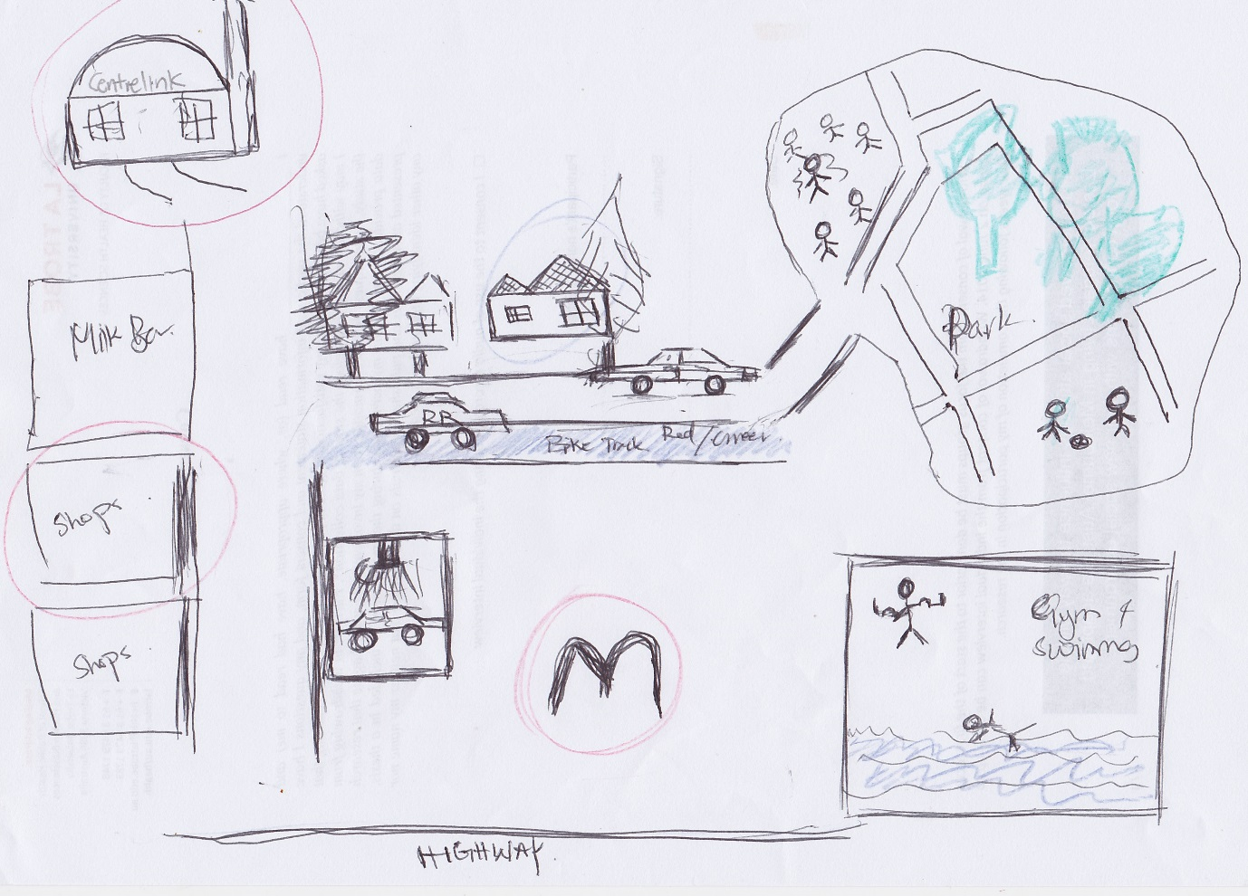
Situated within the therapeutic landscape theory, this paper examines how young Middle-Eastern refugee individuals perceive their health and wellbeing. The paper also addresses the barriers they face in their new homeland and the means that help them to form social connections in their new social environment. Qualitative methods (in-depth interviews and mapping activities) were conducted with ten young people from refugee backgrounds. Thematic analysis method was used to analyse the data. Findings suggested that the young refugees face various structural and cultural inequalities that significantly influenced their health and wellbeing. Mental health wellbeing was their greatest health concern. All reported the significant influence the English language had on their ability to adapt and form connections with their social environment. The presence of positive social support in their new social environment had a great impact on the health and wellbeing of the participants. The findings of this study contributed to the role of therapeutic landscapes and social support in helping young refugees to feel that they belonged to the society, and hence assisted them to adapt to their new living situation.

Image
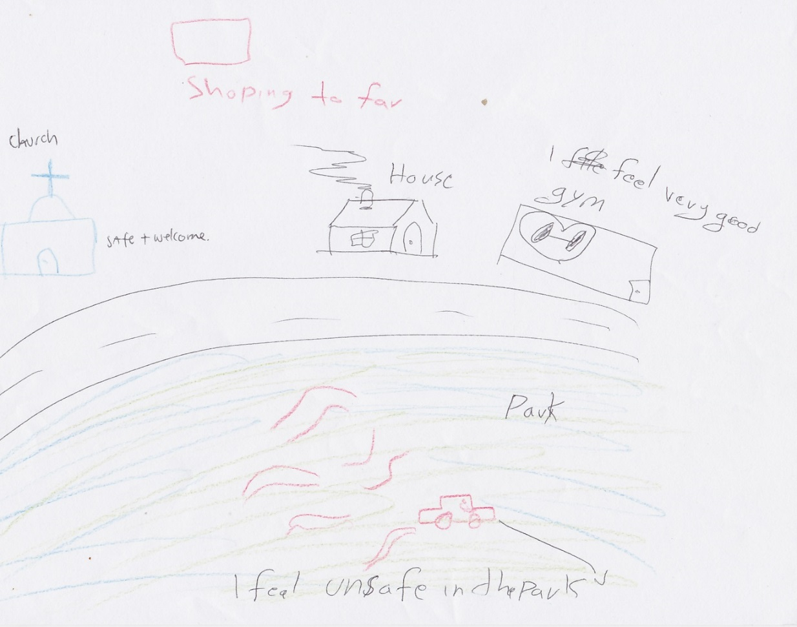

Church as a safe and welcome place

Fadi’s neighbourhood

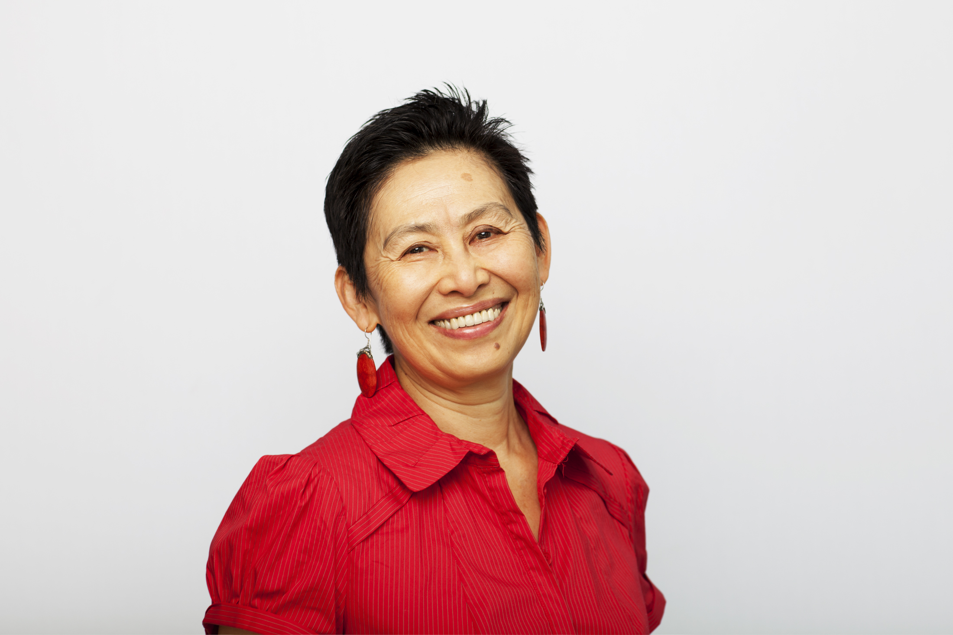

Biography:
Professor Pranee Liamputtong is Professor of Public Health at the School of Science and Health, Western Sydney University, Australia. She has particular interests in issues relating to motherhood, reproductive and sexual health of immigrant and refugee women. Pranee has also conducted extensive research regarding motherhood, childbirth, breast cancer and HIV/AIDS with women in Thailand.
Email: p.liamputtong@westernsydney.edu.au

Hala Kurban obtained her Bachelor of Health Sciences with honours from La Trobe University. Her research involved a qualitative study that examines the lived experience of young refugee people from the Middle-East, under the supervision of Pranee Liamputtong. Together, they have published 2 papers from this project.

Keywords: Young people, refugee, Middle-East, health, social integration, social support, qualitative research

Desired Presentation : Oral

Topic : Social Sciences and Public Health

Corresponding Author Details: Pranee Liamputtong
School of Science and Health, Western Sydney University
Penrith, New South Wales, Australia 2751
Telephone Number 61-2-46203920

