Window Media Player Remotely Controlled with Human Palm Gestures using ARDUINO

Manoj Kumar Sharma , Department of Electronics & Communication Engineering , Amity University Jaipur , Rajasthan , INDIA
Vishal Verma , Department of Electronics & Communication Engineering, MIET, Meerut, Uttarpradesh , INDIA

Abstract
In today's world, out of total population, 1 % of peoples need a system for physical support. They are not able to stand alone and need support for every work. In this paper, we developed a system that will improve the lifestyle of impaired peoples with the minimum cost. In order to make a gesture-based media control system. In recently developed technologies, image processing techniques were generally used for controlling any system, but they were costly and complex. To make cost-effective, less complex and easy to interact with humans. We have explained the development the gesture control windows media player which is operated & controlled wirelessly with the help of hand gestures. It consists of mainly two parts, one is transmitter part and another is receiver part. In our system, a gesture-based method is used to build an interface for human-machine interaction, i.e. HMI. The transmitter ((ZS-040) Bluetooth module) will transmit the signal according to the position of hand gesture and the receiver (laptop) will receive the signal through and control the WMP through visual Basic.

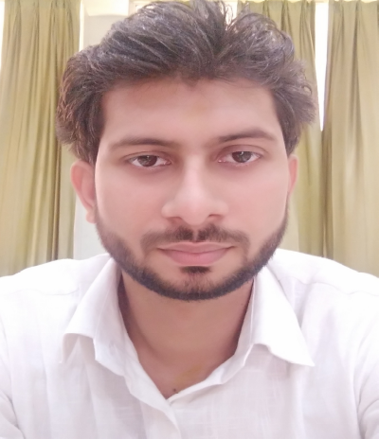
Image
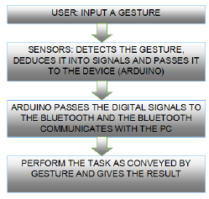

Figure1. Flow chart of the proposed Method
Recent Publications
- Singh, G., Kumar, R., & Sharm, M. K. (2013). Comparative analysis of conventional CMOS and energy efficient adiabatic logic circuits. International Journal of emerging Technology and advanced engineering, 3(9), 260-264..

Biography
Manoj Kumar Sharma has received degree of Bachelor of Technology from UPTU, Lucknow in June 2009 in the Electronics and Communication Engineering. He has started his academic career as a lecturer in the department of faculty of Electronics, Informatics & Computer Science Engineering in Shobhit University, Meerut from 2009 to 2012. His quest for Knowledge and keen interest in learning advance technologies. He pursue his passion and awarded M.Tech in 2012 form Shobhit University, Meerut in (VLSI Engineering). After completion of the Masters he has been apointed as Assitant Professor in the department of faculty of Electronics, Informatics & Computer Science Engineering in Shobhit University, Meerut. In 2015 again he has started a journey as a researcher in the field of neuro sciences and try to integrate it with the communication Engineering to give some noble solution for the predict neuro deasises in advance and providing better treatment.
Email: vmanojsharma@gmail.com
Notes/Comments:

