Sterilization of the Operating Theater Using Two UGV & One UAV

Mohamed Mahmood Alseddiqi, alseddiqi25@hotmail.com
Mohamed Abdulla Almahmood, mohamedalmahmood11@gmail.com

Abstract— There have been many cases in hospitals were the disinfection team get infected after sterilizing and disinfecting an infected area. The current practice takes a very long time to implement, it is very risky and needs many employees specially in operating theatre rooms were cases are ongoing between each case, the rooms should be disinfected[1]. To provide a solution for this problem, this paper simulates three robots that will assist in the disinfection process in hospitals. The first robot is a UAV which is responsible for mapping the environment, it also includes a feature called OpenCV which is responsible detecting the blood on the floor. The robot moves autonomously and sends the map to the second robot. The second robot is a UGV that is responsible to wipe the floor. It will receive the map from the UAV and move autonomously inside the chosen room, it will wipe the areas that are covered with blood. When the wiping is done, the third robot will step up after receiving the map from the UAV and enter the room. This robot is equipped with ultraviolet lights. It will pass through the whole room with the UV on in able to disinfect. It has been proven scientifically that ultraviolet light type C are very effective for disinfection[2][3]. When the third robot finish the disinfection process it will exit the room and go back to its origin. The whole idea is tested simultaneously in GAZEBO simulator in Robotics Operating System (ROS). The three robots worked perfectly together in the simulation program, implementing it in real life will help ease up the disinfecting process in the health industry.
.
Keywords—UAV,UGV,ROS,UV

Introduction
Healthcare industry is one of the biggest as well as one of the vital sectors globally[4]. Working in Hospital expose the workers to many types of infections such as COVID-19, bacterial infections, viral infections and fungus infections. After each operation in the operation theatre room, the room needs to be disinfected and sterilized in able to use it for different patients. Many other rooms in wards, ICU and Long Term Units require disinfection as well. The infection control department is responsible for those jobs, precautions must be taken seriously in this job. A gown, gloves, masks and many other accessories should be worn by the employees in able to prevent infection[5][6]. The whole process takes a very long time, there are many steps to be implemented from wearing the suitable uniform to disinfecting using the traditional ways. Another setback to the current process is exposing the employees to the high risk of getting infected.
The technique that is currently used to disinfect is to spray or use wet towels to clean the infectious facility. There is an infection control department in every hospital that works to prevent these germs from spreading in the hospital. These employees are exposing themselves to danger.
The role of the infection control department is very important and too risky for those staff to ensure a high level of hygiene in all the hospital facilities, the demand for cleaning and disinfecting has increased during the corona pandemic[5]. Those reasons inspired the idea of building a UV disinfectant Robot. A robot that is capable to work in a swarm of robots, disinfect the facility efficiently and ease up the whole process. The idea also reduces the time consumption. It plays an important role in the cost since the number of employees will be reduced if the idea is implemented in the field.
The presence of robots in the healthcare industry has increased rapidly in the recent years[7]. Specially in cases that expose humans to big risks. The time is ripe with all the data available globally and the researches that smooth up the process of implementing those kind of robots[8].
Many of the current applications used for disinfection robots are manual [9]. The robots implemented in this research works simultaneously together and autonomously. Each robot is responsible for a specific job and it will implement it in the right time. Even though autonomous robots have relatively a high cost. Turtlebot 3 includes all the needed features and the price is acceptable. The first robot is a UAV. The type used is Hector Quadrotor drone. This drone is responsible of 2 main functions. The first function is to map the environment, RVIZ software is used for mapping. The second function of the drone is to detect the blood on the floor using OpenCV and computer vision. The second robot is a turtlebot 3. It receives the mapping from the UAV and enters the room to wipe any blood detected. The third robot also uses turtlebot3, its responsible for the whole disinfection process using Ultraviolet lights type C. the lights will cover the whole room in ale to make sure that every spot is disinfected.
UltraViolet Light C (UVC) have the shortest wavelength among the three types of UltraViolet (UV) lights, it have (100-280nm) wavelength. UVC lights have been used for a long time to disinfect the wastewater and dirty surfaces form different types of pathogens, most of the bacteria and viruses are responding to UV at different ranges. UVC is an Ionizing Radiation which have the capability to destroy the proteins in Deoxyribonucleic Acid (DNA) in most of the living organisms.The UVC light show it is reliability to kill several pathogens like Corona virus. It has been proven for its effectivity to work as a disinfectant in many studies [10][11].

BACKGROUND

The operating system used for the three robot project is Robotics Operating System (ROS). The benefit of this operating system is that it is an open source system. It provides hardware abstraction, message passing between processes, package management and low-level device control. A large community for the robotics industry uses ROS which also helps in finding all kind of environments, packages and many more advantages. It includes many available codes for many applications. For simulation, it has a friendly software called Gazebo which was used for the project [12].
in the first UGV robot, which is used for wiping the floor. TurtleBot3 Burger was used. This is a new generation mobile robot that can be customized accordingly to the needs of the project. It includes Raspberry Pi 3. The robot can run through Ubuntu and ROS [13].
In the second UGV robot, which is used to disinfect the environment using the UVC lights. TurtleBot3 Burger was used. This robot can carry a high payload and can accept additional sensors. It is also a new generation mobile robot and used in ROS and Ubuntu[13].
Simultaneous Localization And Mapping (SLAM) is a method used in robotics to map a specific environment. Based on the map created, the SLAM is able to localize the robot at any point. This Algorithm allows the robot to map any environment. Based on the data created by this algorithm the engineers use these data to develop several robotics applications such as path planning and obstacles avoidance [14].
In the indoor environment, it is not efficient to rely on Global Positioning System (GPS) because it works for outdoor applications. Thus, SLAM algorithms map the areas and discover the unknown environment using laser rangefinder. It uses a 2D laser scanner to map any indoor environment [15].
Gmapping is a ROS package installed in the project in able to provide the laser-based SLAM. Gmapping is a ROS node which is called slam_gmapping in ROS. The node provides a 2D map, It gives position using a laser scanner [16].
The visualization tool that was used in the project is called Rviz, it is implemented in ROS. This tool gives a view of the robot model, it can capture the information collected by different sensors. It has the ability to display images and videos from the camera of the robot and thus creating a 3D or 2D map [17].
To simulate the hospital environment, Amazon Web Services (AWS) developed an environment in Gazebo that can view the hospital in different positions. Its published as open source, this helps the roboticist to develop and simulate different scenarios in different locations within the hospital. In the chosen environment, there were different rooms with nursing work stations and patient beds making it look like a real hospital [18].

SYSTEM ARCHITECTURE
Scenario
The project uses one UAV and Two UGVs . In the operation theater, when the operation is done. The operator runs the start command. It runs the roscore and launch the gazebo with all three robots.
In the first step, the UAV enters the theater room and then uses the SLAM to map the room and then it exits the room.
In the second phase, the first UGV with the vacuum cleaner enters the room and wipes the blood on the floor after getting the locations from the UAV.
In the last phase, the second UGV with the UV Radiator enters the room and walk around the room causing the UVC lights to kill the infections. It then returns to its origin along with the other 2 robots leaving the room disinfected and ready to use.
Architecture
The figure1 below shows the system architecture.
Use Cases
The table1 in the next page states the use case, actor, description and stimulus.

EXPERIMENTAL SETUP AND RESULTS
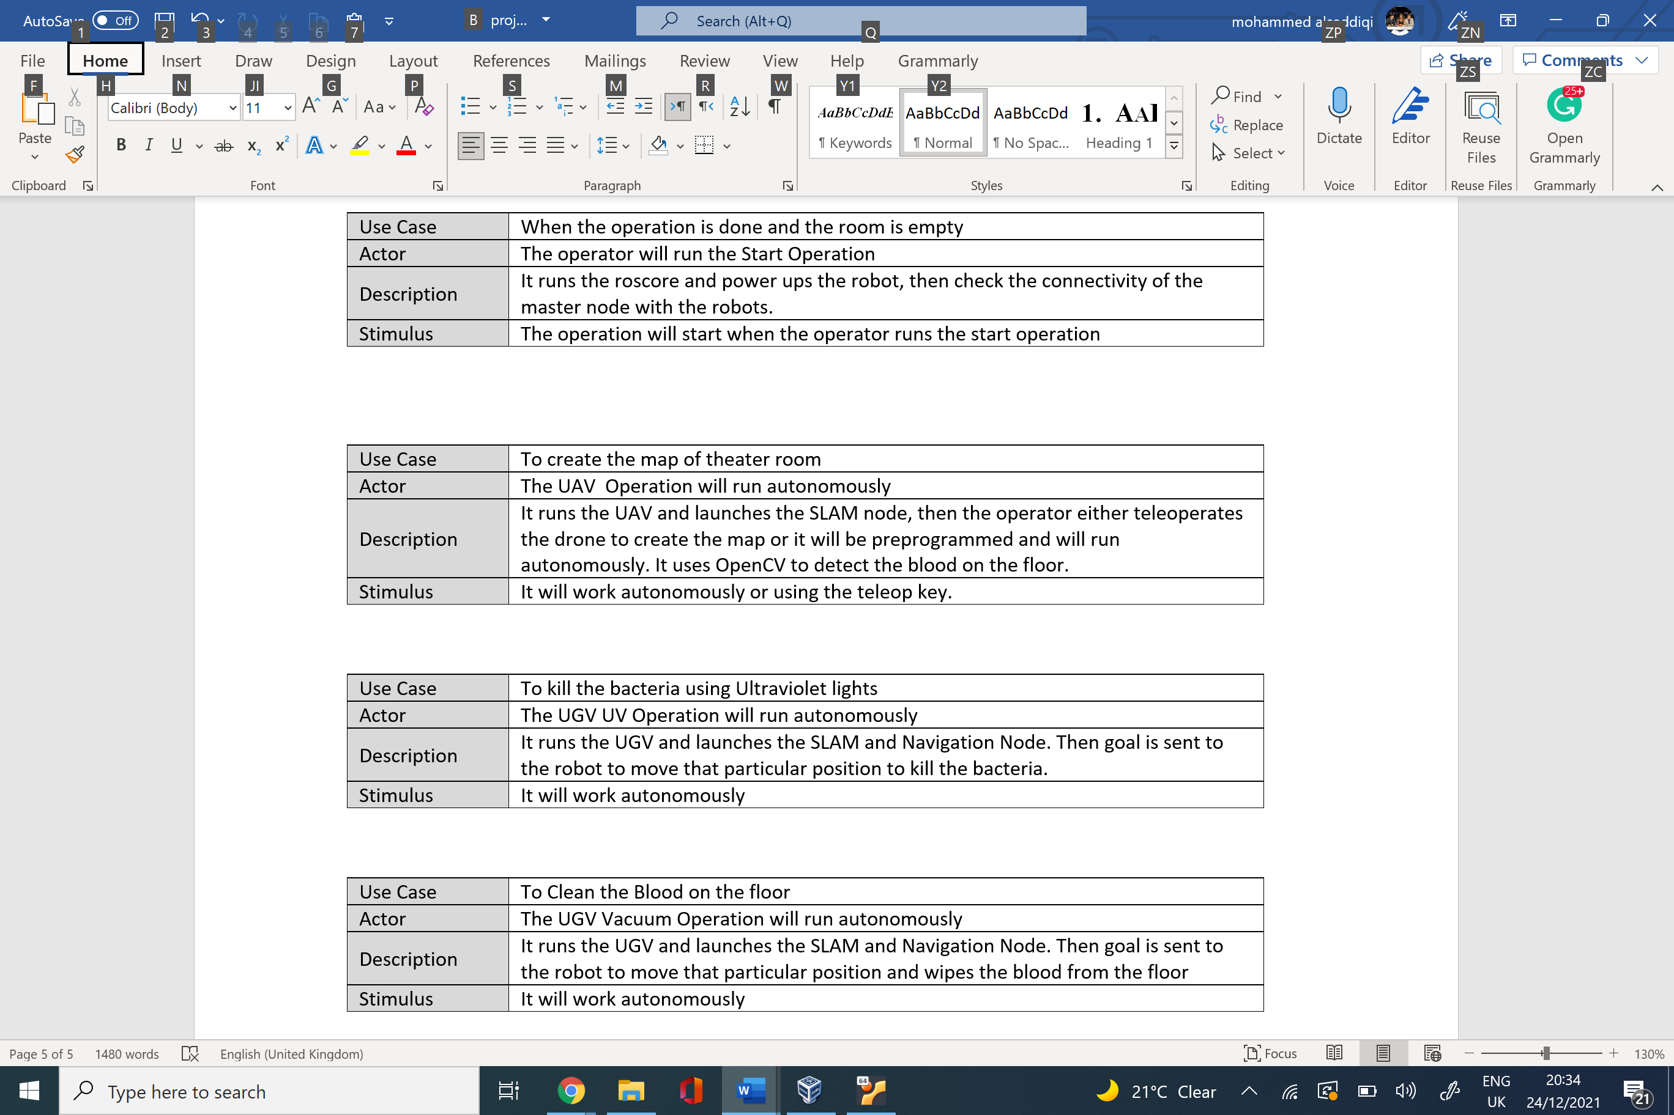
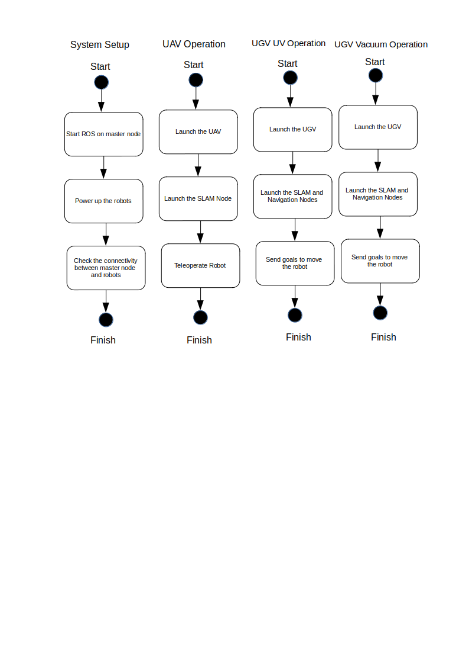
The three robot project was implemented in the Gazebo simulator as shown in figure 2. The first step involved mapping and blood detection by the UAV. This job was done successfully by the UAV. It entered the room, mapped the environment according to the positions set earlier, detected the blood and finally exited the room and sent the information of the mapping to both UGV’s. the below figure shows the map created by the UAV. The UAV sent the blood detection part to one of the UGV’s which is responsible for wiping the blood. In the next step, the first UGV entered the room according to the map created by the UAV. It moved around the room and detected the blood on the floor. When it is done it returned to its original position and the second UGV enters the room and reached its goal. It then exits and all robots are back to their original parking area.
Table 1 Use Cases
Figure 1 System Architecture

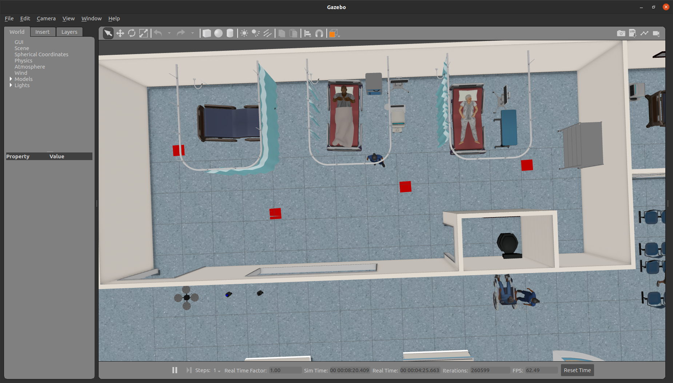
Figure 2 Three Robots in the Initial Position
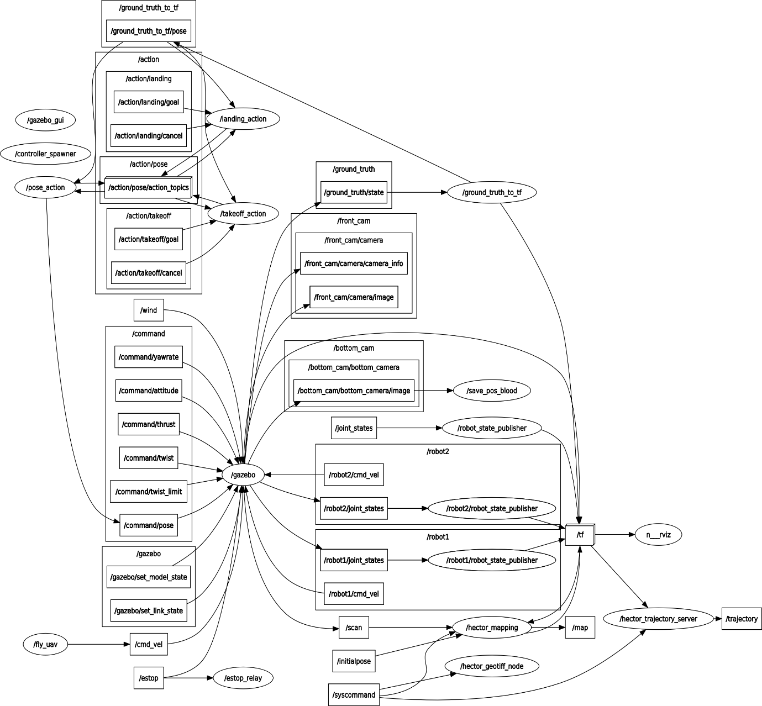
The below figures show the RQT graph for the whole project. The figure 3 is initiated through the gazebo simulator by using the RQT graph code. The second graph is initiated through the navigation launch.
Figure 3 RQT Graph for Gazebo
Both diagrams show the nodes and all topics whether they are published or subscribed. The first diagram, which was created for the gazebo simulator, includes the nodes that are already available within the gazebo. Additional two nodes have been added for this process that were not available originally. The first node is save_pose_blood, this node is responsible to determine the location of the blood for the UAV. The positions are then viewed exactly using the rosparam command. Using a python code, the node was defined and responsible to convert the image from RGB format to BGR format in able to allow the OpenCV to read it. The second node that was added is fly_uav. This node is used to publish cmd_vel command which is used to fly the drone. The python code that was responsible to define this node was also responsible to specify the exact positions of the UAV. Both nodes use publish subscribe method since they have only specific tasks and not multiple tasks together. The pose_action node and takeoff_action node both used action The The UAV sent the blood detection part to one of the server as a way to communicate. Both have multiple tasks and if publish subscribe were to be used, it would have been complicated.
In the second diagram figure 4, the amcl node is subscribed to the first UGV robot, scan, tf (transformation) and intialpose. It also publishes topic to tf and particlecloud. This node acts as a publisher and subscriber in the same time. This node is used to localize the robot in the map. When the robot moves around the amcl it uses the scan and odometry data topredit the position of the robot in the map.
The move_base node uses the action server to communicate and as shown in the diagram, it has many publishing and subscribers.
Challenges
The challenges faced during the project:
Figure 4 RQT Graph for Navigation
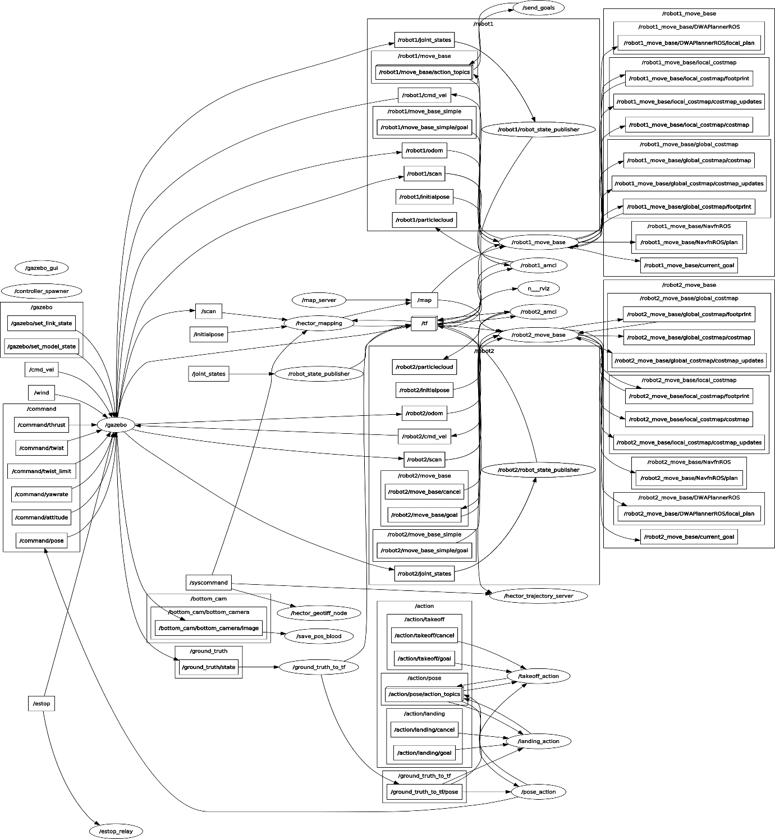
Simulating multiple robots in the ROS: - the first challenge was to simulate one UAV and two UGV’s simultaneously in ROS. For the two UGV’s, TurtleBot3 was used. The problem was that both had the same name so it was impossible to use them both in the same time,to solve these issues, namespace command is used to differentiate between the two robots. The namespace provides a solution to run the same nodes under different name. it is possible after using this command to have two nodes of robot_state_publisher under two namespaces: /robot1/robot_state_publisher and /robot2/robot_state_publisher.By using the namespace and following some resources from the turtlebot3 github repository, the launch file was created which is responsible to runs two UGVs on different namespaces.
Another challenged faced was that the Robot kept on rotating when reaching the Goal: - Sometimes, the robot keeps rotating in its position to meet the goal tolerance values and complete the action. To solve this issue, goal tolerance values were increased as well as the forward_point_distance.
Adding the blood samples on the floor of the operation theatre as per figure 5 shows, was among the challenges that took some time. To simulate that there are blood drops on the floor of the hospital, the gazebo cube objects were used and scaled the cube to the thin rectangle. It was then realized that the color could change through the python code. The grey color was replaced with red to simulate blood.
The thickness of the blood objects. The objects that were created to simulate the blood on the floor have some thickness, this causes the turtlebot to get stuck with it sometimes. It was difficult to find a solution to this problem because when the size is further reduced, the object will not appear in the environment.
Automatic control of the drone: To automatically control the UAV, a node was created which is able to publish to the /cmd_vel topic. This helps in flying the robot and creating some function to move it in the operation theatre room. This in able the UAV to map the environment and detect the blood.
Simulating the UV Sensor in figure 6: To simulate the UV sensor, the cylinder on top of the turtlebot with the blue colour was used from the gazebo simulator.
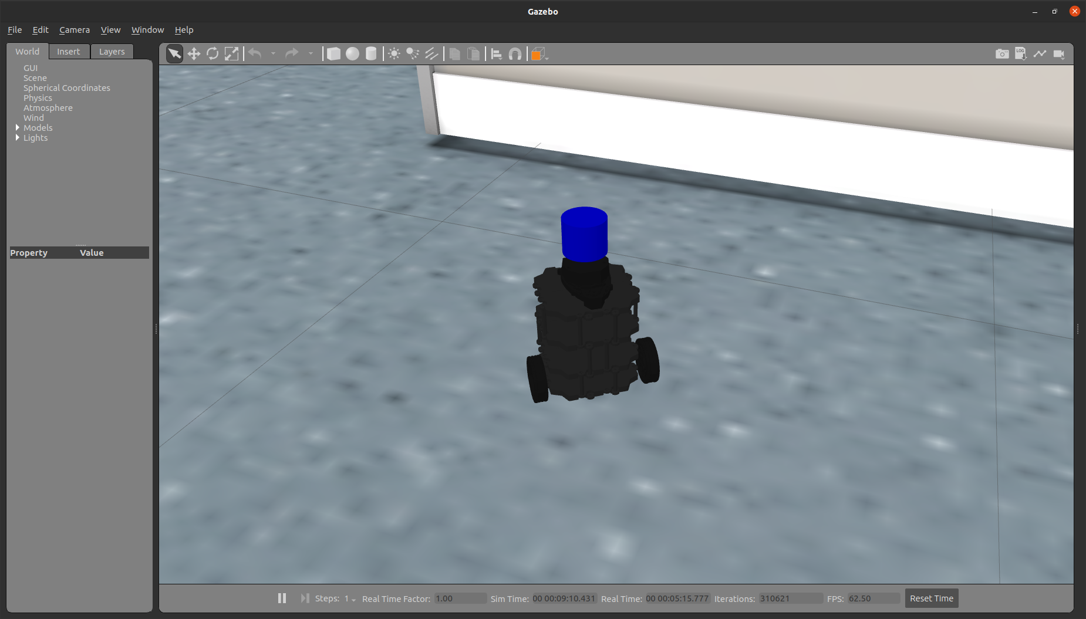
Figure 6 Simulation UV Sensor
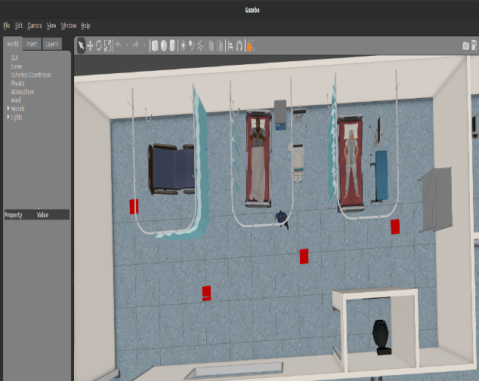

CONCLUSION
The recent methods for disinfection are very risky for human beings since they might get infected if the precautions are not followed smoothly. In hospitals, it takes a lot of time to disinfect the areas needed which makes it difficult to utilize rooms immediately specially when needed. The project chosen for this report showed a significant output for applying this idea in real life in the health industry. The UAV was able to map the environment and detect blood on the floor, this data is sent to the first UGV which is responsible to go to the blood positions and wipe it. In simulation, the blood was not wiped even though the UGV could reach to each position of the blood. The second UGV received the map and had a simulator for the UV light, it passed through the whole room using the map from the UAV. If this project is implemented in real life, approximately all aspects are ready, the only thing that needs to be added is the UVC light along with a wiping technique that is able to wipe the blood. Implementing this idea in real life and start using it in each hospital will reduce the risk of the staff getting infected, will consume less time and the cost will be much less sine the robots can reduce the number of employees in the infection control team. For future work, better robots should be used since hospitals require robots that are medical grade. Using a UAV in the hospital might be dangerous so applying the jobs of UAV to the UGV might be better even though it is challenging.

REFERENCES:
[1] Ge, Tianxiang, et al. "Evaluation of disinfection procedures in a designated hospital for COVID-19." American journal of infection control 49.4 (2021): 447-451.‏
[2] Mackenzie, Dana. "Ultraviolet light fights new virus." Engineering (Beijing, China) 6.8 (2020): 851.‏
[3] Buonanno, Manuela, et al. "Far-UVC light (222 nm) efficiently and safely inactivates airborne human coronaviruses." Scientific Reports 10.1 (2020): 1-8.‏
[4] Saheb, Tahereh, and Leila Izadi. "Paradigm of IoT big data analytics in the healthcare industry: A review of scientific literature and mapping of research trends." Telematics and Informatics 41 (2019): 70-85.‏
[5] Yen, Muh-Yong, et al. "Quantitative evaluation of infection control models in the prevention of nosocomial transmission of SARS virus to healthcare workers: implication to nosocomial viral infection control for healthcare workers." Scandinavian journal of infectious diseases 42.6-7 (2010): 510-515.‏
[6] Leclair, Jeanne M., et al. "Prevention of nosocomial respiratory syncytial virus infections through compliance with glove and gown isolation precautions." New England Journal of Medicine 317.6 (1987): 329-334.‏
[7]Iroju, Olaronke, Oluwaseun A. Ojerinde, and Rhoda Ikono. "State of the art: a study of human-robot interaction in healthcare." (2017).‏
[8] Group, Blue Ocean Robotics. “UVD - Case Studies.” UVD Robots, http://uvd.blue-ocean-robotics.com/cases.
[9] “UVHammer: Operator-Driven Mobile UV Disinfection.” Dimer, 3 June 2021, https://www.dimeruv.com/uvhammer/.
[10] Center for Devices and Radiological Health. “UV Lights and Lamps: Ultraviolet-C Radiation, Disinfection, and Corona.” U.S. Food and Drug Administration, FDA, https://www.fda.gov/medical-devices/coronavirus-covid-19-and-medical-devices/uv-lights-and-lamps-ultraviolet-c-radiation-disinfection-and-coronavirus.
[11] Rastogi, Rajesh P., et al. "Molecular mechanisms of ultraviolet radiation-induced DNA damage and repair." Journal of nucleic acids 2010 (2010).‏
[12] “Wiki.” Ros.org, http://wiki.ros.org/ROS/Introduction.
[13] Name, Your. “Robotis e.” Manual, https://emanual.robotis.com/docs/en/platform/turtlebot3/overview/.
[14] Durrant-Whyte, Hugh, and Tim Bailey. "Simultaneous localization and mapping: part I." IEEE robotics & automation magazine 13.2 (2006): 99-110.‏
[15] Krinkin, Kirill, et al. "Evaluation of modern laser based indoor slam algorithms." 2018 22nd Conference of Open Innovations Association (FRUCT). IEEE, 2018.‏
[16] “Wiki.” Ros.org, http://wiki.ros.org/gmapping.
[17] Rviz - AWS Robomaker - Docs.aws.amazon.com. https://docs.aws.amazon.com/robomaker/latest/dg/simulation-tools-rviz.html.
[18] Aws-Robotics. “AWS-Robotics/AWS-Robomaker-Hospital-World: This Gazebo World Is Well Suited for Organizations Who Are Building and Testing Robot Applications in Hospitals.” GitHub, https://github.com/aws-robotics/aws-robomaker-hospital-world.

