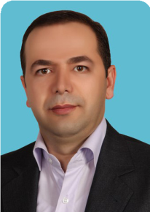

Aziz Homayouni Rad1, Samira Hosseini2 and Masoud Moghadaszadeh3
1Department of Food Science and Technology, Tabriz University of Medical Science, Iran 2Department of Food Hygiene and Safety, Tabriz University of Medical Science, Iran 3Department of Biotechnology, Tabriz University of Medical Sciences, Iran

Postbiotics as dynamic biological molecules and their antimicrobial activity: A review

Abstract
S
ince postbiotics have as of late been found and investigate
has not developed, get to probiotics isn’t easy. If you’re seeking out for postbiotic supplements, select items that incorporate distinctive sorts of postbiotic, particularly short- chain greasy acids. As an alternative, adding some nutrients to your diet can increase the production of postbiotics in the body more naturally. Some of the best sources to help you with this include fermented spirulina, chlorella, aloe vera, apple vinegar and coconut vinegar. As mentioned earlier, the human gut is home to millions of bacteria, known as the microbiome or microbiota. Prebiotics, probiotics, and postbiotics all help maintain the microbiome balanc. Probiotics are non- digestible carbohydrates by the human body. Their objective is to supply probiotic vitality through its part as a nourishment source. Probiotics are great microscopic organisms that offer assistance keep up stomach related wellbeing by controlling the development of destructive microscopic organisms and bolster prebiotics amid a fermentation process, which could be a byproduct of postbiotics. In an unused ponder, analysts at McMaster College found that postbiotics may offer assistance anticipate total diabetes in individuals with pre-diabetes. When microscopic organisms are incidentally out of balance, it is conceivable to make affront resistance or pre-diabetes within the person. This awkwardness of intestinal microscopic organisms is common among hefty individuals. The analysts found that a particular postbiotic called Muramyl Di Peptide (MDP) was able to diminish affront resistance notwithstanding of conditions such as weight misfortune or changes within the intestine microbiome amid corpulence. Schertzer accepts that postbiotics can make a modern course in diabetes inquire about. Researchers moreover need to ponder the impact of postbiotics on lessening irritation and in this way decreasing the hazard of sort-2 diabetes. We know that intestine microscopic organisms, frequently called microbiomes, send provocative signals that influence how affront works to lower blood sugar. Karim et al. inspected Effects from distinctive composition of postbiotics and inulin RG14 upon development execution, cecal smaller scale biota, unstable greasy volatile fatty acids and perfect cytokine explanation at Broilers. The discoveries of inquire about appear that the expression of Interleukin 8 (IL8 or chemokine (C-X-C
motif)) quality was not affected with slim down. Postbiotics and inulin composition are potential substitutions to anti-microbial development boosters within Aviculture industry. Konstantinos et al. summarized a part from postbiotics at keeping up colonics wellbeing then offered that postbiotics can stand a more secure elective at analogy to live microbes those assist recommended plausibility from postbiotics at making It affects the quality of life of patients within afterward organize in rectal cancer, whereas Tsilengiri et al.

Biography

Aziz Homayouni Rad has received his PhD in Food Science and Technology Engineering at Tehran University during 2003- 2007. Currently, he is working as Associate Professor in Tabriz University of Medical Sciences. He has successfully completed his administrative responsibilities as Vice Chancellor of Education in the Nutrition Faculty. His research has included functional food with emphasis on probiotic, prebiotic and synbiotic dairy foods. Based on this research and fellowship training, he has received several awards and honors, such as “Top Researcher in Nutrition Faculty of Tabriz University of Medical Sciences at 2013” and “Journal of Dairy Science Most-cited Award in Dairy Foods in 2014”. He is serving as an Editorial Board Member of several reputed journals like Journal of Food Research and expert Reviewers for journals like “Food Chemistry” and “Nutrition”. He has authored more than 80 research articles and more than 8 books. He is a member of Iranian Probiotic Association.

*Address for Correspondence: Aziz Homayouni Rad, Department of Food Science and Technology, Tabriz University of Medical Science, Tabriz, Iran, Tel: +989185754875; E-mail: Homayounia@ tbzmed.ac.ir
Copyright: © 2022 Aziz H. R, et al. This is an open-access article distributed under the terms of the Creative Commons Attribution License, which permits unrestricted use, distribution, and reproduction in any medium, provided the original author and source are credited.

Importance of Research
Intestinal coccidian parasites cause disease predominantly in immunodeficient patients, quite a few of them are reported in immunocompetent patients. These can be acquired easily and are difficult to treat. There are battery of tests ranging from microscopy to molecular methods available for detecting these protozoa. But many of these are cumbersome, time consuming thus posing a diagnostic challenge. Therefore, there is need for highly sensitive rapid techniques which aid in early diagnosis and accurate treatment. Though more sensitive methods like antigen detection, nucleic acid amplification assays are available but as they are expensive most of the laboratories still rely on microscopic examination. Kinyoun’s acid fast stain is used in detection and differentiation of coccidian parasites based on their size and morphology. Auramine stain is a fluorescent dye used in mycobacteriology in detection of acid- fast microorganisms and has replaced Kinyoun’s acid fast stain because of the ease and sensitivity of interpretation. In India every RNTCP lab is provided with a LED microscope which can be utilised for screening of coccidian parasites without allocation of additional budget. By both techniques, Cryptosporidium spp (3%) and Cystoisospora spp (3%) were the coccidian parasites detected. Similar results were obtained by Abou El-Naga and colleagues, 1998, and Hanscheid and colleagues, 2008. This fluorescent stain could easily differentiate the artifacts from the coccidial parasites, thus yielding better results than Kinyoun’s acid-fast stain. The advantage of the auramine over Kinyoun’s acid-fast stain was reported by Abou El-Naga and colleagues in 1998, and by Hanscheid and colleagues in 2008. The ease of interpretation varied with 2 methods.

About University

The University consists of eleven faculties: Medicine, Pharmacy, Dentistry, Paramedical Sciences, Health, Nutrition and Food Sciences, Rehabilitation, Nursing & Midwifery, Health management and medical informatics, Advanced Medical Sciences and Traditional Medicine. The school offers professional degrees in Medicine (M.D.), Dentistry (D.D.S.), Pharmacy (Pharm.D.); Bachelor’s, Master’s, and Doctor of Philosophy (Ph.D.) in various other medically related subjects. The school also offers technical courses in pursuit of associate degrees and certification in medically related fields. In addition, TUMS operates over 10 teaching hospitals and is a major medical care provider in East Azarbaijan Province and the surrounding provinces.
References
- Bindels, Laure, Nathalie Delzenne, Patrice Cani, and Jens Walter. “Towards a More Comprehensive Concept for Prebiotics.” Nature Rev Gastroenterol Hepatol 12 (2015): 303-310.
- Kumar, Manoj, Ravinder Nagpal, Vinod Verma and Ashok Kumar, et al. “Probiotic Metabolites as Epigenetic Targets in the Prevention of Colon Cancer.” Nutrition Rev 71 (2013): 23-34.
- Kareem, Karwan Yassen, Hooi Ling Foo, Teck Chwen Loh, and Ooi May Foong, et al. “Inhibitory Activity of Postbiotic Produced by Strains of Lactobacillus plantarum using Reconstituted Media Supplemented with Inulin.” Gut Pathogens 6 (2014): 1-7.
- Howarth, Gordon, and Hanru Wang. “Role of Endogenous Microbiota, Probiotics and Their Biological Products in Human Health.” Nutrients 5 (2013): 58-81.
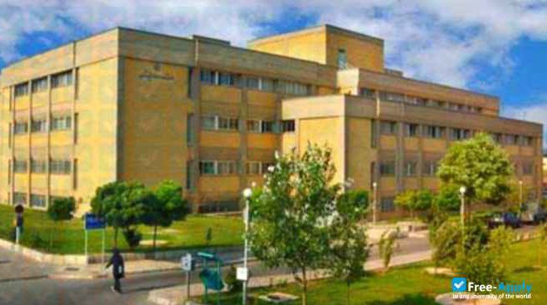
- Alloui, Mohamed Nabil, Witold Szczurek, and Sylwester Swiatkiewicz. “The Usefulness of Prebiotics and Probiotics in Modern Poultry Nutrition: A Review.” Ann Animal Sci 13 (2013): 17.

Tabriz University of Medical Sciences (TUOMS) is public medical sciences university located in Tabriz, East Azarbaijan Province, Iran. It is ranked as one of Iran’s top medical schools, with more than 5000 students.
- Kareem, Karwan Yassen, Tech Chwen Loh, Hooi Ling Foo and Asmara, et al. “Influence of Postbiotic RG14 and Inulin Combination on Cecal Microbiota, Organic Acid Concentration, and Cytokine Expression in Broiler Chickens.” Poultry Sci 96 (2017): 966-975.
- Konstantinov, Sergey, Ernst Kuipers, and Maikel Peppelenbosch. “Functional Genomic Analysis of the Gut Microbiota for CRC Screening.” Nature Rev Gastroenterol Hepatol 10 (2013): 741-745.
- Chuah, Li-Oon, Hooi Ling Foo, Teck Chwen Loh, and Noorjahan Banu Mohammed Alitheen, et al. “Postbiotic Metabolites Produced by Lactobacillus plantarum Strains Exert Selective Cytotoxicity Effects on Cancer Cells.” BMC Complement Alt Med 19 (2019): 1-12.

NOTE: This is a sample proceedings abstract template. The content will be changed while publishing respective abstract in supporting journal website.

