Fabrication of antireflection and anti-soiling coatings for desert based solar panels

Written By: Nujood Saeed Ali AlShehhi, Masters Student in Materials Science and Engineering
Adviser: Dr. Khalid Askar

Abstract

This research paper focuses on the fabrication of antireflection and anti-soiling polymer composite by means of spray coating, which can be applied for solar panels. Due to the frequent sandstorms within the region dust accumulates on the panels reducing their efficiency in the absorption of solar radiation, and because of scarcity of water sources in the Middle East in general the frequent cleaning consumes a lot of money and water. The objective is to fabricate and develop a coating for solar panels with anti-soiling and anti-reflection characteristics. The composite material chosen is the mineral material halloysite nanotube (HNTs). HNTs are chemically non-toxic and can be found in large amounts at low prices. The proposed method involves spray coating a polymer composite followed by plasma etching the surface to generate the necessary roughness. The first step is to etch the surface by exposing the samples to varying types of plasma with certain condition, varying time and concentration to obtain a rough surface, and to make the etched surface suitable for the air refractive index. The second step is functionalization of the etched surface by CF₄ plasma surface treatment. The Scanning Electron Microscope image shows how the different types of etching can affect the surface roughness, how HNTs are exposed to enhance the light transmission and to reduce/increase the wettability between the surface and the contact angle to achieve anti-reflection and self-cleaning properties. Optical and surface properties are further studied using spectroscopy and goniometer testing. From the results the optimum HNT concentration is 20 wt.% and the optimum etching conditions are etching with CF₄ gas at 2 Pa and high power for 10 minutes. Finally, the spray coating can be developed with multi-characterization, long stability and low-cost coating that can easily be scaled up and applied onto current solar cells.

Image

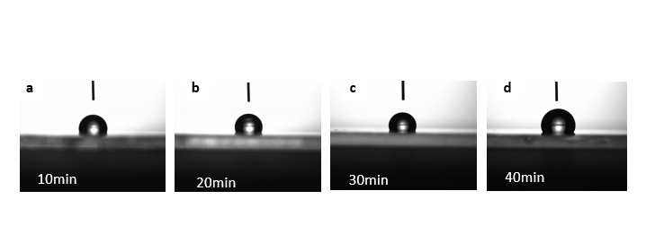

Figure 1 4-5EH% Step 2 Etching

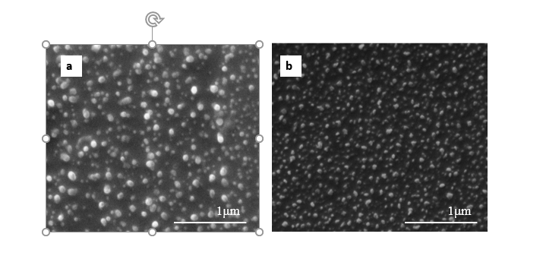

Figure 2 CF4-5EH%

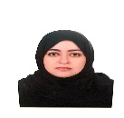Biography
I’m a current graduate student in Khalifa University (Masdar Institute branch) working on my Master’s degree in Materials Science and Engineering. The focus of my research is developing a polymer coating material with anti-reflective and anti-soiling properties as part of the project of a super coating. During my studies, I have taken training in working in clean room labs, testing using electron microscope, chemical analysis, and solar characterization, therefore I have basic technical expertise. I have 12-year work experience as a Physics teacher therefore I have a lot of knowledge of dealing with people of different personalities. I have leadership qualities and am a creative person who likes to think outside the box
Email: nalshehhi@masdar.ac.ae
Contact number: 00971501277191

Notes/Comments:

