Physicochemical properties of Ti-based MXenes obtained from SHS synthesized MAX phases and their application for energy storage
Sergii A. Sergiienko, PhD, National University of Science and Technology MISiS, Russia.
Vladislav A. Kolotygin, PhD, Institute of Solid State Physics RAS, Russia.
Nataliya D. Shcherban, PhD, L.V. Pisarzhevsky Institute of Physical Chemistry, Ukraine.

Abstract (300 word limit)
MXenes attract attention as electrodes for energy storage applications e.g. for supercapacitors. The problem is that the methods of MXenes preparation described in the literature are often multi-stage and complicated. So the purpose of our work is the development of more simple and technologically acceptable method of MXenes preparation. In the literature the synthesis of MAX phases (precursors for MXenes synthesis) has been realized by different methods. We used one stage self-propagating high-temperature synthesis (SHS) that seems most suitable due to 1) simplicity 2) short reaction time 2) cost-effective 3) little demand on external energy. Commercially available Ti, Al and carbon black powders were used. Several phases (mainly Ti₃AlC₂, Ti₂AlC, TiC) were among the products after SHS. Obtained products are crushed in a roll crusher and then automatic agate mortar. For Al etching from the MAX phase a dilute solution of HF was used. Then delamination of MXenes in N,N-dimethylformamide and isopropanol mixture with sonication were lasted during 3 days. The content of unreacted MAX phase particles in MXene powder can be reduced by using hydrocyclone assembly and alcohol medium instead of water. Suspension stability of MAX phase particles decreases rapidly while suspension of MXene particles is fairly stable. Also alcohol medium can protect Ti₃C₂T_{x} Mxene from oxidation. Since both layered Ti₃C₂T_{x} and Ti₂CT_{x} obtained can be used as electrodes for supercapacitors SHS method is suitable for Ti_{x+1}AlC_{x} phases preparation. In 1M solution of Na₂SO₄ obtained electrodes demonstrated gravimetric capacitance up to 220 Fg^{–1} at charge-discharge rates 2mVs^{–1}.

Image

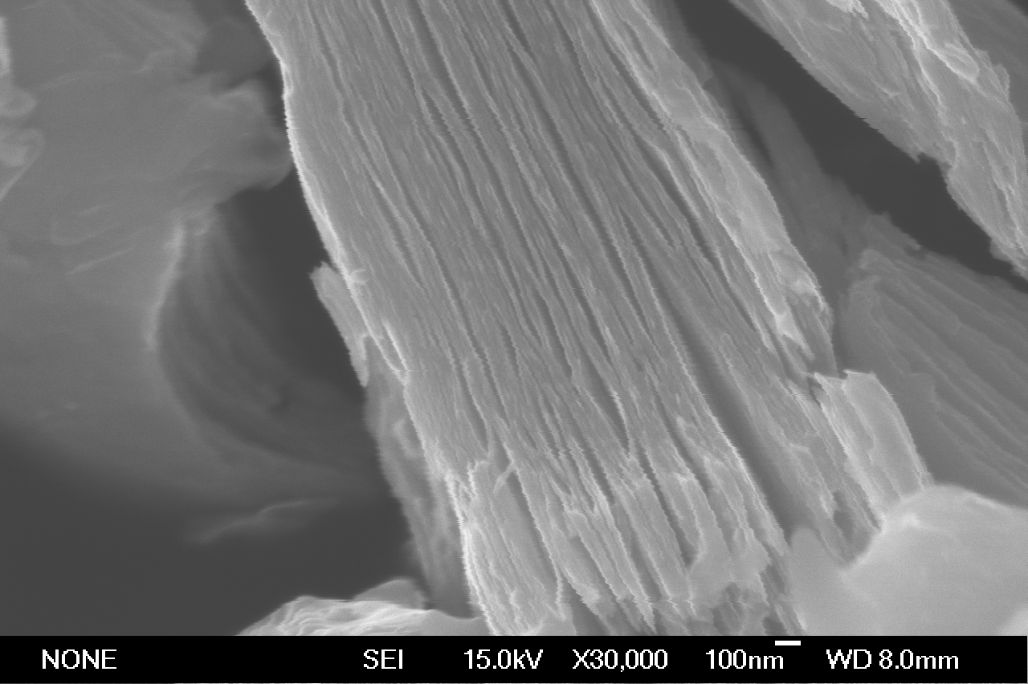
Figure 1: SEM images of Ti₃C₂ MXene
Recent Publications (minimum 5)

- S. A. Sergiienko, V. A. Kolotygin, N. D. Shcherban, S. M. Filonenko, D. O. Moskovskikh, A. A. Nepapushev, D. I. Arkhipov, O. B. Tursunov. Structure and transport properties of the spark plasma sintered barium cerate based proton conductor // Ceramics International.Vol. 43, Issue 17, 2017, Pages 14905–14914.

- N. D. Shcherban, S. M. Filonenko, S. A. Sergiienko, P. S. Yaremov, M. A. Skoryk, V. G. Ilyin, D. Yu. Murzin, Morphological features of porous silicon carbide obtained via a carbothermal method // International Journal of Applied Ceramic Technology 2018.

- N. D. Shcherban, S. M. Filonenko, R. Yu. Barakov, S. A. Sergiienko, Kai Yu, Ivo Heinmaa, A. Ivaska, D. Yu. Murzin, New insights in evaluation of acid sites in micro-mesoporous zeolitelike materials using potentiometric titration method // Applied Catalysis A: General. Vol. 543, 2017, 34–42.

- N. D. Shcherban, S. M. Filonenko, P. S. Yaremov, S. A. Sergiienko, V. G. Ilyin, D. Yu. Murzin. Carbothermal synthesis of porous silicon carbide using mesoporous silicas // J. of Materials Science. April 2017, Volume 52, Issue 7, pp 3917–3926.

- S. Sergiienko, K. Moor, K. Gudun, Z. Elemessova and R. Bukasov Nanoparticle-nanoparticle vs nanoparticle-substrate hot spot contributions to SERS signal: studying Raman labelled monomers, dimers and trimers, Phys. Chem. Chem. Phys., 2017, 19, 4478–4487.

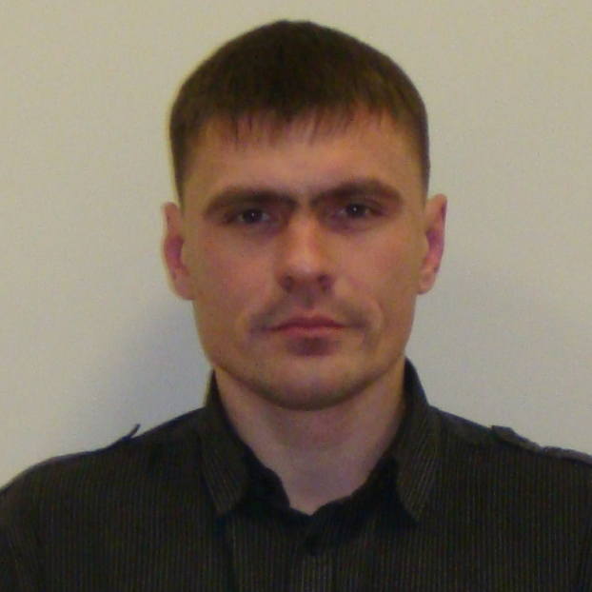 Biography (150 word limit)
Sergii A. Sergiienko has ten years of working research experience at L.V. Pisarzhevskii Institute of Physical Chemistry of the National Academy of Sciences of Ukraine. Research projects mainly devoted to synthesis and investigation of functional properties of ordered porous materials. Published 14 international research papers. Current research project: “Synthesis and Characterization of Novel Nano-Hetero-Structured MXene-based materials for electrochemical energy storage” at National University of Science and Technology «MISiS».
E mail: s.sergienko@misis.ru, sergeenko_sergei@ukr.net
Contact number: +79850898427

Notes/Comments:

