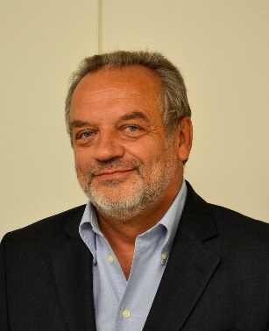



Title: New Materials and Technologies for Energy
Name: Igor Kosacki

Honeywell Process Solutions, 11201 Greens Crossing Blvd, Houston, TX 77067, USA

Global energy demand is projected to rise as high as 60% over the next 30 years. It is a challenging trend that may be met only by revolutionary breakthroughs in energy science and technology. To achieve this goal, the efforts in areas including exploration new fossil resources, developing renewable energy and improving energy efficiency are needed. Developing advanced energy technologies requires more that applied research, therefore progress in basic science has a vital role to play in this process. To address the novel energy challenges, the new functional materials systems should be developed and their applicability in energy conversion devices as fuel cells, batteries, nuclear reactors, and conventional hydrocarbons conversion should be proved.

In this presentation, new insights adapting fundamental sciences to accelerate development of new energy technologies will be discussed. The ability to use nanomaterials in energy conversion devices will be highlighted. Scaling factors, such as grain size, thin film thickness, and porosity will be discussed in the context of a lattice defect model, and will be illustrated by recent results obtained for nanoceramic thin films, nanoscale superlattices, and mesoporous materials. This lecture focuses on methodologies to develop new energy technologies through physics, chemistry and materials science.

Biography

Igor Kosacki has completed his PhD in Physics from Institute of Physics Polish Academy of Sciences and postdoctoral studies from Pierre and Marie Curie University in Paris and Massachusetts Institute of Technology in Cambridge. He is holding Professor Title awarded by the President of Poland. Currently, he is Emerging Technologies Expert at Honeywell International Inc. In his role, he is responsible for the development new research program for oil and gas materials. He has published more than 120 papers in reputed journals and has over 4500 citations. He is serving as Chair of Nanotechnology and Corrosion Symposium on NACE Conferences.

Presenting author details:
Full name: Igor Kosacki
Contact number: 832-306-9831
Email ID: igor.kosacki@honeywell.com
Linked In account: www.linkedin.com/in/igor-kosacki-6a214525/
Session name: Materials Science and Engineering; Nanotechnology; Materials for Industry
Category: Oral Presentation

