Mechanics based design and testing of crack closing self-healing materials to carry external loads.
Nathan P Salowitz Ph.D., University of Wisconsin – Milwaukee, USA
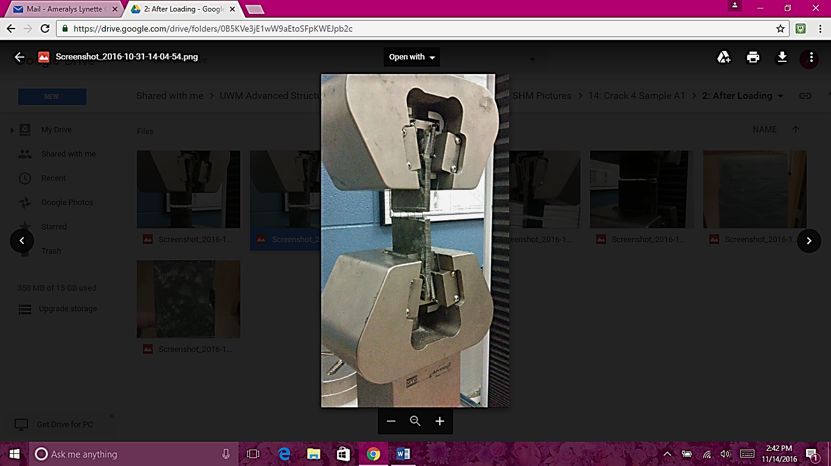
Ameralys Correa
Figure 1 – Experimental tensile testing of a self-healing specimen (left) and bending analysis with internal loads (right)
+
=
Afsaneh Moghadam Ph.D.
Pradeep Rohatgi Ph.D.

Abstract
Self-healing materials have innate capabilities to restore geometry and mend damage in a structure. These materials have tremendous potential to prevent catastrophic failures and overcome fatigue issues by repairing structural damage as it occurs, while in service. In order to restore bulk deformations and close macroscopic cracks self-healing materials have been developed that are essentially sparse fiber composites, composed of a structural matrix reinforced with shape memory fibers. This composition is capable of closing large cracks and restoring bulk geometry in a free, unloaded, state.
A significant limitation of this technique is that structures are not capable of overcoming or withstanding externally applied loads while restoring their original geometry. This is because the shape memory material used to restore geometry is currently cast in its trained geometry. Therefore, activation and recovery will only provide loads to return to that original geometry, negating plastic deformation of the matrix, and any externally applied load will cause deviation, inhibiting geometric restoration.
Seeking to overcome this limitation, polymer samples were created containing prestrained nickel titanium shape memory fibers that undergo constrained recovery upon activation. Actuation of the shape memory fibers generates internal/residual loads allowing the healed structure to withstand and overcome externally applied loads.
Theory, experimental results, analysis, and future vision for self-healing materials composed of prestrained nickel titanium shape memory fibers are discussed. A mechanics based derivation is presented relating internal/residual loads to allowable externally applied loads. Experimental results are presented from samples composed of prestrained shape memory alloy reinforced polymer with an internal framework to ensure load transfer between components. Samples were loaded in tension with a constant crosshead speed until matrix failure, then healed through thermal actuation and loaded to crack opening multiple times. Analysis of theory and experimental results are presented.

Image

Recent Publications (minimum 5)
- Suri S., Correa A., Rohatgi P. and Salowitz N. (2016) “Initial integration of structural health monitoring of self-healing materials," in Proceedings of the 8th European Workshop on Structural Health Monitoring, Balboa, Spain.
- Salowitz N., Kim S.-J., Kopsaftopoulos F., Li Y.-H., and Chang F.-K. (2016) "Design and Analysis of Radially Polarized Screen Printed Piezoelectric Transducers," Journal of Intelligent Material Systems & Structures, Accepted.
- Salowitz N., Guo Z., Kim S.-J., Li Y.-H, Lanzara G., and Chang F.-K. (2014) "Microfabricated Expandable Sensor Networks for Intelligent Sensing Materials," IEEE Sensors Journal, vol. 14, no. 7, pp. 2138-2144.
- Salowitz N., Guo Z., Roy S., Nardari R., Li Y.-H, Kim S.-J., Kopsaftopoulos F., and Chang F.-K. (2014), "Recent advancements and vision toward stretchable bio-inspired networks for intelligent structures," Structural Health Monitoring - An International Journal, vol. 13, no. 6, pp. 609-620, November.
- Lanzara G., Salowitz N., Guo Z., and Chang F.-K. (2010) "A Spider-Web-Like Highly Expandable Sensor Network for Multifunctional Materials," Advanced Materials, vol. 22, no. 41, pp. 4643-4648

Biography (150 word limit)
Nathan P. Salowitz received the B.S. degree in engineering mechanics from the University of Wisconsin – Madison in 2001 and the M.S. and Ph.D. degrees in aeronautics and astronautics from Stanford University in 2006 and 2013, respectively.
From 2003 to 2005 he was a Structural Analysis Engineer with The Boeing Company. From 2013 to 2014 he was a postdoctoral Engineering Research Associate at Stanford University. Since 2014 he has been an Assistant Professor with the Mechanical Engineering Department with Adjunct Professor appointments in the Electrical Engineering and Civil and Environmental Engineering departments at the University of Wisconsin – Milwaukee. He has more than 16 publications and is currently pursuing research in Intelligent Materials and Structural Health Monitoring with particular interests in sensor design, mass sensor deployment, wireless communication, and the interaction of sensors and structures.
Email: Salowitz@UWM.edu

Notes/Comments:

