Gradually Porous Bio Ceramic Scaffolds using Ceramic/Camphene-based Three-Dimensional Co-Extrusion
Min-Kyung Ahn, PhD, Department of Bio-convergence Engineering, Korea University, Seoul, Korea
Jong-Woo Kim,Ph.D. candidate,Department of Bio-convergence Engineering, Korea University, Seoul, Korea
Yong-Hag Koh, PhD, Department of Bio-convergence Engineering, Korea University, Seoul, Korea

Abstract (300 word limit)
Porous bio ceramics have been extensively used in diverse fields, for examples, as scaffolds for bone regeneration, components for thermal insulation and filters, and preforms for structural composites. Fundamentally, the functions of porous ceramics are strongly affected not only by their porous structure (e.g., overall porosity, pore size, pore geometry, and pore interconnectivity), but also by the distribution of those pores.We herein demonstrate a novel, versatile approach to produce biomimetic porous ceramics with a continuously gradient porous structure using three-dimensional extrusion of a bilayered ceramic-camphene mixture/pure camphene feedrod. In this study, bi-layered feed rod comprised of the ceramic/camphene mixtures and law contents of ceramic or pure camphene used as the lower and upper part feed rod. Bi-layered feed rod could be gradually extruded with core/shell structure because of the wall slip phenomenon. This enabled the formation of green filaments comprised of a camphene core surrounded by a ceramic/camphene shell, where the core/shell thickness ratio increased gradually as extrusion proceeded. Biphasic calcium phosphate (BCP) ceramics with a gradient porous structure could be successfully produced by three-dimensionally depositing the extruded filaments layer by-layer. We evaluated gradient micro structure with produced gradient porous BCP ceramic scaffold by scanning electron microscopy (SEM) and Micro CT.

Image
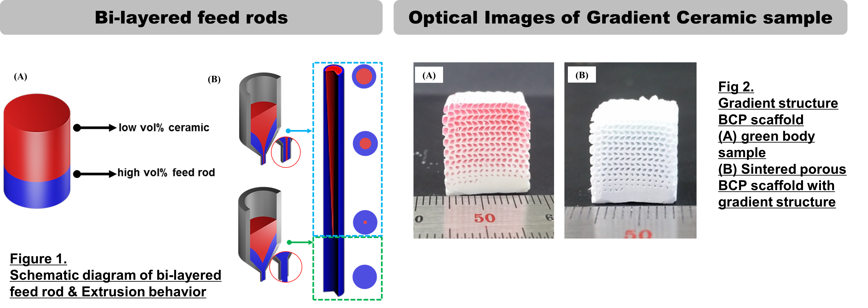
Recent Publications (minimum 5)
- Min-Kyung Ahn , Young-Wook Moon, Woo-Youl Maeng , Young-Hag Koh,* and Hyoun-Ee Kim (2017) Design and Production of Continuously Gradient Macro/Microporous Calcium Phosphate (CaP) Scaffolds Using Ceramic/Camphene-Based 3D Extrusion .MATERIALS 10,7
- Min-Kyung Ahn , Young-Wook Moon, Woo-Youl Maeng , Young-Hag Koh,* and Hyoun-Ee Kim (2016) Calcium phosphate ceramics with continuously gradient macrochannels using three-dimensional extrusion of bilayered ceramic-camphene mixture/pure camphene feedrod. CERAMICS INTERNATIONAL 42:15603-15609
- Min-Kyung Ahn , Jung-Bin Lee , Young-Hag Koh *, Hyoun-Ee Kim (2016) Rapid direct deposition of TiH2 paste for porous Ti scaffolds with tailored porous structures and mechanical properties. MATERIALS CHEMISTRY AND PHYSICS 176:104-109
- Min-Kyung Ahn, In-Hwan Jo, Young-Hag Koh , Hyoun-Ee Kim (2014) Production of highly porous titanium (Ti) scaffolds by vacuum-assisted foaming of titanium hydride (TiH2) suspension. MATERIALS LETTERS 120:228-231

Biography (150 word limit)
Minkyung AHN has her extensive experience in the field of biomaterials. She has a lots of experience in bio materials research, evaluation, and operation in the lab. She has many papers and patents in this field and has high passion for biomaterial development.

Email: alsrud4286@hanmail.net

Notes/Comments:

