pH RESPONSIVE LIPIDS FOR TARGETED DELIVERY OF ANTIBIOTICS
Mahantesh Jadhav ª, Rahul S. Kalhapure^{a*}, Sanjeev Rambharose ª, Sanil Singh^{b}, Linda Bester ^{b}, Tetsuya Kodama ^{c}, Chunderika Mocktar ª and Thirumala Govender ª*
ª Discipline of Pharmaceutical Sciences, School of Health Sciences, University of KwaZulu-Natal, Westville Campus, Durban 4000, South Africa
^{b} Biomedical Resource Unit, University of KwaZulu-Natal, Westville Campus, Durban 4000, South Africa
^{c} Graduate School of Biomedical Engineering, Tohoku University, Sendai, Japan

Abstract:
Problem Statement: The limitations of conventional dosage forms of antibiotics is a major factor contributing to the current global drug resistance crisis. Innovative materials are required for the development of nano drug delivery systems to improve antibiotic therapy. The aim of this study was to design new biocompatible pH-sensitive lipids (PSLs) with three hydrocarbon tails and a head group with a secondary amine and carboxylate function for delivery of Vancomycin (VCM) to acidic conditions of infection sites. Methods: A series of lipids was designed, synthesized and their structures were confirmed. The physicochemical, in vitro and in vivo properties of PSLs were determined. Findings: PSLs had diameters and polydispersity indices of 99.38 ± 6.59 nm to 105.60 ± 5. 38 nm and 0.161 ± 0.003 to 0.219 ± 0.05 respectively. The zeta potential values were negative at physiological pH 7.4 but changed to positive values with a decrease in pH. The drug encapsulation efficiency was 30 – 40%. Higher drug release was demonstrated at acidic pH as compared to physiological pH. The in vitro antibacterial activity of PSLs against sensitive and resistant bacterial strains revealed ‎superior ‎antibacterial activity ‎compared to ‎bare ‎VCM at both ‎pH ‎‎conditions, with higher activity being observed at pH 6 as compared to pH 7.4. The in vivo study in a mice skin infection model revealed that ‎‎MRSA CFU load in ‎‎mice skin treated with ‎PSLs were able to kill MRSA up to 75x more than bare ‎VCM (Figure 1) ‎Histomorphological skin analysis also correlated with the in vivo study. Conclusion and Significance: This study confirmed the pH responsiveness of the novel fatty acid based lipids and its applicability for enhancing the treatment of bacterial infections. It serves as a platform for the design of pH responsive materials for various other diseases as well such as cancer and inflammation characterized by acidic conditions.

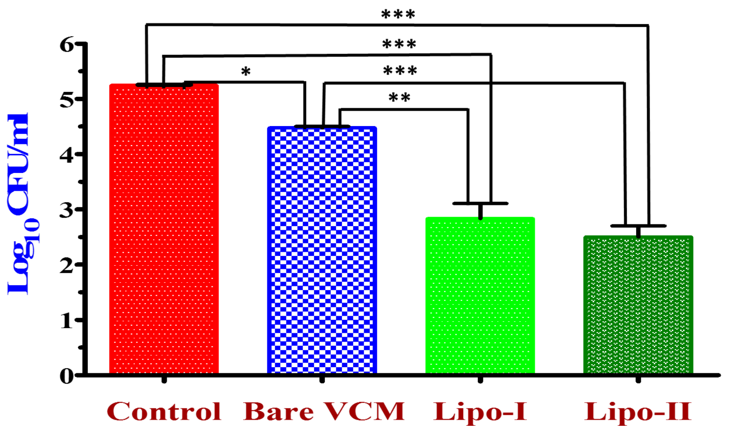

MRSA burden after 48 h of treatment. (* p<0.025; ** p<0.008; *** p<0.0001).
Recent Publications
- Kalhapure, R.S., Sikwal, D.R., Rambharose, S., Mocktar, C., Singh, S., Bester, L., Oh, J.K., Renukuntla, J., Govender, T. Enhancing targeted antibiotic therapy via pH responsive solid lipid nanoparticles from an acid cleavable lipid. Nanomed. Nanotech. Biol. Med. 2017, 13, 2067-2077.
- Jadhav M, Kalhapure RS, Rambharose S, Mocktar C, Singh S, Kodama T, Govender T, Novel lipids with three C18-fatty acid chains and an amino acid head group for pH-responsive and sustained antibiotic delivery. Chemistry and Physics of Lipids, 2018, 212, 12-25.
- Sikwal, DR, Kalhapure, RS, Jadhav, M, Rambharose, S, Mocktar, C, Govender, T. Non-ionic self-assembling amphiphilic polyester dendrimers as new drug delivery excipients. RSC Advances, 2017, 7, 14233 – 14246.
- Sonawane, S, Kalhapure, RS, Govender, T., Hydrazone linkages in pH responsive drug delivery systems. European Journal of Pharmaceutical Sciences, 2017, 99, 45-65.
- Omolo, C, Kalhapure, RS, Jadhav, M, Rambharose, S, Mocktar, C, Ndesendo, VMK, Govender, T, PEGylated oleic acid: a promising amphiphilic polymer for nano-antibiotic delivery. European Journal of Pharmaceutics and Biopharmaceutics, 2017, 112, 96-108.



Thirumala Govender completed a PhD in Nanotechnology at University of Nottingham (UK) after being awarded a Commonwealth Scholarship. Her current research on novel delivery systems focuses on nanotechnology and alternate routes of drug delivery. She has published widely in top ranked international journals on the successful formulation of various novel drug delivery systems as well as the design of new pharmaceutical materials for various communicable and non-communicable disease conditions. She is currently Professor of Pharmacy in the Discipline of Pharmaceutical Sciences, Head of the Drug Delivery Research Unit and Head of the NanoHealth Pillar of the UKZN Nanotechnology Platform at UKZN. In recognition of her scientific expertise in pharmaceutical technology, Prof Govender is currently appointed as an Expert Evaluator on the Medicines Control Council of South Africa for the quality evaluation of new medicines for regulatory approval. Prof Govender is also a past Vice Chair of the Academy of Pharmaceutical Sciences of South Africa.
Email: govenderth@ukzn.ac.za

