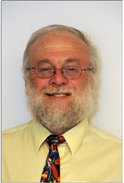
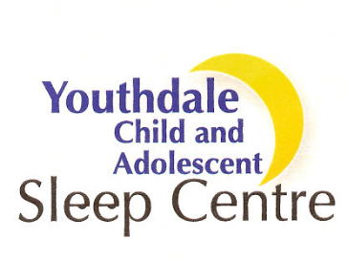

Dr. Colin M Shapiro, BSc. (Hons), MBBCh, MRCPsych,Ph.D, FRCP(C)
Professor, Department of Psychiatry and Opthalmology
Director, International Sleep Clinic, Parry Sound
Youthdale Child and Adolescent Sleep Centre, Toronto
Abstract: Biological Sleep Markers of Depression
Depression is one of the most debilitating, widespread, costly and stigmatized illnesses of our time. Despite the importance of depression, there is to date no commercially available technological support to diagnose depression and guide treatment. We have developed for the first time a system that automatically and objectively diagnoses depression by using macro and micro sleep architecture. Using these biological markers, we have achieved a detection rate of 92% for controls and 83% for depressed adults, while for children, we reached a detection rate of 100% for controls and 75% for depressed children. We anticipate that our innovative use of biological markers of depression will bring an important advance to the field and offer the much needed technological support to the diagnosis of depression. For the first time psychiatrists will have in their toolbox an easy-to-use, computerized diagnostic technique that will complement the current method of enquiry, improve diagnostic specificity and guide treatment. Currently we are investigating the possibility of using our method for predicting the road to suicide and to guide pharmacological treatment. We believe our work constitutes an important step toward the possibility of real standardization of diagnosis and in addition providing an important link in the chain leading to the elimination of stigma in psychiatry.

Biography
Dr. Colin Shapiro has been involved in sleep research for over thirty years. He trained in medicine in South Africa subsequently doing his PhD in sleep physiology at the University of Edinburgh. Dr. Shapiro founded the British Sleep Society and the International Neuropsychiatry Association. Dr. Shapiro has over 300 publications in this field and a over a dozen books including a book on Forensic aspects of sleep and several books for the lay public including “Fighting Fatigue and Sleepiness”, and very recently "Insomnia in a nutshell" He also co-authored “Working the Shift” and children’s book “Who needs to sleep anyway”.

