Home Sleep Apnea Testing in Children: A Prospective Pilot Study
Amee A Patel, DO; Jason Vecchio, BA, RPSGT; Danielle Guffey, MS; Charles G Minard, PhD; Daniel G Glaze, MD
Department of Pediatrics, Baylor College of Medicine; Children’s Sleep Center, Texas Children’s Hospital, Houston, TX
** (Presented recently at the Pediatric Sleep Conference 2017)

There is limited availability and restricted access to pediatric attended laboratory polysomnography (PSG) resulting in delays in treatment. There is growing evidence that Home Sleep Apnea Test (HSAT) can successfully be used to identify adults with moderate to severe OSA; however, there are limited studies validating the accuracy and utility of HSAT compared to PSG in children. The purpose of this study was to compare the gold standard, PSG to HSAT and to determine sensitivity and specificity of HSAT in efforts to identify children with moderate to severe OSA. The study was approved by the Baylor College of Medicine Institutional Review Board. Methods: Inclusion criteria included the following: children aged 4-18 years who underwent sleep clinic evaluation and overnight polysomnography (PSG). Exclusion criteria inclusion included the following children who had prior tonsilloadenoidectomy, previous diagnosis of OSA, use of PAP therapy, presence of complex medical problems and/or other sleep disorders, and less than 4 hours (240 minutes) of HSAT recording time. On the first night, subjects were set up by a sleep technologist with the Carefusion NOX T3 ambulatory device and then sent home. On the next consecutive night, subjects were then evaluated with a PSG. Subjects were recruited from Texas Children’s Hospital/ Children’s Sleep Center. Both HSAT and PSG were scored by a board certified sleep specialist. AASM pediatric scoring rules were used for the PSG but modified the HSAT adult algorithm but scoring events of 2 breaths or more. Fifty-three subjects were enrolled. Eight (15%) subjects were excluded due to equipment malfunction/incomplete HSAT recording time, 4 (7%) did not complete the two nights of the study, 3 (6%) cancelled due to the hurricane. Therefore, 38 (72%) subjects completed both HSAT and PSG. Results: We found a cutoff value of HSAT oAHI>=0.8 had a sensitivity of 62.5% and specificity of 71.43% in those with PSG oAHI of >=5. For a cutoff of HSAT oAHI>=0.9, the sensitivity was 71.43% and specificity was 95.83% for identifying those with PSG oAHI of >=10. For a cutoff of HSAT oAHI>=3.1 the sensitivity was 87.50% and specificity was 86.67% for identifying those with PSG oAHI of >=20. Conclusion: This prospective, pilot study suggests that HSAT may be utilized in clinical practice in children with non-complex medical history who have a high probability of moderate to severe OSA. We found that HSAT OAHI value ≥ 0.9 is predictive of a PSG OAHI ≥ 10 and HSAT OAHI value ≥ 3.1 is predictive of a PSG OAHI ≥ 20 both with a high sensitivity and specificity. Future direction include larger sample size as including well non-obese and obese children.

Pediatric Bradycardia associated with isolated obstructive respiratory events in a 12 year old female: A case report.
Amee A Patel, DO
Children’s Sleep Center, Texas Children’s Hospital, Houston, TX
**not submitted or presented yet

This is a 9 year old female with a history of CHARGE syndrome and correction of tetralogy of fallot who presents for baseline polysomnography after tonsillectomy. Current medications included Allegra, Nasonex, Montelukast, Atenolol, Ranitidine, Omeprazole. The patient has had a tonsillectomy or adenoidectomy. On the Pediatric Daytime Sleepiness Scale the patient's score was 11 (significant values >15). The initial study was completed in 12/2015. The study showed moderate OSA and mild CSA (AHI 16.5, RDI 17.63, CAI 5.54, oxygen nadir of 87 %, TCO2 values were elevated over 50 mmHg for 0% of the total monitoring time).
The repeat baseline study showed a total sleep time of 7.59 hours accounting for a sleep efficiency of 86.8%.
The patient was recorded while sleeping on the back. The baseline oxygen saturation was 96%. The oxygen nadir was 92%. The patient spent 0% of the total sleep time with oxygen saturation values less than 90%. The transcutaneous CO2 values were elevated to as high as 48 mmHg.

AASM pediatric scoring rules were used to score this sleep evaluation. The apnea hypopnea index was 12.12. The obstructive apnea hypopnea index was 8.83. The central sleep apnea index was 3.29 central apneic events per hour of sleep. Of note, there were several episodes of flow limitation that were associated with episodes of bradycardia; however, these were not scored as they do not meet the AASM scoring criteria (see arrow below). The heart rate was typically in the range of 43-74 beats per minute. Frequent episodes of sinus bradycardia were recorded.

In this case report, air flow limitation was found to be associated with isolated episodes of bradycardia in the setting of mild obstructive sleep apnea. The episodes were not associated with a desaturation or arousal thus were not scorable per AASM scoring rules. It is known that patients with moderate to severe OSA can present with intermittent episodes of bradycardia. However, there is variation in regards to cofounding factors that contribute to the arrhythmia. There is little known of sinus bradycardia in relation to patients with mild OSA such as in this patient.

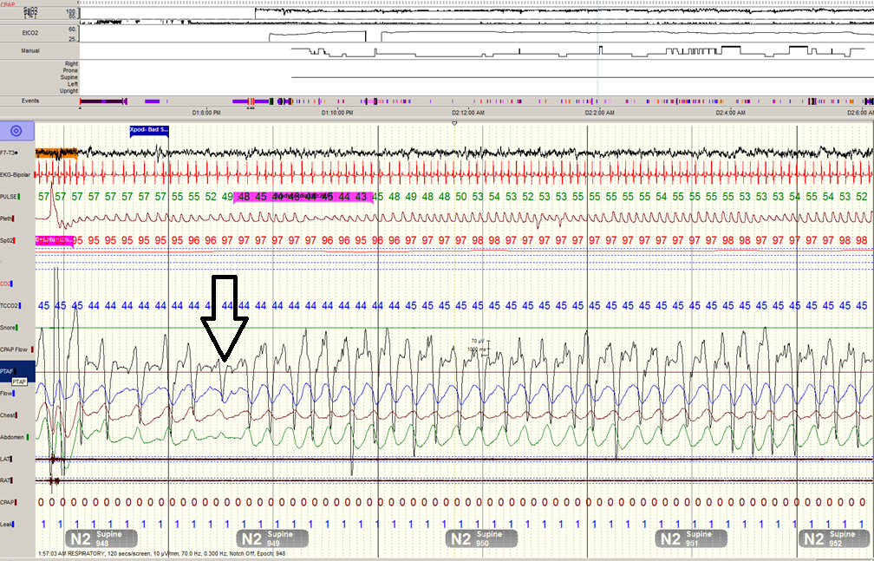

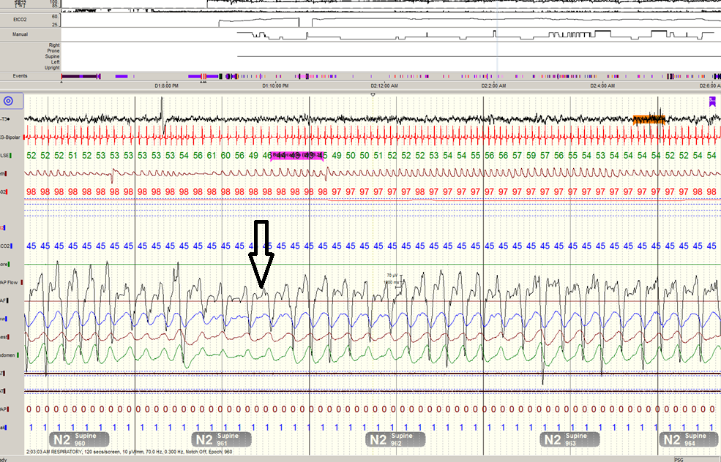
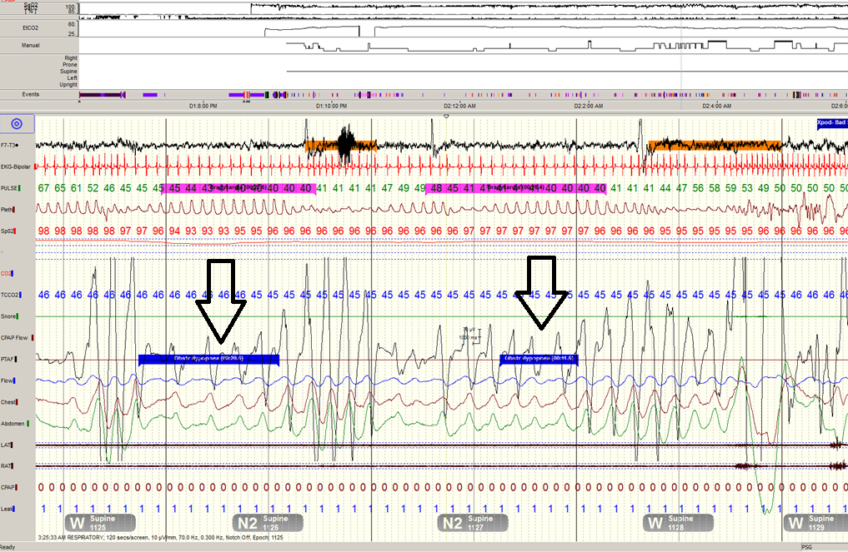

Author description:

Amee A Patel, DO is Assistant Professor of Pediatrics at Texas Children’s Hospital/ Baylor College of Medicine. Dr Patel is triple board certified in general pediatrics, pediatric pulmonology and sleep medicine. Recently, she presented a prospective, pilot study (abstract) in Home sleep apnea testing in children at the Pediatric Sleep Conference 2017. She is active in promoting pediatric sleep education of trainees and is the fellowship Advisor of Research. In addition to her clinical work, she is creating a multidisciplinary clinic involving psychology and sleep medicine providers for children with autism and sleep disorders.

