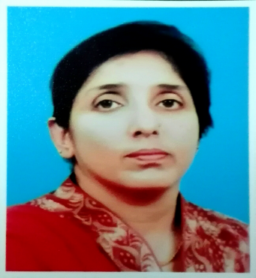



Jinnah Medical & Dental College Musavvir Stem Cell Clinic

Title: PLATELET-RICH PLASMA USE IN THE TREATMENT OF ECZEMA (ATOPIC DERMATITIS): A CASE REPORT
Name: Dr Rubina Ghani
Jinnah Medical and Dental College/Musavvir Stem Cell Clinic, Sindh, Karachi, Pakistan.
Abstract:
Background:In the last few decades, thousands of patients have benefited from platelet rich plasma (PRP) therapies, emerging as a safe alternative in many different medical fields. The use of Platelet-Rich Plasma (PRP) in medicine has become increasingly more widespread during the last decade. The eczema (atopic dermatitis) is a complex disorder caused by the interplay between multiple genetic and environmental factors. Particularly in patients with severe disease, the effect is not just an itchy rash but also the secondary effects on the psychological well-being of the patient and their carers, particularly disturbed sleep. The aim of the study was treat the patient by using the platelet rih plasma.
Materials& Methods: 15 cc blood sample was collected from the patient. The base line parameters included complete blood count (CBC), erythrocyte sedmentation rate(ESR), fasting blood sugar/ransom blood sugar(FBS/RBS), urea, creatinine and uric acid, We also checked for the inflammation by performing C-Reaactive Protein(CRP) and immunoglobulin Ig E for the alllery. The rest of the blood sample was used for the PRP .The platelet rich plasma (PRP) was collected with the help of spiral needle in sterilized falcon tube which was then place in Adilight 2 for the activation of PRP for 15 minutes.
Result: In base line reports it was noted that eosinophil was elevated , with ESR. The sugar level, urea, creatinine and Uric acid were at normal range. The CRP was high and ig E was abnormal. She underwentthree consecutive platelet-rich plasma therapywith a gap of 15 days in between. We assessed the patients by taking the photograph and repeating the parameters which were elevated before the second and third treatment. After the first therapy, the images showed the improvement. However after the second therapy, the patient reported marked control on the itchy and disappearance of rash. She was quite satisfied with the treatment, because the treatment she was taking increasing the rashes.
Conclusion:This study suggests the use of platelet-rich plasma has a beneficial effects on skin diseases and can thus be attributed to various platelet-derived growth factors causing improvement in the function on skin and promotion to decrese the rashes and itching . It is safe, cheap, and non-allergic and it appears to be a useful adjuvant in the management of eczema.

Keywords:Atopic dermatitis; Eczema; Platelet rich plasma, separation, principles, standardization
Images/Graphs/Tables:

CASE 1
Day |  | Response of Eczema to PRP |  | Biomarkers
1 |  | 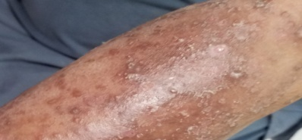 |  | Eosin = 14%  ESR = 78  CRP =14.7  IgE = 320
15 |  | 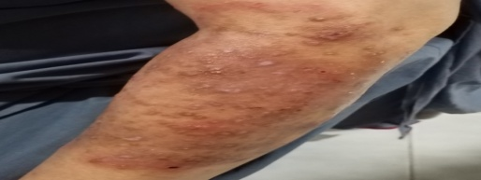 |  | Eosin = 08%  ESR = 60  CRP = 9.6  IgE = 285
30 |  | 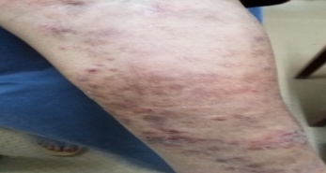 |  | Eosin = 02%  ESR = 45  CRP = 3.2  IgE = 145
Note: ESR, mm in 1sthr; CRP, mg/L; IgE, IU/mL
Abbreviations: Eosin, eosinophil; ESR, erythrocyte sedimentation rate; CRP, C-reactive protein; IgE, immunoglobulin E
CASE 2
Day | Response of Eczema to PRP |  | Biomarkers
1 | 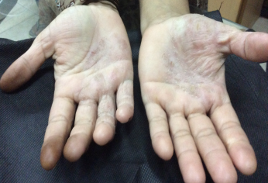 |  | Eosin = 31%  ESR = 82  CRP =36.9  IgE = 411
15 | 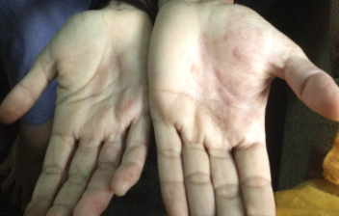 |  | Eosin = 22%  ESR = 55  CRP = 13.4  IgE = 299
30 | 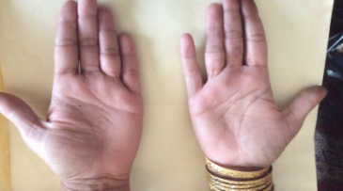 |  | Eosin = 03%  ESR = 25  CRP = 4.4  IgE = 112
Note: ESR, mm in 1sthr; CRP, mg/L; IgE, IU/mL
Abbreviations: Eosin, eosinophil; ESR, erythrocyte sedimentation rate; CRP, C-reactive protein; IgE, immunoglobulin E

Recent Publications:
- International Journal of Current Research(2016). “Evaluation Of Hepatitis B And C related in Oral Health: A PopulationStudy in Karachi, Pakistan” volume 8, Issue, 02, pp.26834-26838` Impact factor 6.24
- Journal of Life Sciences (2016) ‘Identification of 11 STD Pathogens in Semen Using Polymerase Chain Reaction (PCR) and “Flow-through” Hybridization Technology’ (10) 91-99. Impact factor 3.81

- International Journal of Current Research in Life Sciences (2016).’Role of serum retinol-binding protein 4 levels for the early detection of liver cirrhosis’ Vol. 05, No. 05, pp. 587-590. Impact factor 6.39
- International Journal of Current Research (2016) ‘Frequency rate of divorce in Malir district, Karachi, Pakistan. Vol. 8, Issue, 08, pp.36690-36697. Impact factor 6.24
- Advances in Enzyme Research (2016). ‘Biological Association and Expressions of NOS3 & SOD2 in Non-Diabetic Senile Cataractogenesis.’ Vol. 4: pp. 87-97. Impact factor 1.02
- European Journal of Biology and Medical Science Research ‘Comparison of anthropometric measurement and total cholesterol in calcific aortic stenosis.’Vol.5, No.2, pp.1-6(2017) Impact factor 5.01
- Journal of the Pakistan Medical Association ‘Molecular basis of superoxide dismutase alteration in Spirometry proven bronchial asthma’ JPMA 67: 1393; 2017.
- International Journal of Advance Research, “Knowledge, attitude and practice, regarding maternity care among married Women related to age, education and antenatal care in different maternity homes of central district Karachi, Pakistan.”5(12), 1240-1247, 2017.
- International of Biological Research “Comparative study for the rapid detection and genotyping of MTB and RIF / INH resistant MTB Mutants with Gene Flow Hybridization and Conventional PCR” 2017;8(4):-6121-6124. Impact factor 5.51.
- Imperial Journal of Interdisciplinary Research,” Screening of β-Thalassemia Trait from Iron Deficiency Anemia on the bases of Absolute Indices” Vol-4, Issue-1, 2018. Impact factor 3.7
- Medical Research and Clinical Case Report “Benefits of CIMT to diagnosis of Coronary Artherosclerosis.” Vol 1 issue 2; 2018; 49-52 ISSN: 2578-3416
Biography:(Minimum 150 words Maximum 250 words)

Dr. (Miss) Rubina Ghani d/o (Late) Abdul Ghani Musavvir. Educational Qualification: done MSc.& Ph.D. topic “Biochemical studies in the patients with hemoglobin Abnormalities”
Teaching Experience:Baqai Medical University and joined as Assistant Professor in October 2005 and Resigned as Professor in December 2015.joined in 2016 Jinnah Medical & Dental Collegeas Professor and Head of Department till now. Dadabhoy Institute for Higher Education in December 2015 as visiting faculty till now. Presented Poster on National/ International (15), Paper National/ International (27). Publication National/International (43), Under publicationin international (accepted)02.
Workshops Attended: National/International (10). Workshops Arranged.National (09). HEC Approved supervisor 2014, Under my supervision M.Phil06 Ph. D 02, Visiting Supervisor Zaiuddin University
&Hamdard University, BASR Member atHamdardUniversity (Eastern Medicine)Field of interestInherited diseases, infectious diseases, and stem cell therapy

Presenting author details
Full name(As per the passport):Rubina Ghani
University/Industry/Organization name(Present working): Jinnah Medical & Dental Colloege/Musavvir Stem Cell
DesignationDirector/Professor
Country:Pakistan
Mobile number+92213323317900
Official Email ID: rg-musavvir33@hotmail.com
Presentation type(Oral/Poster): oral presentation
Category(Invited talk/Young researcher Invited talk/E-poster): invited talk
Track number(This is very important to schedule your talk): 9.2 Follow this link –https://stemcell.conferenceseries.com/call-for-abstracts.php
Research interest: Stem Cell /infectious disease

Your profile page URL in your department:/ Head of the Department
Date of birth as per the passport: 12.4.1967
Linked In/Facebook/twitter account:Rubina Ghani on facebook
Postal address: 22-23 Shaheed –e-Millat, Road Medicare Hospital , Karachi, Pakistan

Note: Please fill up the Red mark fields so that it would be easier for us to cite your details in the conference particulars. (Please do not forget to fix your photo and Logo above the title)

