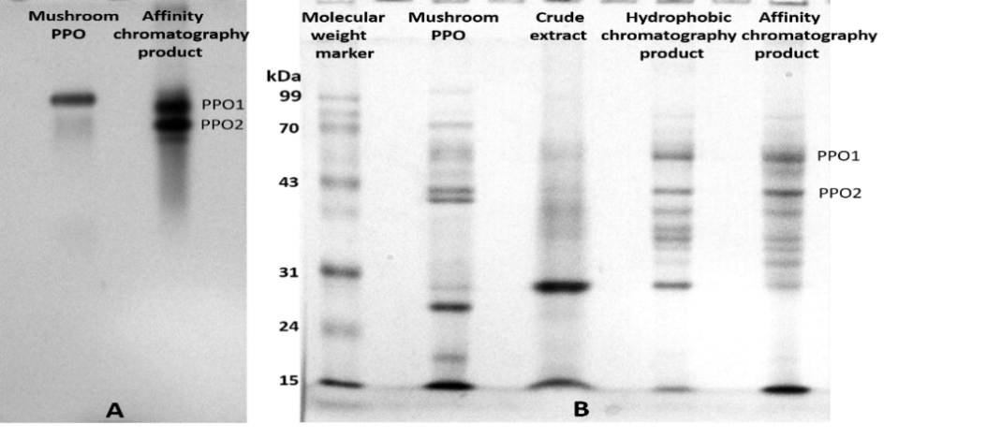
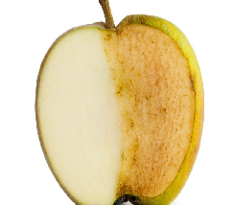
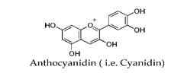
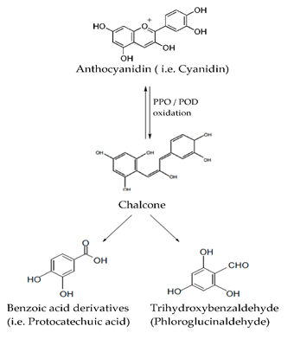
Inactive PPO
Active PPO

Abstract
Polyphenol Oxidase: Enzyme responsible for a browning in fruit products, a detail study of its purification and a green and economical method for its deactivation.
M. Kamran Khan
Dept. of Chemical Engineering,
Tsinghua University, Beijing China.

Statement of the Problem: Polyphenols are recently getting attention because of its antioxidative properties and beneficial role in health. Because of its instability its degradation products cause browning of fruit product, which is considered a serious issue. Polyphenol oxidase is the main enzyme mainly responsible for polyphenol degradation. In food processing industry quite a few conventional techniques are applied for the deactivation of PPOs regardless of its source but its structure, molecular weight and stability differs with its resource. For example, it has a broad range of optimum temperature 20-75 degrees, that why sometime a normal thermal deactivation method works negatively for PPO from some resources. Therefore, its properties need to be studied in more detail and a green technique is required for its deactivation on industrial scale.
Methodology: Hydrophobic chromatography was used to partially purify PPO from blueberry extract. And then affinity column was prepared via activating Sepharose-4B Coloumn via CnBr, using tyrosine as a linker and benzoic acid diazo coupling for the affinity separation of PPO. A novel method of deactivation via ethanol was studied for PPO deactivation which is not only FDA approved but also very easy to scale up as it is used for further purification in subsequent extraction of polyphenols from fruit products.
Finding: Blueberry PPO was purified and its mass was determined by SDS-page for the first time. Ethanol inactivation of the purified PPO was investigated. An irreversible deactivation of B.B PPO was achieved at high concentration of ethanol (70 %). Based on this finding an efficient anthocyanin extraction process was revealed, in which the blueberry fruit was soaked in ethanol (70%) for an hour before subjecting to grinding. This new procedure resulted in high extraction yield of anthocyanin.
Conclusion and Significance: Fruit polyphenols causes a huge loss to the economy of farmers and food industry via fruit browning. We found that its properties are different to each fruit source that’s why the conventional deactivation methods may have a negative effect on its deactivation and also on polyphenol loss which is a very important fruit product. We give a green and economic solution for its deactivation and scale up of fruit polyphenol extraction with high yield.

Recent Publications (minimum 5)

- M. Kamran Khan, Jianquan Luo, Zhaoshuai Wang, Rashid Khan, Xiangrong Chen, Yinhua Wan, Journal of Material Chemistry. B 6(11), 2018, 5-14.
- M. Kamran Khan, Jianquan Luo, Rashid Khan, Jinxin Fan, Yinhua Wan, Journal of Chromatography A, 1521 (2017) 19–26.
- M. Kamran Khan, Jianquan Luo, Rashid Khan, Yinhua Wan, Sino-Us Joint Conference on Chemical Engineering, Oct 2017, Ustb, Beijing, China
- Rashid Khan, Fei Shen, M. Kamran Khan, Lixia Liu Huanhuan Wu, Jianquan Luo, Yinhua Wan, Rsc Advance 6(34), 2016.
- M. Kamran Khan, Rashid Khan, Yinhua Wan, May 2015 Ipe Cas, Beijing China.

Bibliography:

Dr. Kamran khan is an experienced chemical engineer. Most specifically his research work focus on in surface functionalization and fabrication of membranes and resins via novel and green techniques. He works on chromatographic applications of membrane and resin media for biosepration of proteins and natural products in food industry. Furthermore, Dr khan work on enzymatic bio-catalysis and water purification via membrane based technologies. Dr khan also work on production of antifouling membranes for industrial applications.
Dr. Muhammad Kamran Khan
Tel: 0086-15650784477
Session Separation techniques in food chemistry
Category: (Oral presentation
Email: kamran88@mail.tsinghua,.ed.cn

