Multivariate optimization by central composite design (CCD) of a low density solvent based solvent terminated dispersive liquid liquid microextraction (ST-DLLME) combined with GC-FID for determination of acrylamide in water samples
Maryam Sayah, Vahid Kiarostami,
Department of Chemistry, North Tehran Branch, Islamic Azad University, Tehran, Iran

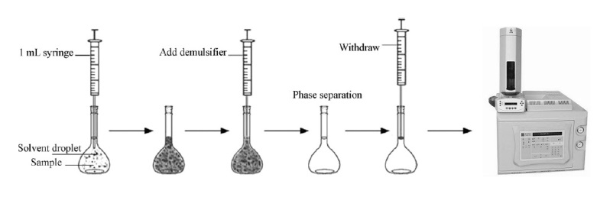
Abstract

Statement of the Problem: Polyacrylamide can be applied with multiple purposes in some industries such flocculants for clarification of potable water and treatment of municipal and industrial effluents and also used as grouting agents in the construction of drinking water reservoirs and wells, soil conditioning agents. Residual levels of unreacted acrylamide monomer in polyacrylamide can easily transfer to environmental and drinking water due to its water solubility and consequently caused the most important source of water contamination. Acrylamide has been stated as carcinogenic to humans (Group 2A) with a life time cancer of 10⁻⁵ in 0.5 µg L⁻¹ in drinking water. Methodology & Theoretical Orientation: A reliable, fast and safe method with easy operation for determination of acrylamide in water samples using a low density solvent based solvent-terminated dispersive liquid liquid microextraction (ST-DLLME) combined with GC-FID as a low cost detector which is available for most research laboratories has been developed and studied. Octanone and methanol were selected as the best extraction and dispersive solvents, respectively, using one factor at a time method. A central composite design (CCD) as a response surface methodology was used for multivariate optimization of the influences of other five factors (Volumes of extraction and dispersive solvents, PH, salt addition and extraction time) on the extraction efficiency. Under optimized condition (extraction solvent and its volume: octanone, 175 µl; dispersive solvent and its volume: 683 µl; PH: 6.5; salt addition: 2.5% and extraction time: 4 min), the linear range was 0.3-550 ng mlˉ¹ with detection (S/N=3) and determination (S/N=10) limits of 0.1 and 0.3 ng mlˉ¹, respectively. The percentage recoveries of acrylamide from drinking and well water at spiking level of 0.5, 1 and 10 ng mlˉ¹ were obtained in the range of 90.8-94.1%. Compared with the previously reported methods, the proposed ST-DLLME method indicates adequately figures of merit.
Image

Figure 1: The graphical abstract of the proposed ST-DLLME method coupled GC-FID

Recent Publications

1. Chen L, Haizhu L, Ping Y, Jinun Z, Xi C (2009) Determination of Acrylamide in Foods by Solid Phase Microextraction-Gas Chromatography. Food Science and Biotechnology 18(4):895-899.
2. Sobhi HR, Ghambarian M, Behbahani M, Esrafili A (2017) Application of modified hollow fiber liquid phase microextraction in conjunction with chromatography-electron capture detection for quantification of acrylamide in waste water samples at ultra-trace levels. J Chromatogr A 1487: 30-35.
3. Alpmann A, Morlock G (2008) Rapid and sensitive determination of acrylamide in drinking water by planar chromatography and fluorescence detection after derivatization with dansulfinic acid. Journal of separation science 31(1): 71-77.
4. Cavalli S, Polesello S, Saccani G (2004) Determination of acrylamide in drinking water by large-volume direct injection and ion-exclusion chromatography–mass spectrometry. Journal of Chromatography A 1039(1): 155-159.

Biography
Maryam Sayah has completed her master's degree in 2016 from the Department of chemistry, North Tehran Branch, Islamic Azad University, Tehran, Iran. Her research project under the supervision of Dr Vahid Kiarostami (Associate professor in analytical chemistry who also is the second author) was on the development of a low density solvent based solvent-terminated dispersive liquid liquid microextraction (ST-DLLME) for the extraction of acrylamide in water sample using central composite design (CCD). She is interested in chromatography (GC and HPLC), microextraction and chemometric methods.

Email: m_sayah977@yahoo.com v_kiarostami@iau-tnb.ac.ir

Name: Maryam Sayah
Email: m_sayah977@yahoo.com, v_kiarostami@iau-tnb.ac.ir
Contact number:00982177009836-42
Session name/ Track name:
Category: (Oral/ poster): Oral

Notes/Comments:

