Title : Synthesis and gas transport properties of substituted bicyclodianhydride-based polyimides

Mahmoud A. Abdulhamid, Ingo Pinnau*

King Abdullah University of Science and Technology (KAUST), Advanced Membranes and Porous Materials Center (AMPMC), Division of Physical Sciences and Engineering, Chemical and Biological Engineering Program, Thuwal 23955-6900, Saudi Arabia

Abstract (300 word limit)
Three novel polyimides were synthesized from a 9,10-dimethyl-2,6(7)-diaminotriptycene (T) with a commercially available bicyclo[2.2.2]oct-7-ene-2,3,5,6-tetracarboxylic dianhydride (BC) and its halogenated derivatives. The non-halogenated T-BC polyimide derivative was made as a reference material to evaluate the effect of the halogen groups in T-BCCl₄ and T-BCBr₄ on its gas transport properties. Pure-gas permeability coefficients of He, H₂, N₂, O₂, CH₄, and CO₂ were measured at 35 °C and 2 atm. The BET surface area based on nitrogen adsorption at 77 K of T-BC was 570 m² g⁻¹ while those of tetrachloro-functionalized T-BCCl₄ and tetrabromo-functionalized polyimide T-BCBr₄ were reduced significantly to 340 and 30 m² g⁻¹, respectively. The decrease in BET surface area in the halogenated polyimides resulted from reduction in their pore volumes relative to that of T-BC due to occupation of free volume space by the halogens. The freshly prepared T-BC membrane had a pure-gas O₂ permeability of 66 Barrer and O₂/N₂ selectivity of 5. The permeability decreased significantly by replacing the hydrogen groups by the chloro- or bromo groups in the cycloaliphatic dianhydride building block. For example, the permeability of O₂ decreased by 3-fold from 66 in T-BC to 20 Barrer in T-BCBr₄, while the permeability of nitrogen was reduced from 13 to 3.4 Barrer. As expected for lower permeability polymers, the O₂/N₂ selectivity increased concurrently from 5 in T-BC to 6 in T-BCBr₄. Long-term testing over 365 days resulted in only ~ 15% loss in gas permeabilities and without significant changes in selectivities, which demonstrated that these polyimides were resistant to physical aging. These combined results suggest that BC-based polyimides are promising candidate membrane materials for gas separation applications.

Image

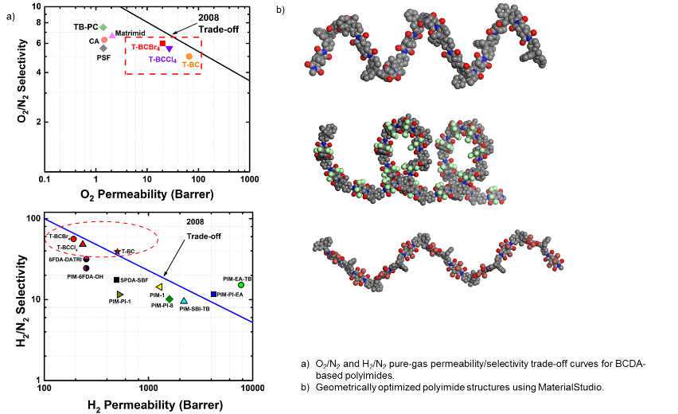
Recent Publications (minimum 5)
- Matsumoto, T. and T. Kurosaki, Soluble and Colorless Polyimides from Bicyclo[2.2.2]octane-2,3,5,6-tetracarboxylic 2,3:5,6-Dianhydrides. Macromolecules, 1997. 30(4): p. 993-1000.
- Chun, B.-w., Preparation and characterization of organic-soluble optically transparent polyimides from alicyclic dianhydride, bicyclo[2.2.2]-oct-7-ene-2,3,5,6-tetracarboxylic dianhydride. Polymer, 1994. 35(19): p. 4203-4208.
- Liu, J.G., et al., Organosoluble and transparent polyimides derived from alicyclic dianhydride and aromatic diamines. Journal of Polymer Science Part A: Polymer Chemistry, 2002. 40(1): p. 110-119.
- Ma, X., et al., Novel Spirobifluorene- and Dibromospirobifluorene-Based Polyimides of Intrinsic Microporosity for Gas Separation Applications. Macromolecules, 2013. 46(24): p. 9618-9624.
- Pascoe, E.V. and I.I. Harruna, Synthesis and characterization of high temperature polyimides from bicyclic dianhydrides. Journal of Macromolecular Science, Part A, 2003. 40(9): p. 915-932.

 Biography (150 word limit)
Mahmoud A. Abdulhamid is a PhD student at King Abdullah University of Science and technology (KAUST) located in Saudi Arabia at the shore of the Red sea. Mahmoud earned his Bachelor and master’s degrees from the Lebanese University in Organic and Polymer chemistry, he did his master’s thesis in France, university of Pau where he worked on an industrial project for six month to modify the natural polymers by green chemistry. Mahmoud has been working on his PhD thesis entitled Structure-property relationship for membrane-based polyimides, where he synthesizes monomers and then making different type of polymers and test for gas separation. Mahmoud is an inventor on one US patent application and co-inventor on other two applications.
Email: mahmoud.abdulhamid.2@kaust.edu.sa

Name:Mahmoud Abdulhamid
Email:Mahmoud.abdulhamid.2@kaust.edu.sa
Contact number: +966561440426
Session name/ Track name: Novel Separation Techniques in Chemistry
Category: (Oral/ poster): Oral

Notes/Comments:

