Cu-Zn/SBA -16 integrated tubular carbon molecular sieve membrane reactor for high H₂ yield in the water-gas shift reaction
Hui-Hsin Tseng, Professor, Chung Shan Medical University, Taiwan, ROC.
Yi-Ning Tu, Master, Chung Hsing University, Taiwan, ROC
Ming-Yen Wey, Professor, Chung Hsingl University, Taiwan, ROC

Abstract
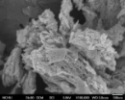
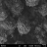
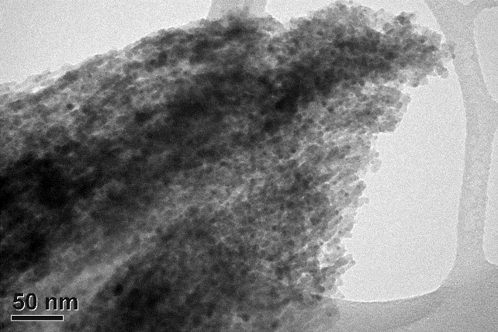

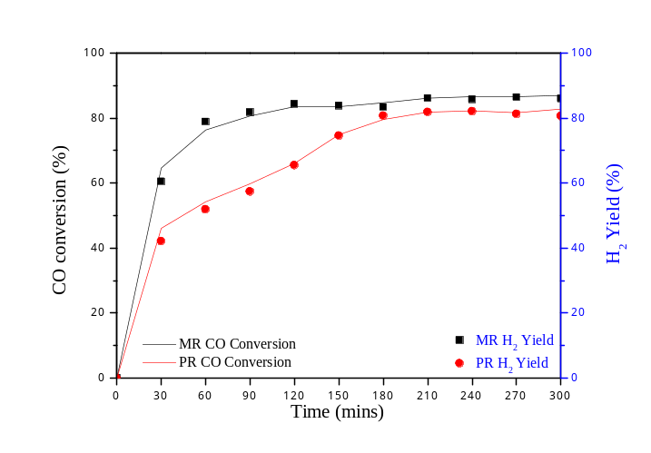To develop cleaner energy, the production of hydrogen (H₂) with carbon dioxide (CO₂) via water gas shift (WGS) reaction was applied after gasification system to enhance the H₂ generation capacity. However, due to the thermodynamic limits of equilibrium, the WGS reaction should be occurred at low temperature and the CO conversion rate cannot be high. The increase of the CO conversion above the equilibrium values appears to be possible when product, i.e. H₂ and CO₂, is removed through the membrane. Therefore, in this study, the carbon molecular sieve (CMS) membrane was integrated into the WGS system into the catalytic membrane reactor (MR). The effect of feeding pure reagents on the MR efficiency was evaluated to determine the best conditions in terms of CO conversion. At this purpose, experimental tests were carried out in two different systems of reaction: (1) traditional fixed-bed reactor, and (2) MR with CMS membrane.
The CMS membrane was prepared using polyethyleneimine as precursor and then coated on porous TiO₂/Al₂O₃ tubes to form tubular CMS membrane. The Cu/Zn/SBA–16 catalyst was synthesized with co-precipitation method. The results indicated that the CO conversion and H2 yield of reaction become higher with the raising operating temperature and decreasing GHSV in the traditional fixed-bed reactor. The optimal reaction temperature, GHSV and steam contain of Cu/Zn/SBA–16 catalyst were 300 ℃、2,500 h⁻¹and S/C (Steam/CO ratio) = 1 with CO conversion 82.76%. Finally, Cu/Zn/SBA–16 catalysts were used in catalytic membrane reactor with the same condition above, result in increasing the CO conversion about 4.19%. With the MR we not only successfully prepared with high CO conversion and fine H₂/CO₂ selectivity, but also cutting the time of reaction equilibrium.

Image

Fig. 1. The CO conversion & H₂ yield of WGSR, compare PR with MR.

Recent Publications
- Zhuang GL, Wey MY, Tseng HH** (2017) Effect of copolymer microphase-separated structures on the gas separation performance and aging properties of SBC-derived membranes. Journal of Membrane Science529:63-71.
- Zhuang GL, Wey MY*, Tseng HH** (2016) A novel recovery technique for recycling waste tire rubber into gas separation membranes. Journal of Membrane Science 520:314-325.
- Tseng HH*, Wang CT, Zhuang GL, Uchytil P, Reznickova J, Setnickova K (2016) Fabrication of a TiO₂/Al₂O₃ supported sandwich carbon molecular sieve membrane for gas separation: effects of TiO₂ intermediate layer preparation variables on interfacial adhesion. Journal of Membrane Science 510:391-404.
- Tseng HH, Zhuang GL, Lin MD, Chang SH, Wey MY (2015) The influence of matrix structure and thermal annealing-hydrophobic layer on the performance and durability of CMS membrane during physical aging. Journal of Membrane Science 495:294-304.
- Tseng HH, Chang SH, Wey MY (2014) A carbon gutter layer-modified α-Al₂O₃ substrate for PPO membrane fabrication and CO₂ separation. Journal of Membrane Science 454:51-61.

 Biography (150 word limit)
Professor Hui-Hsin Tseng is currently the chair of Occupational safety and health at Chung Shan Medical University, Taiwan. She has her expertise in preparation and characterization of nanostructured materials and polymer-derived membranes, such as polymer membrane, mixed matrix membrane, and carbon molecular sieving membrane for environmental and energy-related applications. Her major research interests includes: (1) development of polymer and inorganic membrane for gas separation/water treatment, and (2) integrating heterogeneous catalysis into membrane technology to solve the environment remediation, sustainable and green energy. Her contributions to environmental remediation and green energy achieved several research awards, and 64 SCI papers publication.
Email: hhtseng@csmu.edu.tw

.

Name: Hui-Hsin Tseng
Email: hhtseng@csmu.edu.tw
Contact number: +886-4-24730022 ext. 12118
Session name/ Track name: Track 1-4 Hydrogen separation and purification processes via membrane reactors technology
Category: (Oral/ poster): Oral

Notes/Comments:

