 Official Photo  University/Organization Logo

Can remote sensing technologies capture the extreme precipitation event and its cascading hydrological response? A case study of Hurricane Harvey using EF5 modeling framework
Deanna L Mulvihill, RN PhD, TLI Foundation, USA Deanna L Mulvihill, RN PhD, TLI Foundation, USA

Abstract (300 word limit)
A new generation of precipitation measurement products has emerged, and their performances have gained much attention from the scientific community, such as Multi-Radar Multi-Sensor system (MRMS) from the National Severe Storm Laboratory (NSSL) and Global Precipitation Measurement Mission (GPM) from the National Aeronautics and Space Administration (NASA). This study statistically evaluated the MRMS and GPM products and investigated their cascading hydrological response in August of 2017, when Hurricane Harvey brought the historical and record-breaking precipitation to the Gulf Coast (>1500 mm), causing107 fatalities along with about $125 billion worth of damage. Rain-gauge observations from Harris County Flood Control District (HCFCD) and stream-gauge measurements by the United States Geological Survey (USGS) were used as ground truths to evaluate MRMS, GPM and National Centers for Environmental Prediction (NCEP) gauge-only data by using statistical metrics and hydrological simulations using the Ensemble Framework for Flash Flooding Forecast (EF5) model. The results indicate that remote sensing technologies can accurately detect and estimate the unprecedented precipitation event with their near-real-time products, and all precipitation products produced good hydrological simulations, where the Nash-Sutcliff model efficiency coefficients (NSCE) were close to 0.9 for both MRMS and GPM products. With the timeliness and seamless coverage of MRMS and GPM, the study also demonstrated the capability and efficiency of the EF5 framework for flash flood modeling over the United States and potentially additional international domains.

Key words: Hurricane Harvey, radar, satellite, evaluation, hydrological simulation, EF5

Image
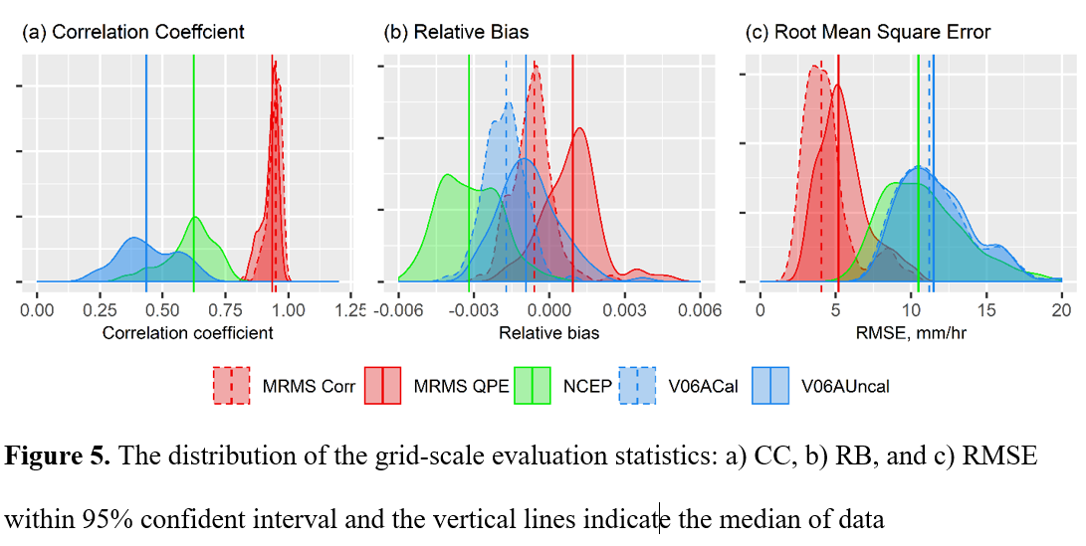
Recent Publications (minimum 5)
- Chen, M.; Nabih, S.; Brauer, N.S.; Gao, S.; Gourley, J.J.; Hong, Z.; Kolar, R.L.; Hong, Y. Can Remote Sensing Technologies Capture the Extreme Precipitation Event and Its Cascading Hydrological Response? A Case Study of Hurricane Harvey Using EF5 Modeling Framework. Remote Sens. 2020, 12, 445.
- Onal, H.; Woodford, P.; Tweddale, Scott A.; Westervelt, James D.; Chen, M.; Dissanayake, Sahan T.M.; Pitois, G. A dynamic simulation/optimization model for scheduling restoration of degraded military training lands. Journal of Environmental Management. 2016, 171, 144-157.
- Zhi, L.; Chen, M.; Tang, G.; Hong, Z.; Gourley, J.J.; Wen, Y.; Gourley, J.J.; Hong, Y. Cross-examination of Similarity, Difference and Advantages of Gauge, Radar and Satellite Precipitation Measuring Uncertainties for Extreme Events using Multiplicative Triple Collocation. Submitted.
- Chen, M.; Zhi, L.; Gao, S.; Luo, X.; Wing, O.; Bates, P.; Shen, X.; Gourley, J.J.; Kolar, R.L.; Hong, Y. Flood Inundation Mapping for Hurricane Harvey: A Review of Recent Methods and Operational Models. To be submitted.
- Chen, M.; Gao, S.; Gourley, J. J.; Xue, M.; Kolar, R. L.; Hong, Y. An Evaluation of the Forecastability of a Comprehensive Flood Warning System during Hurricane Harvey Using an Integrated Hydrological and Hydraulic Modeling Framework. In preparation.

Biography
Mengye Chen is a Ph.D. candidate in the School of Civil Engineering and Environmental Science, University of Oklahoma. He is a scientist focusing on multi-scale flood simulation and forecasting technologies and flood-related damage estimations. He is a senior researcher of Hydrometeorology and Remote Sensing Laboratory. He is an active member of the American Geophysical Union, American Meteorology Society, Water Environment Federal, and American Water Works Association, and an invited reviewer by multiple scientific journals. He was the winner of the WEF Student Design Competition in 2012 for the advanced oxidation process design. Mengye has a Bachelor's Degree in Environmental System Engineering from the Pennsylvania State University, and two Master's Degrees in Environmental Engineering and Sciences/ Applied Economics from the University of Illinois at Urbana-Champaign. He is the author and co-author on multiple papers and journal articles about flood risk and flood inundation.

Presenting author details
Full name (As per the passport): Mengye Chen
University/Industry/Organization name: University of Oklahoma
Designation (Director/Prof/Assistant or Associate prof/Researcher/Student): PhD Candidate
Country: USA
Mobile number (country code – number): +1-814-769-6703
Email: mchen15@ou.edu
Track number: https://satellite.insightconferences.com/abstract-submission.php (For track number follow this link)
Category (Oral presentation/ Poster presentation/Young researcher forum/E-poster):Oral
Research interest: Remote Sensing Hydrology
Your profile page URL in your department: http://hydro.ou.edu/
Year of birth: 1986
Linked In/Facebook/twitter account:

Note: Please fill up the Red mark fields so that it would be easier for us to cite your details in the conference particulars. (Please do not forget to fix your photo and Logo above the title)

