

An Evaluation Framework for Urban Cadastral System Policy in Ethiopia
- Solomon Dargie Chekole (PhD Candidate), Institute of Land Administration, Bahir Dar University, Ethiopia
- Walter Timo de Vries (Prof. Dr. Ing.) Department of Aerospace and Geodesy, TUM, Germany
- Gebeyehu Belay Shibeshi (PhD) Bahir Dar University, Ethiopia.

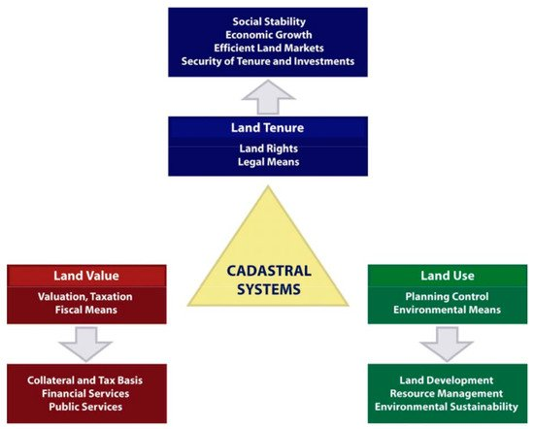
Abstract
Land is the most vital resource on earth from which people derive their basic needs. In order to administer and manage this vital resource in a sustainable way, there are several mechanisms, of which the cadastral system is the prime one. Literature documents that the performance measurement methods of cadastral systems are not appropriate. In most developing countries, systematic performance evaluation mechanisms for cadastral systems are very inadequate. For example, Ethiopia has no systematic evaluation framework to measure and evaluate the state of cadastral systems. This article aims to develop an evaluation framework to measure and evaluate the performance of urban cadastral systems in Ethiopia based on the methods that have proven successful in developed countries. The goal is furthermore to present a set of good practices and a set of indicators that can provide an objective basis to support a systematic evaluation of urban cadastral systems in Ethiopia. The study employs a desk review research strategy and a qualitative analytical approach. The study has contributed an evaluation framework to evaluate urban cadastral system policy of Ethiopia, which is not currently available.

Keywords:

Cadastral system; cadastral policy; performance indicator; evaluation framework
Image

Recent Publications (minimum 5)
- Chekole, S.D. Evaluation of Accuracy, Precision and Time Expenditure of Integrated Survey (GPS, Total Station and Terrestrial Laser Scanner), MSc Thesis in Geodesy No. 3131, TRITA-GIT EX 14-001.
- Evaluation of Current Urban Cadastre Practice in Ethiopia: Case of Bahir Dar, Gondar and Dessie. (Performed in group with staff members of ILA) can be accessed at: https://www.fig.net/resources/proceedings/fig_proceedings/fig2017/papers/iss7b/ISS7B_yehun_reda_et_al_8804_abs.pdf.
- Chekole, S.D.; de Vries, W.T.; Shibeshi, G.B. An Evaluation Framework for Urban Cadastral System Policy in Ethiopia. Land 2020, 9, 60. Link: https://doi.org/10.3390/land9020060.
- Chekole, S.D. Evaluation of Urban Land Administration Processes and Institutional Arrangements of Ethiopia: Based on Advocacy Coalition Theory. African Journal of Land Policy and Gespatial Sciences, V 3, issue 1 https://revues.imist.ma/index.php?journal=AJLP-GS&page=issue&op=view&path[]=1172&path[]=showToc.

Biography
Solomon Dargie is a lecturer and researcher in the areas of Land Administration, Land Surveying and Cadastral Systems at the Institute of Land Administration, Bahir Dar University, Ethiopia. He has graduated his BSc degree in Land administration Bahir Dar University in 2010. He received his MSc degree in Geodesy and Geo-informatics in 2013 from the Royal Institute of Technology (KTH), Sweden. While teaching and researching for four years, he has worked as chair of Geodesy and Geo-informatics and head of land administration department. Currently, he is PhD candidate in Land Policy and Governance, and visiting PhD Scholar at TUM, Germany.

Presenting author details
Solomon Dargie Chekole
Technical University of Munich (TUM)
PhD Student, land Policy and Governance
Germany
+49 1577230065
solomondargie@yahoo.com
Track number: Earth Science
Category: Oral presentation
Your profile page URL in your department: https://ila.bdu.edu.et/
Year of birth: 1985
Facebook: https://www.facebook.com/solomon.dargie/

Note: Please fill up the Red mark fields so that it would be easier for us to cite your details in the conference particulars. (Please do not forget to fix your photo and Logo above the title)

