

Approaches of determination of the meteoroid characteristics according to seismic data
Victor S Seleznev, Prof., GS RAS, Russia
Aleksei V Liseikin, PhD, GS RAS, Russia

Abstract
Determining such characteristics as the trajectories, times, and energies of explosions of meteor bodies that have collapsed in the Earth’s atmosphere is a very difficult problem for meteor astronomy. In the modern world, cases of fixing falls and explosions of meteoroids on video recording devices are very common. The decoding of the videos gives only approximate characteristics of the meteoroids, due to the fact that most of the devices in whose frame the ones accidentally fell are not designed for high-precision video recording. The study showed that, interpreting the records of seismic waves generated by the explosion of a meteoroid in the atmosphere and recorded by seismic stations on the Earth's surface (Fig. 1), it is possible to determine the required parameters with high accuracy. The approaches to determining the parameters of two events — the falls and explosions of meteoroids in the region of the city of Chelyabinsk and the city of Sayanogorsk (Russia) on February 15, 2013 and December 6, 2016, are considered in detail.

Key words: seismological observation, meteoroid, seismic and explosion energy

Image

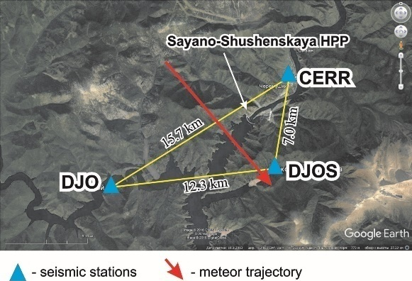

Figure 1: The scheme of local seismological net of Sayano-Shushenskaya HPP and Sayan (06.12.2016) meteor trajectory.

Recent Publications
- Seleznev V.S., Liseikin A.V., Emanov A.A., Belinskaya A.Yu. The Chelyabinsk meteoroid: a seismologist’s view. Doklady Earth Sciences. 2013. Т. 452. № 1.976-978.
- Seleznev V.S., Liseikin A.V., Emanov A.A., Belinskaya A.Y. Geophysical observations during the flight of the Chelyabinsk meteoroid. Russian Geology and Geophysics. 2014. Т. 55. № 3. 405-410.
- Seleznev V.S., Liseikin A.V., Emanov А.А., Belinskaya А.Y. Meteoroid Chelyabinsk (seismologist point of view). In digest: Meteorite Chelyabinsk – a year on Earth. Materials of Russian national academic conference. Compiler: N. А. Аntipin. 2014. P. 678-681. (in russian)
- Berngardt O.I., Perevalova N.P., Kutelev K.A., Zherebtsov G.A., Dobrynina A.A., Shestakov N.V., Bakhtiarov V.F., Kusonsky O.A., Zagretdinov R.V. Toward the azimuthal characteristics of ionospheric and seismic effects of “Chelyabinsk” meteorite fall according to the data from coherent radar, GPS, and seismic networks. Journal of Geophysical Research: Space Physics. 2015. Т. 120. № 12. 10754-10771.
- Li L., Wang B., Wang W., Peng Z. Seismic detections of the 15 February 2013 Chelyabinsk meteor from the dense ChinArray. Earthquake Science. 2016. Т. 29. № 4. 221-233.

Biography
Victor Sergeevich Seleznev–Deputy Director of Geophysical Survey of RAS and Director of Seismological Branch of Geophysical Survey of RAS, Russia, city of Novosibirsk. His areas of expertise involve local and engineering seismology, geophysical methods of research of the Earth deep structure. He develops methods of seismic monitoring of the state of large buildings and equipment.

Presenting author details
Full name: Victor Sergeevich Seleznev
Organization name: Geophysical Survey of Russian Academy of Science
Designation: Deputy Director
Country: Russia
Mobile number: +7-913-985-37-19
Email: svs0428@mail.ru
Mail id: 630090, Russia, Novosibirsk, Acad. Koptyug Prospect, 3
Category: Poster presentation
Research interest: local and engineering seismology, geophysical methods of research of the Earth deep structure

